



THE SOCIALIST REPUBLIC OF VIETNAM

Independence – Freedom – Happiness

Ho Chi Minh City, May 2024

**MISSION OF THE GRADUATION THESIS**

Student name: DANG MAI HUONG Student ID: 20110099

Student name: NGUYEN THI THU HANG Student ID: 20110473

Major: INFORMATION TECHNOLOGY

Project name: BUILDING A WEBSITE AND MOBILE APPLICATION TO SUPPORT HUMANITARIAN BLOOD DONATION

Advisor: M.Sc. NGUYEN DUC KHOAN

Date receive: 2024-03-04 Date submit: 2024-06-30

1. Project name: BUILDING A WEBSITE AND MOBILE APPLICATION TO SUPPORT HUMANITARIAN BLOOD DONATION

2. Figures and original document: This project is built from ReactJs for website and React Native for mobile application.

3. Product: A website and mobile application to support humanitarian blood donation

**Chief of department Advisor**

THE SOCIALIST REPUBLIC OF VIETNAM

Independence – Freedom – Happiness

Ho Chi Minh City, May 2024

**ADVISOR EVALUATION SHEET**

Student name: DANG MAI HUONG Student ID: 20110099

Student name: NGUYEN THI THU HANG Student ID: 20110473

Major: INFORMATION TECHNOLOGY

Project name: BUILDING A WEBSITE AND MOBILE APPLICATION TO SUPPORT HUMANITARIAN BLOOD DONATION

Advisor: M.Sc. NGUYEN DUC KHOAN

1. Content of the project:

...........................................................................................................................................

...........................................................................................................................................

1. Strengths:

...........................................................................................................................................

...........................................................................................................................................

1. Weaknesses:

...........................................................................................................................................

...........................................................................................................................................

1. Approval for oral defense?

...........................................................................................................................................

1. Overall evaluation:

...........................................................................................................................................

1. Mark:.................................(in words:....................................................................)

Ho Chi Minh City

**Advisor**

*(Sign with full name)*

THE SOCIALIST REPUBLIC OF VIETNAM

Independence – Freedom – Happiness

Ho Chi Minh City, May 2024

**PRE-DEFENSE EVALUATION SHEET**

Student name: DANG MAI HUONG Student ID: 20110099

Student name: NGUYEN THI THU HANG Student ID: 20110473

Major: INFORMATION TECHNOLOGY

Project name: BUILDING A WEBSITE AND MOBILE APPLICATION TO SUPPORT HUMANITARIAN BLOOD DONATION

Advisor: M.Sc. NGUYEN DUC KHOAN

* + - 1. Content of the project:

...........................................................................................................................................

...........................................................................................................................................

* + - 1. Strengths:

...........................................................................................................................................

...........................................................................................................................................

* + - 1. Weaknesses:

...........................................................................................................................................

...........................................................................................................................................

* + - 1. Approval for oral defense?

...........................................................................................................................................

* + - 1. Overall evaluation:

...........................................................................................................................................

* + - 1. Mark:................................ (in words:....................................................................)

Ho Chi Minh City

**Advisor**

*(Sign with full name)*

THE SOCIALIST REPUBLIC OF VIETNAM

Independence – Freedom – Happiness

Ho Chi Minh City, May 2024

**PRE-DEFENSE EVALUATION SHEET OF**

**DEFENSE COMMITTEE MEMBER**

Student name: DANG MAI HUONG Student ID: 20110099

Student name: NGUYEN THI THU HANG Student ID: 20110473

Major: INFORMATION TECHNOLOGY

Project name: BUILDING A WEBSITE AND MOBILE APPLICATION TO SUPPORT HUMANITARIAN BLOOD DONATION

Advisor: M.Sc. NGUYEN DUC KHOAN

Content of the project:

......................................................................................................................................................................................................................................................................................

Strengths:

......................................................................................................................................................................................................................................................................................

Weaknesses:

............................................................................................................................................

Approval for oral defense?

............................................................................................................................................

Overall evaluation:

............................................................................................................................................

Mark:................................ (in words:....................................................................)

Ho Chi Minh City

**Advisor**

*(Sign with full name)*

**ACKNOWLEDGEMENT**

We would like to express my deep gratitude to the Board of Directors of Ho Chi Minh City University of Technology and Education, especially the teachers of the Faculty of Information Technology, and at the same time, I would like to express my sincerest thanks to Mr. Nguyen Duc Khoan, the teacher who directly helped and guided me to complete this thesis.

This is the team report, it's also our first time doing an essay so there will be mistakes. Please review and evaluate, so that we can improve ourselves and complete better in the next projects.

Finally, we would like to express our sincerest thanks to the teachers and especially Mr. Nguyen Duc Khoan.

**Students Group**

**Dang Mai Huong**

**Nguyen Thi Thu Hang**

**TABLE OF CONTENT**

CHAPTER 1: INTRODUCTION 1

1.1. Introduction 1

1.2. Current situation 1

1.3. Problem definition 3

1.4. Proposed solution 3

CHAPTER 2: PROJECT SPECIFICATION 4

2.1. Functional requirement 4

2.1.1. User requirement 4

2.1.2. System requirement 10

2.1.2.1. Use case diagram 10

2.1.2.2. Use case description tables 14

2.2. Non-functional requirement 86

2.2.1.Performance requirements 86

2.2.2. Security requirements 87

CHAPTER 3: SYSTEM DESIGN 88

3.1. System Architecture 88

3.2. Entity Relation Diagram 90

3.3. Database Design 91

3.3.1. Account Collection 92

3.3.2. UserProfile Collection 92

3.3.3. HospitalProfile Collection 93

3.3.4. AdminProfile Collection 94

3.3.5. Event Collection 94

3.4. Sequence Diagram 96

3.5. User Interfaces Design 108

3.5.1. Screens Description 108

3.5.2. Screens Design 111

3.5.2.1. Website Screens 111

3.5.2.2. Mobile Screens 152

CHAPTER 4: SYSTEM IMPLEMENTATION 178

4.1. Environment 178

4.2. Technology 178

4.2.1. ReactJs 178

4.2.2.MongoDB 179

4.2.3. Express 180

4.2.4. NodeJs 181

4.2.5. React Native 182

CHAPTER 5: VALIDATION AND DEPLOYMENT 184

5.1. Test case Design 184

5.1.1. Admin 184

5.1.2. Hospital 185

5.1.3. User 185

5.2. Deployment 188

5.2.1. Hardware requirements 188

5.2.2. Software requirements 188

5.2.3. System installation 189

5.3.2.1. Run web application mobile application 189

5.3.2.2. Run mobile applications. 190

5.2.4. Deploy web with Vercel 191

CHAPTER 6: CONCLUSION 195

6.1. Evaluation 195

6.2. Difficulties and challenges 195

**LIST OF FIGURES**

*Figure 1.1. Website giotmauvang.com 2*

*Figure 2. 1 Guest’s use case diagram for Mobile 10*

*Figure 2. 2 Guest’s use case diagram for Website 11*

*Figure 2. 3 User’s use case diagram 12*

*Figure 2. 4 Hospital’s use case diagram 13*

*Figure 2. 5 Admin’s use case diagram 14*

*Figure 2. 6 Use case Register 15*

*Figure 2. 7 Use case Forgot Password 17*

*Figure 2. 8 Use case Login 20*

*Figure 2. 9 Use case View list of events 22*

*Figure 2. 10 Use case View hospital detail 23*

*Figure 2. 11 Use Case Request for cooperation 25*

*Figure 2. 12 Use Case Search event 27*

*Figure 2. 13 Use Case Filter event 29*

*Figure 2. 14 Use Case View a route on a map 31*

*Figure 2. 15 Use Case Logout for User 33*

*Figure 2. 16 Use Case Register Event for User 35*

*Figure 2. 17 Use Case Edit Profile for User 37*

*Figure 2. 18 Use Case View Blood Donation History for User 39*

*Figure 2. 19 Use Case View appointment schedule for User 41*

*Figure 2. 20 Use Case Change Schedule for User 42*

*Figure 2. 21 Use Case Cancel Schedule for User 44*

*Figure 2. 22 Use Case Reset Password for User/ Hospital/ Admin 46*

*Figure 2. 23 Use Case View and download certificate for User 48*

*Figure 2. 24 Use Case View Reward for User 50*

*Figure 2. 25 Use Case View List of Event for Hospital/ Admin 52*

*Figure 2. 26 Use Case Add New Event for Hospital 53*

*Figure 2. 27 Use Case Edit Event 55*

*Figure 2. 28 Use Case Close Event for Hospital 57*

*Figure 2. 29 Use Case View the list of registrants for each event for Hospital 59*

*Figure 2. 30 Use Case Update user Status for Hospital 61*

*Figure 2. 31 Use Case Export to excel for Hospital 63*

*Figure 2. 32 Use Case View the statistics for each event organized by itself for Hospital 65*

*Figure 2. 33 Use Case View List of Accounts forAdmin 67*

*Figure 2. 34 Use Case Add New Account for Admin 69*

*Figure 2. 35 Use Case Edit account 71*

*Figure 2. 36 Use Case Close Account 74*

*Figure 2. 37 Use Case View of List Hospital 76*

*Figure 2. 38 Use Case Add New Hospital 78*

*Figure 2. 39 Use Case Edit Hospital 80*

*Figure 2. 40 Use Case View statistics 82*

*Figure 2. 41 Use Case Approve cooperation request for Admin 84*

*Figure 3. 1 System Architecture 88*

*Figure 3. 2 Entity Relation Diagram 91*

*Figure 3. 3 Login Sequence Diagram 96*

*Figure 3. 4 Sign up Sequence Diagram 97*

*Figure 3. 5 ForgotPassword Sequence Diagram 97*

*Figure 3. 6 Profile update (for user, hospital and admin) Sequence Diagram 98*

*Figure 3. 7 User register event Sequence Diagram 99*

*Figure 3. 8 Update User schedule Sequence Diagram 100*

*Figure 3. 9 View history and download e-Certification Sequence Diagram 101*

*Figure 3. 10 Update Password Sequence Diagram 101*

*Figure 3. 11 Search event Sequence Diagram 102*

*Figure 3. 12 Filter event Sequence Diagram 102*

*Figure 3. 13 Add New event Sequence Diagram 103*

*Figure 3. 14 Update event Sequence Diagram 103*

*Figure 3. 15 Update status user for each event Sequence Diagram 104*

*Figure 3. 16 Search event by hospital Sequence Diagram 105*

*Figure 3. 17 List Management Sequence Diagram 105*

*Figure 3. 18 Search account Sequence Diagram 106*

*Figure 3. 19 Statistic Sequence Diagram 106*

*Figure 3. 20 Export to excel Sequence Diagram 107*

*Figure 3. 21 Register for cooperation become Hospital Sequence Diagram 107*

*Figure 3. 22 Accept/Decline Request Cooperation Sequence Diagram 108*

*Figure 3. 23 Screen Guest Login 112*

*Figure 3. 24 ScreenGuest Sign Up 113*

*Figure 3. 25 Screen Guest Forgot Password 115*

*Figure 3. 26 Screen Guest / User Reset Password 116*

*Figure 3. 27 Screen Header before login 117*

*Figure 3. 28 Screen Header after login 117*

*Figure 3. 29 Screen Footer 118*

*Figure 3. 30 Screen Guest / User Event Page 120*

*Figure 3. 31 Screen Guest / User Collaborator Hospital Page 121*

*Figure 3. 32 Screen Detail Hospital Page 123*

*Figure 3. 33 Screen Detail Profile 124*

*Figure 3. 34 Screen Edit Profile 125*

*Figure 3. 35 Screen Modal Edit Information 126*

*Figure 3. 36 Screen Modal Edit Contact Information 127*

*Figure 3. 37 Screen Edit password 128*

*Figure 3. 38 Screen Schedule page 129*

*Figure 3. 39 Screen Blood donation history page 129*

*Figure 3. 40 Screen View and download Certificate 130*

*Figure 3. 41 Screen Event Detail, register date and amount of blood 131*

*Figure 3. 42 Screen Confirm register 133*

*Figure 3. 43 Screen Reward page 135*

*Figure 3. 44 Screen Hospital/ Admin login page 136*

*Figure 3. 45 Screen Sidebar 137*

*Figure 3. 46 Screen Dashboard 139*

*Figure 3. 47 Screen List Events 140*

*Figure 3. 48 Screen Add new Event 141*

*Figure 3. 49 Screen Edit Event 143*

*Figure 3. 50 Screen Event statistics 144*

*Figure 3. 51 Screen List Accounts 146*

*Figure 3. 52 Screen Add new account 147*

*Figure 3. 53 Screen Edit account 148*

*Figure 3. 54 Screen List Hospitals 149*

*Figure 3. 55 Screen Edit Hospital 151*

*Figure 3. 56 Screen Login User Mobile 152*

*Figure 3. 57 Screen Register User Mobile 153*

*Figure 3. 58 Screen Forgot Password Mobile 154*

*Figure 3. 59 Screen Home Page User Mobile 156*

*Figure 3. 60 Screen Event Page User Mobile 158*

*Figure 3. 61 Screen Cooperation Page Mobile 159*

*Figure 3. 62 Screen Detail event Mobile 161*

*Figure 3. 63 Screen Register event Mobile 162*

*Figure 3. 64 Screen Profile Page Mobile 164*

*Figure 3. 65 Screen Individual Information Page Mobile 165*

*Figure 3. 66 Screen Edit Individual Information Mobile 167*

*Figure 3. 67 Screen Schedule Page Mobile 168*

*Figure 3. 68 Screen History donation and Certification Page Mobile 170*

*Figure 3. 69 Screen Reward Page Mobile 171*

*Figure 3. 70 Screen Home Page Hospital Mobile 172*

*Figure 3. 71 Screen Add new Event Mobile 174*

*Figure 3. 72 Screen Detail, Edit Event and Update Status User Mobile 175*

*Figure 4. 1 ReactJs 178*

*Figure 4. 2 MongoDb 179*

*Figure 4. 3 Express 180*

*Figure 4. 4 NodeJs 181*

*Figure 4. 5 React Native 182*

*Figure 5. 1 TestCase login at admin page with user role 184*

*Figure 5. 2 TestCase admin view list of accounts 184*

*Figure 5. 3 TestCase hospital view list of accounts 185*

*Figure 5. 4 TestCase hospital add new event 185*

*Figure 5. 5 TestCase login user 186*

*Figure 5. 6 TestCase register new user account 186*

*Figure 5. 7 TestCase register for an event without being logged in 187*

*Figure 5. 8 TestCase register for an event being logged in 187*

*Figure 5. 9 Test case update schedule register donation blood 188*

*Figure 5. 10 Config vercel.json 191*

*Figure 5. 11 Configure project 193*

*Figure 5. 12 Set up frontend deployment 194*

**LIST OF TABLES**

*Table 2. 1 Requirement description 6*

*Table 2. 2 Actor description 14*

*Table 2. 3 Register Account for Guest Use Case 15*

*Table 2. 4 Forgot Password for Guest Use Case 17*

*Table 2. 5 Login for Guest Use Case 20*

*Table 2. 6 View List of Events for Guest, User Use Case 22*

*Table 2. 7 View Hospital Detail for Guest,User Use Case 23*

*Table 2. 8 Request for cooperation for Guest,User Use Case 25*

*Table 2. 9 Search event for Guest,User Use Case 27*

*Table 2. 10 Filter event for Guest,User Use Case 29*

*Table 2. 11 View a route on a map for Guest,User Use Case 31*

*Table 2. 12 Logout for User/ Hospital/ Admin Use Case 33*

*Table 2. 13 Register Event for User Use Case 35*

*Table 2. 14 Edit Profile for User/ Hospital/ Admin Use Case 37*

*Table 2. 15 View Blood Donation History for User Use Case 39*

*Table 2. 16 View appointment schedule for User Use Case 41*

*Table 2. 17 Change Schedule for User Use Case 42*

*Table 2. 18 Cancel Schedule for User Use Case 44*

*Table 2. 19 Reset Password for User/ Hospital/ Admin Use Case 46*

*Table 2. 20 View and download certificate for User Use Case 48*

*Table 2. 21 View Reward for User Use Case 50*

*Table 2. 22 View List of Event for Hospital/ Admin Use Case 52*

*Table 2. 23 Add New Event for Hospital Use Case 53*

*Table 2. 24 Edit Event for Hospital Use Case 55*

*Table 2. 25 Close Event for Hospital Use Case 57*

*Table 2. 26 View the list of registrants for each event for Hospital Use Case 59*

*Table 2. 27 Update user Status for Hospital Use Case 61*

*Table 2. 28 Export to excel for Hospital Use Case 63*

*Table 2. 29 View statistics for each event organized by itself for Hospital Use Case 65*

*Table 2. 30 View List of Accounts forAdmin Use Case 67*

*Table 2. 31 Add New Account for Admin Use Case 69*

*Table 2. 32 Edit account for Admin Use Case 71*

*Table 2. 33 Close Account for Admin Use Case 74*

*Table 2. 34 View of List Hospital for Admin Use Case 76*

*Table 2. 35 Add New Hospital for Admin Use Case 78*

*Table 2. 36 Edit Hospital for Admin Use Case 80*

*Table 2. 37 View statistics for Admin Use Case 82*

*Table 2. 38 Approve cooperation request for Admin Use Case 84*

*Table 2. 39 Non-functional requirements 86*

*Table 3. 1 Component description 88*

*Table 3. 2 Account Collection 92*

*Table 3. 3 UserProfile Collection 92*

*Table 3. 4 HospitalProfile Collection 93*

*Table 3. 5 AdminProfile Collection 94*

*Table 3. 6 Event Collection 94*

*Table 3. 7 User interface for Guest 108*

*Table 3. 8 User interface for User 109*

*Table 3. 9 User interface for Hospital 110*

*Table 3. 10 User interface for Admin 110*

*Table 3. 11 Screen Guest Login description 112*

*Table 3. 12 Screen Guest Sign Up description 113*

*Table 3. 13 Screen Forgot Password description 115*

*Table 3. 14 Screen Guest / User Reset Password description 116*

*Table 3. 15 Screen Header description 117*

*Table 3. 16 Screen Footer description 118*

*Table 3. 17 Screen Guest / User Event Page description 120*

*Table 3. 18 Screen Guest / User Collaborator Hospital Page description 121*

*Table 3. 19 Screen Detail Hospital Page description 123*

*Table 3. 20 Screen Detail Profile description 124*

*Table 3. 21 Screen Edit Profile description 125*

*Table 3. 22 Screen Modal Edit Information description 126*

*Table 3. 23 Screen Modal Edit Contact Information description 127*

*Table 3. 24 Screen Edit password description 128*

*Table 3. 25 Screen Schedule page description 129*

*Table 3. 26 Screen Blood donation history page description 129*

*Table 3. 27 Screen View and download Certificate description 130*

*Table 3. 28 Screen Event Detail, register date and amount of blood description 131*

*Table 3. 29 Screen Confirm register description 134*

*Table 3. 30 Screen Reward page description 135*

*Table 3. 31 Screen Hospital/ Admin login page description 136*

*Table 3. 32 Screen Sidebar description 137*

*Table 3. 33 Screen Dashboard description 139*

*Table 3. 34 Screen List Events description 140*

*Table 3. 35 Screen Add new Event description 141*

*Table 3. 36 Screen Edit description 143*

*Table 3. 37 Screen Event statistics description 144*

*Table 3. 38 Screen List Accounts description 146*

*Table 3. 39 Screen Add new account description 147*

*Table 3. 40 Screen Edit account description 148*

*Table 3. 41 Screen List Hospitals description 149*

*Table 3. 42 Screen Edit Hospital description 151*

*Table 3. 43 Screen Login User Mobile description 152*

*Table 3. 44 Screen Register User Mobile description 153*

*Table 3. 45 Screen Forgot Password Mobile description 154*

*Table 3. 46 Screen Home Page User Mobile description 156*

*Table 3. 47 Screen Event Page User Mobile description 158*

*Table 3. 48 Screen Cooperation Page Mobile description 159*

*Table 3. 49 Screen Detail event Mobile description 161*

*Table 3. 50 Screen Register event Mobile description 162*

*Table 3. 51 Screen Profile Page Mobile description 164*

*Table 3. 52 Screen Individual Information Page Mobile description 166*

*Table 3. 53 Screen Edit Individual Information Mobile description 167*

*Table 3. 54 Screen Schedule Page Mobile description 168*

*Table 3. 55 Screen History donation and Certification Page Mobile description 170*

*Table 3. 56 Screen Reward Page Mobile description 171*

*Table 3. 57 Screen Home Page Hospital Mobile description 172*

*Table 3. 58 Screen Add new Event Mobile description 174*

*Table 3. 59 Screen Detail, Edit Event and Update Status User Mobile description 175*

*Table 5. 1 Hardware requirements 188*

*Table 5. 2 Software requirements 188*

*Table 6. 1 Difficulties and challenges 195*

# **CHAPTER 1: INTRODUCTION**

## **1.1. Introduction**

In the incredible developments in knowledge and technology in today's world, it is much more important than ever to spread the word about blood donation for humanitarian purposes. Giving blood saves millions of lives every day and is not only a great humanitarian gesture. It is also a vital source of blood. Modernizing the registration and administration procedure is a crucial first step in inspiring and motivating people to donate blood.

BloodnHeart was founded with this vital goal in mind, marking a significant advancement in the matching of blood donors and recipients or hospitals. BloodnHeart is a fully functional technological application that enables users to conveniently participate in blood donation activities at any time and location. It is not just a platform for registering blood donations.

Not only an app, BloodnHeart is a community of blood donors that connects hospitals and donors with receivers of blood. Technology in the blood donation sector not only makes things more convenient, but it additionally fosters an atmosphere that encourages, motivates and disseminates the humanitarian spirit. Joining forces allows us to spread donation blood and work toward building a community that is strong and ready to overcome any challenge.

BloodnHeart: The connection between blood and life is made possible by technology!

## **1.2. Current situation**

Blood donation activities have been greatly impacted by the COVID-19 pandemic, which also has certain negative consequences:

* Reduced Number of Blood Donors: The possibility of infection has reduced the participation of some people in blood donation, leading to a decrease in blood supply.
* Limitations on Organizing Blood Donation activities: Blood collection from the community is made more challenging by social distancing policies and gathering restrictions that have made it harder to organize blood donation activities.
* Blood and Blood Component Shortages: Due to reduced blood supply, many places face shortages of blood and essential blood components.

In conclusion, COVID-19 has made it extremely difficult to manage and keep the blood supply, particularly given the enormous demand that results from patients needing blood for treatment.

Following a survey conducted both before and after the Covid-19 pandemic, we discovered that, at the moment, social media platforms like Facebook and Zalo are the primary means of spreading propaganda and registering blood donors, coupled with links to registration forms from the hospital. The Blood Donation for Community application has been running in Ho Chi Minh City, however it still has issues, most notably inadequate hospital participation.

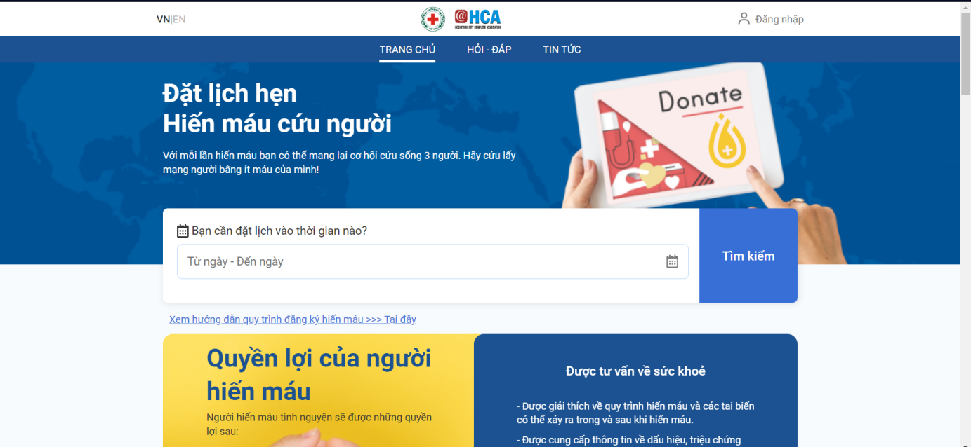

*Figure 1.1. Website giotmauvang.com*

The results of the survey suggest that creating a website for blood donation registration is necessary. This website not only offers trustworthy information, but it also streamlines the registration procedure, links blood donors and hospitals directly, and guarantees a steady and quick supply of blood.

This not only meets the need for blood donation but also increases the general public's understanding of its significance. We trust that BloodnHeart can actively support the community's overall health mission by using the platform for charitable blood donations.

## **1.3. Problem definition**

In modern society, humanitarian blood donation plays an important role in providing safe blood and meeting the medical needs of the community. However, the blood donation registration and propaganda process still has many challenges and limitations. Although efforts have appeared on social networks and mobile applications, the connection between blood donors and hospitals is still not flexible and effective.

The principal issue that needs to be resolved:

* Effective connection: There are still a lot of challenges with the registration and connecting procedure between blood donors and hospitals. An adaptable web platform that makes it simple for blood donors to sign up and get in contact with blood collection locations is required.
* Information management: Information management related to blood donors and blood donation events needs to be organized effectively to ensure transparency and safety.

## **1.4. Proposed solution**

BloodnHeart is a comprehensive solution that meets every challenge in the blood donation sector. BloodnHeart's online registration interface is designed to be simple and easy to use, providing a convenient experience for blood donors, helping them register conveniently and quickly.

During its operations, BloodnHeart places special emphasis on transparency and information security. The information management system not only helps to count the number of registrations effectively, but also manages information related to blood donation events and blood donors in a detailed and organized manner.

BloodnHeart is more than simply a website for registering charitable blood donations. It's a vital link between blood and life, giving people hope and trust as they work to save lives and create a robust community of blood donors. powerful. Specifically, BloodnHeart is an open platform that facilitates collaboration between hospitals and other medical institutions, opening doors for more efficient and adaptable connections during blood donation events.

# **CHAPTER 2: PROJECT SPECIFICATION**

## **2.1. Functional requirement**

### **2.1.1. User requirement**

The system has the following main features:

* **Functions exclusive to Guest (Only on application):**
  + Guests can register a new account.
  + Guests can log in with a registered account to access the application system with user privileges.
  + Guests can recover their password by using forgot password feature
* **Functions exclusive to Guest (Only for website):**
  + Guests can register a new account.
  + Guests can log in with a registered account to access the application system with user privileges.
  + Guests can recover their password by using forgot password feature
  + Guests can view a list of events.
  + Guests can search events by event name and filter events by time range and the organizing hospital unit.
  + Guests can view a routeView appointment schedule onView appointment schedule a map to the blood donation location.
  + Guests can send collaboration requests to become hospitals managing event organizations.
  + Guests can view detailed information about the hospital.
* **Functions exclusive to User:**
  + Users can reset their password.
  + Users can view a list of events.
  + Users can search events by event name and filter events by time range and the organizing hospital unit.
  + Users can view a route on a map to the blood donation location.
  + Users can view detailed information about the hospital.
  + Users can send collaboration requests to become hospitals managing event organizations.
  + Users can update their personal information and contact details.
  + Users can register for blood donation events.
  + Users who have registered for future events can view details about appointments they scheduled to donate blood.
  + Users can edit the donation date in their appointment schedule.
  + Users can cancel event registrations.
  + Users can review their own blood donation history.
  + Users can view and download the e-Certificate when they complete a blood donation.
  + Users can view award points.
  + Users can log out of the system.
* **Hospital (both website and application) :**
  + Hospitals can sign in to the application system provided by the administrator with hospital privileges.
  + Hospitals can add, edit, and close events. In event details, it can update the status of users who have registered for the event.
  + Hospitals can view a list of registrants for each event.
  + Hospitals can view statistics for each event organized by itself.
  + Hospitals can export a list of registrants for each event and can export all of their events.
  + Hospitals can filter events based on their status.
  + Hospitals can update hospital information and account passwords.
* **Admin (only for website)**:
  + Administrators can sign in to the application system provided by the administrator with hospital privileges.
  + Administrators can add, edit, and delete user accounts.
  + Administrators can add, edit, and delete hospitals.
  + Administrators can search for hospitals.
  + Administrators can view the list of events, search for events, filter events by status, and filter events by hospital.
  + Administrators can review collaboration requests from hospitals.
  + Administrators can change the login account password.
  + Administrators can view statistics about the system
  + Administrators can export a list of accounts, a list of event information and a list of hospital collaboration to excel.

Specific requirement will be presented in the table below:

*Table 2. 1 Requirement description*

| **No.** | **Title** | **User story** | **Description** |
| --- | --- | --- | --- |
| 1 | Authentication  Authorization | * As a guest, I want to log in so that I can access the correct system with my role. * As a hospital, I want to log in so that I can access the correct system with my role. * As an administrator, I want to log in so that I can access the management system with my role. | * When users log into the system with their national ID card and password, they will be able to access the user homepage with user privileges. * When a hospital or administrator logs into the system with their identification number and password, the hospital will be able to access the corresponding management homepage with hospital privileges, and the admin will be able to access the admin homepage. |
| 2 | General functionality of guests and users | * As a guest or user, I want to view and search for a list of events. * As a guest or user, I want to view information about the hospital. * As a guest or user, I want to send a collaboration request to become a hospital collaboration to the administrator. |  |
| 3 | Profile Management | * As a user, I want to edit personal information, contact address, and profile picture. * As a user, I want to change my password. * As a hospital, I want to edit hospital information, contact address, and profile picture. * As a hospital, I want to change the password. * As an administrator, I want to change the password. | Profiles will be managed differently based on the privileges of the user, hospital, or administrator. |
| 4 | Event Registration | * As a user, I want to register for participation in a blood donation event. * As a user, I want to view, edit, and cancel appointments for events I have registered for in the future. * As a user, I want to view the history of my blood donation activities. * As a guest or user, I want to view a route on a map to the blood donation location * As a user, I want to view the e-Certificate when I have completed a blood donation. | * Users can register for events and manage appointments for the events which they have registered for in the future. * Users can access a detailed history of all their past blood donation activities. |
| 5 | Event Management | * As a hospital, I want to see all the events in the system I have created. * As a hospital, I want to add a new event to the system. * As a hospital, I want to edit event information in the system. * As a hospital, I want to close my event in the system. * As a hospital, I want to update the status of event registrants. * As a hospital, I want to view statistics for each event. * As a hospital, I want to export a list of registrants for each event and can export all of their events. * As an administrator, I want to see all the events in the system and export to excel. | The hospital can manage its events within the system. |
| 6 | Account Management | * As an administrator, I want to see all the accounts in the system and export to excel. * As an administrator, I want to add a new account in the system. * As an administrator, I want to edit account information in the system. * As an administrator, I want to close accounts in the system. | The administrator can  manage the accounts in his  system. |
| 7 | Hospital Management | * As an administrator, I want to see all the hospitals in the system and export to excel. * As an administrator, I want to add a new hospital in the system. * As an administrator, I want to edit hospital information in the system. * As an administrator, I want to accept the request to collaborate. | The administrator can  manage the hospitals in his  system. |

### **2.1.2. System requirement**

#### **2.1.2.1. Use case diagram**

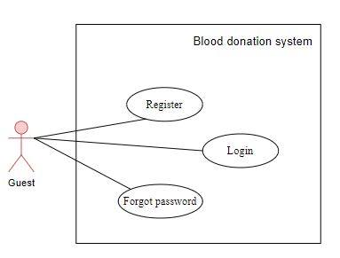

*Figure 2. 1 Guest’s use case diagram for Mobile*

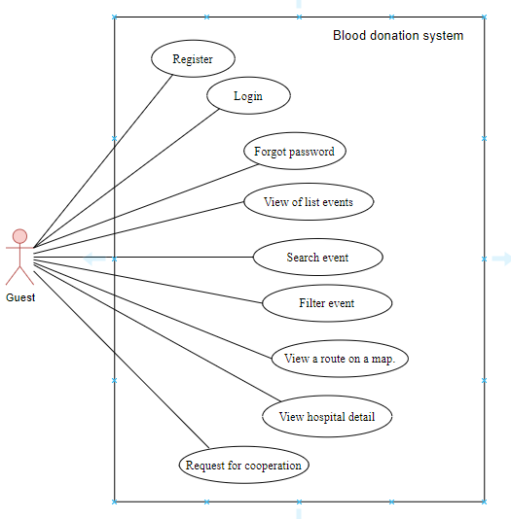

*Figure 2. 2 Guest’s use case diagram for Website*

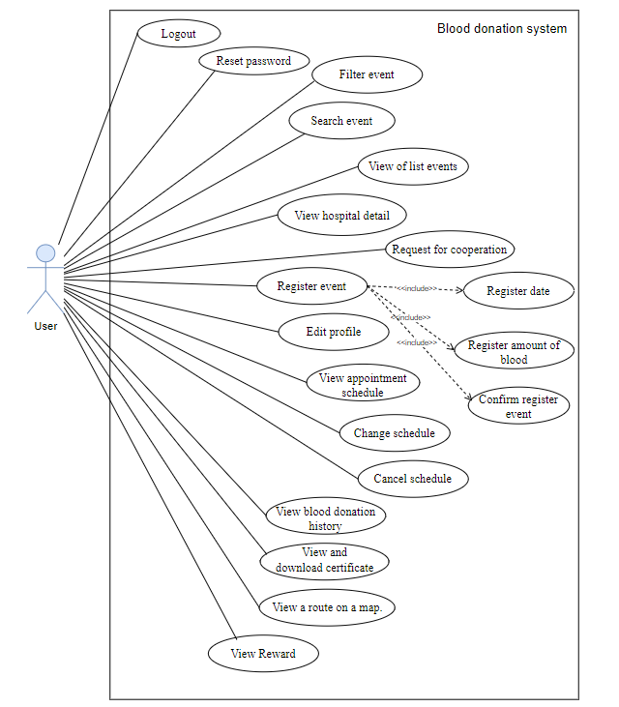

*Figure 2. 3 User’s use case diagram*

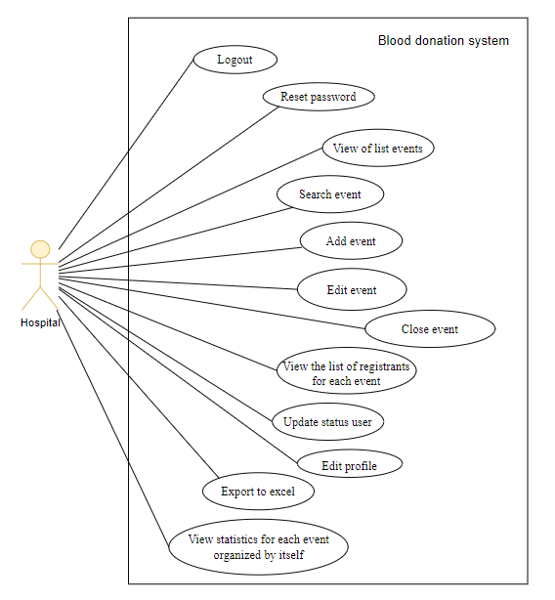

*Figure 2. 4 Hospital’s use case diagram*

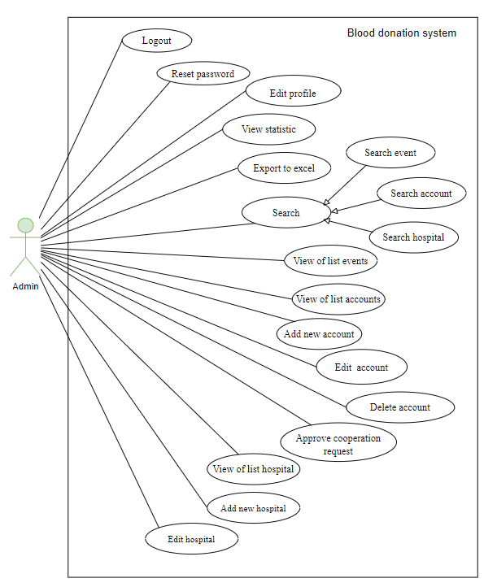

*Figure 2. 5 Admin’s use case diagram*

#### **2.1.2.2. Use case description tables**

*Table 2. 2 Actor description*

| **Actor** | **Description** |
| --- | --- |
| Guest | Guest is an object that is not currently logged in to the system |
| User | User is an object logged into the system using functions for user rights. |
| Hospital | Hospital is an object that has logged into the system with hospital rights and can use hospital functions. |
| Admin | Admin is the administrator of the system; admin has the highest authority of the system |

**2.1.2.2.1. Use case of Guest (Some use cases are for both guest and user)**

**2.1.2.2.1.1. Register Account**

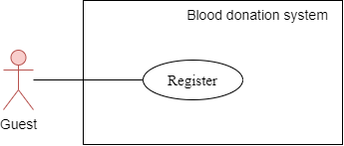

*Figure 2. 6 Use case Register*

*Table 2. 3 Register Account for Guest Use Case*

| **USE CASE - BloodnHeart_UC_01** | | | |
| --- | --- | --- | --- |
| **Use Case No.** | BloodnHeart_UC_01 | **Use Case Version** | 1.0 |
| **Use Case Name** | Register Account | | |
| **Author** | **Dang Mai Huong** | | |
| **Date** | 15/06/2024 | **Priority** | Critical |
| **Actor:**   * Guest   **Summary:**   * Create a new account.   **Goal:**   * Guest successfully creates a new account.   **Trigger:**   * Guest clicks on the 'Đăng ký' button   **Preconditions:**   * No preconditions.   **Post Conditions:**   * **Success:** * Successfully registered for the notification system. * Create a new account in data. * Create a new profile for the account just created in the data. * **Fail:** * Fail registered for the notification system.   **Main Success Scenario:**   | **Step** | **Actor Action** | **System Response** | | --- | --- | --- | | 1 | Guest accesses the system's homepage. | The system will redirect homepage | | 2 | Guest selects the "Đăng ký" button on the system's menu bar. | The system will redirect “Đăng ký” page | | 3 | Guest fills in account information and presses the "Đăng ký" button. | The system will validate the user's email address, password, and citizen identification number before creating a new account and displaying a success message.  In the event that the user submits incorrect data, a failure notice appears. |   **Exceptions:**   | **No** | **Cause** | **System Response** | | --- | --- | --- | | 1 | Invalid Data Submission | Display a failure notice, indicating the specific error(s) in the submitted data | | 2 | Email address already registered | Display a notification error message. | | 3 | Citizen Identification Number already exists | If the provided citizen identification number fails has exist, display an error message | | | | |

**2.1.2.2.1.2. Forgot password**

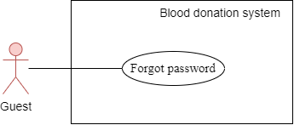

*Figure 2. 7 Use case Forgot Password*

*Table 2. 4 Forgot Password for Guest Use Case*

| **USE CASE - BloodnHeart_UC_02** | | | |
| --- | --- | --- | --- |
| **Use Case No.** | BloodnHeart_UC_02 | **Use Case Version** | 1.0 |
| **Use Case Name** | Forgot Password | | |
| **Author** | **Dang Mai Huong** | | |
| **Date** | 15/06/2024 | **Priority** | Critical |
| **Actor:**   * Guest   **Summary:**   * Request for a new password .   **Goal:**   * Guest successfully changes password.   **Trigger:**   * Guest clicks on the 'Quên mật khẩu' button   **Preconditions:**   * No preconditions.   **Post Conditions:**   * **Success:** * Send a verify account to email * Successfully to change password for guest if account is exist * **Fail:** * Fail to change password for the notification system.   **Main Success Scenario:**   | **Step** | **Actor Action** | **System Response** | | --- | --- | --- | | 1 | Guest accesses the system's homepage. | The system will redirect homepage | | 2 | Guest selects the "Đăng ký" or “Đăng nhập” button on the system's menu bar. | The system will redirect “Đăng ký” or “Đăng nhập” page | | 3 | Guest fills in forgot password form include email and citizen identification and click “Gửi” button | The system will validate the user's email address, and citizen identification number before sending email to verify to change password, displaying a success send to mail message and go to step 4.  In the event that the user submits incorrect data, a failure notice appears and go to step 6 | | 4 | When guest checks this email and clicks at the verify link. A form used to change passwords disappears. Guest enters new password and confirm new password, then click “Xác nhận” button | The system will check the password and confirm the password to see if they are the same. If not, display a notification. If correct, update the new password | | 5 | The end of forgot password function | If true, display a success message.  If not correct, display a error message |   **Exceptions:**   | **No** | **Cause** | **System Response** | | --- | --- | --- | | 1 | Invalid Data Submission | Display a failure notice, indicating the specific error(s) in the submitted data | | 2 | Email address has not already exist | Display a notification error message. | | 3 | Citizen Identification Number has not already exist | If the provided citizen identification number fails hasn’t exist, display an error message | | | | |

**2.1.2.2.1.3. Login**

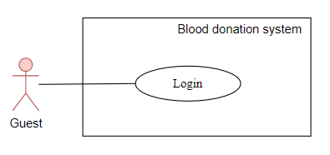

*Figure 2. 8 Use case Login*

*Table 2. 5 Login for Guest Use Case*

| **USE CASE - BloodnHeart_UC_03** | | | |
| --- | --- | --- | --- |
| **Use Case No.** | BloodnHeart_UC_03 | **Use Case Version** | 1.0 |
| **Use Case Name** | Login | | |
| **Author** | **Dang Mai Huong** | | |
| **Date** | 15/06/2024 | **Priority** | Critical |
| **Actor:**   * Guest   **Summary:**   * This case will allow users to access the system   **Goal:**   * Guest can login successfully and can access the system   **Trigger:**   * At the login page, when the guest enters the citizen identify and password and clicks the login button   **Preconditions:**   * Guest needs to be able to access the login page of the system and provide their correct citizen identify and password   **Post Conditions:**   * **Success:** * Guests will be redirected to the home page of the system depending on the permissions * **Fail:** * The system will notify you that the login failed   **Main Success Scenario:**   | **Step** | **Actor Action** | **System Response** | | --- | --- | --- | | 1 | Guest enters the login page | The system will redirect to login page | | 2 | Guest enters citizen identify and password  and click "Đăng nhập" button in the  login form | After verifying the citizen identity and password, the system will show a message indicating the user's successful login.  The homepage of the system will be accessed by the redirect. |   **Exceptions:**   | **No** | **Cause** | **System Response** | | --- | --- | --- | | 1 | Guest entered invalid citizen identify and  password | The system will notify the guest login failed | | | | |

**2.1.2.2.1.4. View of list events**

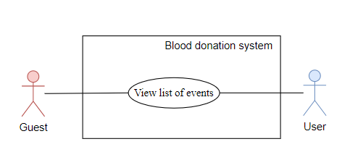

*Figure 2. 9 Use case View list of events*

*Table 2. 6 View List of Events for Guest, User Use Case*

| **USE CASE - BloodnHeart_UC_04** | | | |
| --- | --- | --- | --- |
| **Use Case No.** | BloodnHeart_UC_04 | **Use Case Version** | 1.0 |
| **Use Case Name** | View of list events | | |
| **Author** | **Nguyen Thi Thu Hang** | | |
| **Date** | 15/06/2024 | **Priority** | Critical |
| **Actor:**   * Guest, User   **Summary:**   * Guest / User can view event page   **Goal:**   * Guest/User successfully views the list of events.   **Trigger:**   * Guest/User click “Sự kiện” at the header menu   **Preconditions:**   * No preconditions   **Post Conditions:**   * **Success:** * No post-conditions * **Fail:** * No post-conditions   **Main Success Scenario:**   | **Step** | **Actor Action** | **System Response** | | --- | --- | --- | | 1 | Guest/User accesses the system's homepage. | The system redirects to the homepage. | | 2 | Guest/User clicks at “Sự kiện” at the header menu | The system will redirect to event page |   **Exceptions:** No exception | | | |

**2.1.2.2.1.5. View hospital detail**

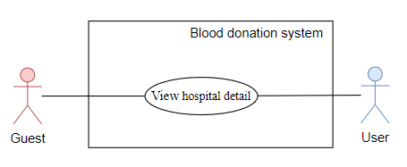

*Figure 2. 10 Use case View hospital detail*

*Table 2. 7 View Hospital Detail for Guest,User Use Case*

| **USE CASE - BloodnHeart_UC_05** | | | |
| --- | --- | --- | --- |
| **Use Case No.** | BloodnHeart_UC_05 | **Use Case Version** | 1.0 |
| **Use Case Name** | View hospital detail | | |
| **Author** | **Nguyen Thi Thu Hang** | | |
| **Date** | 15/06/2024 | **Priority** | Critical |
| **Actor:**   * Guest / User   **Summary:**   * Guest / User can view detailed information about a specific hospital.   **Goal:**   * Guest / User successfully views comprehensive details of a selected hospital.   **Trigger:**   * Guest / User clicks on a hospital's name or selects "View Details."   **Preconditions:**  **Post Conditions:**   * **Success:** * Guest / User has access to detailed information about the selected hospital * **Fail:**   **Main Success Scenario:**   | **Step** | **Actor Action** | **System Response** | | --- | --- | --- | | 1 | Guest / User accesses the system's homepage. | The system redirects to the homepage. | | 2 | Guest / User selects a specific hospital's name or clicks icon eye on image. | The system retrieves and displays detailed information about the selected hospital. |   **Exceptions:**   | **No** | **Cause** | **System Response** | | --- | --- | --- | | 1 | Hospital details are unavailable or cannot be retrieved. | Display an error message | | | | |

**2.1.2.2.1.6. Request for cooperation**

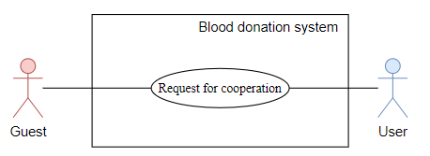

*Figure 2. 11 Use Case Request for cooperation*

*Table 2. 8 Request for cooperation for Guest,User Use Case*

| **USE CASE - BloodnHeart_UC_06** | | | |
| --- | --- | --- | --- |
| **Use Case No.** | BloodnHeart_UC_06 | **Use Case Version** | 1.0 |
| **Use Case Name** | Request for cooperation | | |
| **Author** | **Dang Mai Huong** | | |
| **Date** | 15/06/2024 | **Priority** | Critical |
| **Actor:**   * Guest, User   **Summary:**   * Send a request for collaboration to become a collaborating hospital.   **Goal:**   * The request for collaboration is successfully communicated to the admin system   **Trigger:**   * Guest / User clicks on "Hợp tác" in header menu, fill in the form and click “Gửi” to send a request to be a cooperation-related action   **Preconditions:**   * No preconditions   **Post Conditions:**   * **Success:** * The request for collaboration is successfully sent to the admin system * **Fail:** * The request for collaboration cannot be sent.   **Main Success Scenario:**   | **Step** | **Actor Action** | **System Response** | | --- | --- | --- | | 1 | Guest / User accesses the system's homepage. | The system redirects to the homepage. | | 2 | Guest / User click “Hợp tác” in menu | The system redirects to the “hợp tác” page. | | 3 | Guest / User fill in “Thông tin đăng ký” form in “Hợp tác” page and submits the collaboration request. | The system validates the input. Then sends the collaboration request to admin system, and send message information that errors or not. |   **Exceptions:**   | **No** | **Cause** | **System Response** | | --- | --- | --- | | 1 | Required information is missing or invalid. | The system displays an error message | | 2 | Hospital Identification has exited is this system | The system displays an error message that “Hospital Identification has exited” | | | | |

**2.1.2.2.1.7. Search event**

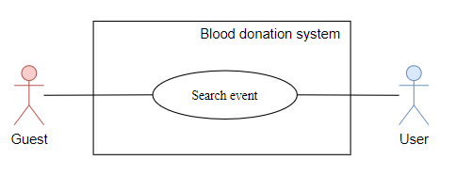

*Figure 2. 12 Use Case Search event*

*Table 2. 9 Search event for Guest,User Use Case*

| **USE CASE - BloodnHeart_UC_07** | | | |
| --- | --- | --- | --- |
| **Use Case No.** | BloodnHeart_UC_07 | **Use Case Version** | 1.0 |
| **Use Case Name** | Search event | | |
| **Author** | **Dang Mai Huong** | | |
| **Date** | 15/06/2024 | **Priority** | Critical |
| **Actor:**   * Guest, User   **Summary:**   * Guest or User can search for events   **Goal:**   * To enable users to search for events based on event name   **Trigger:**   * Guest/User clicks at input text to type information and click button icon search for searching   **Preconditions:**   * The user or guest has access to the application. * Event data is available in the system.   **Post Conditions:**   * **Success:** * The system displays a list of events that match the search criteria. * The API responds with a status 200. * **Fail:** * An error message is shown if no events match the search criteria or if there is a system error.   **Main Success Scenario:**   | **Step** | **Actor Action** | **System Response** | | --- | --- | --- | | 1 | User/Guest selects the option to search for events. | The system displays a search interface. | | 2 | User/Guest enters search criteria with event name | The system processes the input and searches the event database. | | 3 | User/Guest views the search results. | The system displays a list of events that match the search criteria. |   **Exceptions:**   | **No** | **Cause** | **System Response** | | --- | --- | --- | | 1 | No events match the search criteria. | The system shows a message indicating no matches found. | | | | |

**2.1.2.2.1.8. Filter event**

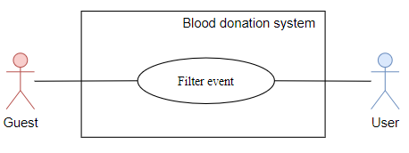

*Figure 2. 13 Use Case Filter event*

*Table 2. 10 Filter event for Guest,User Use Case*

| **USE CASE - BloodnHeart_UC_08** | | | |
| --- | --- | --- | --- |
| **Use Case No.** | BloodnHeart_UC_08 | **Use Case Version** | 1.0 |
| **Use Case Name** | Filter event | | |
| **Author** | **Nguyen Thi Thu Hang** | | |
| **Date** | 15/06/2024 | **Priority** | Critical |
| **Actor:**   * Guest, User   **Summary:**   * A guest or a user can search for events by filtering events by time range and hospital unit.   **Goal:**   * To enable users to search for and find events that match specific criteria, including time range and organizing hospital unit.   **Trigger:**   * Guest/User clicks at input date to choose date or click dropdown button icon to choose hospital unit   **Preconditions:**   * The user or guest has access to the application. * Event data, including time and organizing hospital unit, is available in the system.   **Post Conditions:**   * **Success:** * The system displays a list of events that match the search criteria, including the specified time range and organizing hospital unit. * The API responds with a status 200. * **Fail:** * An error message is shown if no events match the search criteria or if there is a system error.   **Main Success Scenario:**   | **Step** | **Actor Action** | **System Response** | | --- | --- | --- | | 1 | User/Guest selects the option to search for events. | The system displays a search interface. | | 2 | User/Guest enters search criteria, including time range and organizing hospital unit. | The system processes the input and searches the event database. | | 3 | User/Guest views the search results. | The system displays a list of events that match the search criteria. |   **Exceptions:**   | **No** | **Cause** | **System Response** | | --- | --- | --- | | 1 | No events match the search criteria. | The system shows a message indicating no matches found. | | | | |

**2.1.2.2.1.9. View a route on a map**

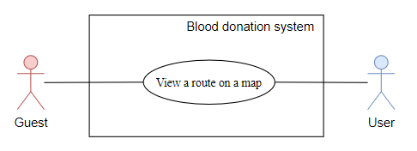

*Figure 2. 14 Use Case View a route on a map*

*Table 2. 11 View a route on a map for Guest,User Use Case*

| **USE CASE - BloodnHeart_UC_09** | | | |
| --- | --- | --- | --- |
| **Use Case No.** | BloodnHeart_UC_09 | **Use Case Version** | 1.0 |
| **Use Case Name** | View a route on a map | | |
| **Author** | **Dang Mai Huong** | | |
| **Date** | 15/06/2024 | **Priority** | Critical |
| **Actor:**   * Guest, User   **Summary:**   * Guest or User can view a route on a map within the system.   **Goal:**   * To enable guests or users to view a route on a map.   **Trigger:**   * Guest/User clicks on “Xem đường đi” button.   **Preconditions:**   * The user or guest has access to the application. * The application is connected to the internet. * The map service is available and functioning.   **Post Conditions:**   * **Success:** * The route is displayed on the map as requested by the user or guest * **Fail:** * An error message is shown if the route cannot be displayed due to system errors or unavailability of the map service.   **Main Success Scenario:**   | **Step** | **Actor Action** | **System Response** | | --- | --- | --- | | 1 | User/Guest selects the option to view a route on the map. | The system displays a map interface. | | 2 | User/Guest views the route on the map. | The system displays the route on the map interface. |   **Exceptions:**   | **No** | **Cause** | **System Response** | | --- | --- | --- | | 1 | Map service is unavailable. | The system shows an error message and suggests retrying later. | | 2 | Invalid route input by the user/guest. | The system shows an error message and suggests retrying later. | | | | |

**2.1.2.2.2. Use case of User (Some use cases are for user, hospital and admin)**

**2.1.2.2.2.1. Logout**

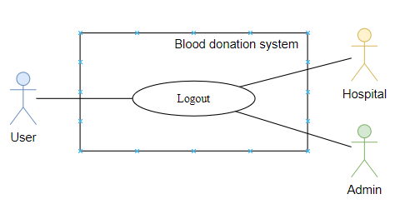

*Figure 2. 15 Use Case Logout for User*

*Table 2. 12 Logout for User/ Hospital/ Admin Use Case*

| **USE CASE - BloodnHeart_UC_10** | | | |
| --- | --- | --- | --- |
| **Use Case No.** | BloodnHeart_UC_10 | **Use Case Version** | 1.0 |
| **Use Case Name** | Logout | | |
| **Author** | **Dang Mai Huong** | | |
| **Date** | 15/06/2024 | **Priority** | Critical |
| **Actor:**   * User, Hospital, Admin   **Summary:**   * User/Hospital/Admin initiates the logout process to terminate the current session.   **Goal:**   * The user's session is successfully terminated,   **Trigger:**   * The user clicks on the "Đăng xuất" button or triggers a designated action to log out   **Preconditions:**  - The user is currently logged in and has an active session  **Post Conditions:**   * **Success:** * The user's session is terminated. * The refresh token and access token is cleared from the client's cookies. * The system responds with a success message. * The API responds with a status 200. * **Fail:** * Having an error when logout * The user's session remains active.   **Main Success Scenario:**   | **Step** | **Actor Action** | **System Response** | | --- | --- | --- | | 1 | User/Hospital/Admin initiates the logout process by clicking on the "Đăng xuất" button. | The system clears the refresh token from the client's cookies  The system responds with a status of 200 and a JSON message for a successful logout. |   **Exceptions:**   | **No** | **Cause** | **System Response** | | --- | --- | --- | | 1 | An error occurs during the logout process. | The system responds with a status of 500 and a JSON object containing details of the error. | | | | |

**2.1.2.2.2.2. Register event**

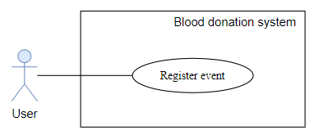

*Figure 2. 16 Use Case Register Event for User*

*Table 2. 13 Register Event for User Use Case*

| **USE CASE - BloodnHeart_UC_11** | | | |
| --- | --- | --- | --- |
| **Use Case No.** | BloodnHeart_UC_11 | **Use Case Version** | 1.0 |
| **Use Case Name** | Register event | | |
| **Author** | **Nguyen Thi Thu Hang** | | |
| **Date** | 15/06/2024 | **Priority** | Critical |
| **Actor:**   * User   **Summary:**   * Users can register for blood donation events.   **Goal:**   * User registered successfully.   **Trigger:**   * The user presses the "Đăng ký" button after selecting the date and presses "Xác nhận" to confirm the information to register for the event.   **Preconditions:**   * The user is currently logged in and has an active session   **Post Conditions:**   * **Success:** * Successfully added registration data to the event's registrant list and the user's profile * Notify the user of success * **Fail:** * Display an error message to the user.   **Main Success Scenario:**   | **Step** | **Actor Action** | **System Response** | | --- | --- | --- | | 1 | User selects "Đăng ký" on the event they want to register for. | System returns the event registration page. | | 2 | User selects the desired date for the event. | System displays available options. | | 3 | User presses the "Đăng ký" button. | The system returns information data that needs confirmation | | 4 | User presses "Xác nhận" to confirm registration. | System adds registration data to the event's list.  System updates user's profile.  System notifies the user of success. |   **Exceptions:**   | **No** | **Cause** | **System Response** | | --- | --- | --- | | 1 | User fails to confirm registration. | Display an error message. | | 2 | System encounters an error during registration. | Display an error message. | | 3 | User is not logged in or the session has expired. | System return the login page. | | | | |

**2.1.2.2.2.3. Edit profile**

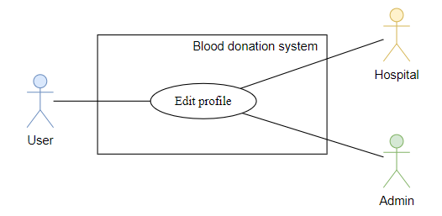

*Figure 2. 17 Use Case Edit Profile for User*

*Table 2. 14 Edit Profile for User/ Hospital/ Admin Use Case*

| **USE CASE - BloodnHeart_UC_12** | | | |
| --- | --- | --- | --- |
| **Use Case No.** | BloodnHeart_UC_12 | **Use Case Version** | 1.0 |
| **Use Case Name** | Edit profile | | |
| **Author** | **Dang Mai Huong** | | |
| **Date** | 15/06/2024 | **Priority** | Critical |
| **Actor:**   * User, Hospital, Admin   **Summary:**   * User/Hospital/Admin can edit their profile information.   **Goal:**   * User/Hospital/Admin profile updated successfully.   **Trigger:**   * The user/hospital/admin navigates to the profile page and modifies the profile information.   **Preconditions:**   * The user/hospital/admin is currently logged in and has an active session.   **Post Conditions:**   * **Success:** * Successfully updates user's profile/hospital’s profile/admin’s profile information. * Notify the user of the successful update. * **Fail:** * Display an error message to the user/hospital/admin   **Main Success Scenario:**   | **Step** | **Actor Action** | **System Response** | | --- | --- | --- | | 1 | User/Hospital/Admin navigates to the profile page. | System displays the profile page | | 2 | User/Hospital/Admin click icon pencil. | System displays current profile information. | | 3 | User/Hospital/Admin modifies the desired information. | System updates the displayed information in real-time | | 4 | User/Hospital/Admin presses the "Lưu" button. | System saves changes to the user's profile.  System notifies the user of a successful update. |   **Exceptions:**   | **No** | **Cause** | **System Response** | | --- | --- | --- | | 1 | User/Hospital/Admin fails to save changes. | The system responds with a status of 500 and a JSON object containing details of the error. | | 2 | Token is expired | The API responds with a status of 401.  The system display “Bạn không có quyền này” | | | | |

**2.1.2.2.2.4. View blood donation history**

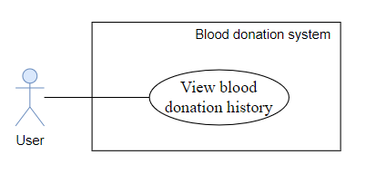

*Figure 2. 18 Use Case View Blood Donation History for User*

*Table 2. 15 View Blood Donation History for User Use Case*

| **USE CASE - BloodnHeart_UC_13** | | | |
| --- | --- | --- | --- |
| **Use Case No.** | BloodnHeart_UC_13 | **Use Case Version** | 1.0 |
| **Use Case Name** | View blood donation history | | |
| **Author** | **Nguyen Thi Thu Hang** | | |
| **Date** | 15/06/2024 | **Priority** | Critical |
| **Actor:**   * User   **Summary:**   * User can view their blood donation history.   **Goal:**   * User successfully views their blood donation history.   **Trigger:**   * The user navigates to the "Blood Donation History" section.   **Preconditions:**   * The user is currently logged in and has an active session.   **Post Conditions:**   * **Success:** * Successfully retrieves and displays the user's blood donation history. * Notify the user of successful retrieval. * **Fail:** * Display an error message to the user.   **Main Success Scenario:**   | **Step** | **Actor Action** | **System Response** | | --- | --- | --- | | 1 | User navigates to "Blood Donation History." | System retrieves and displays the user's donation history. | | 2 | User views the displayed blood donation history. | System presents the blood donation history details. |   **Exceptions:**   | **No** | **Cause** | **System Response** | | --- | --- | --- | | 1 | System encounters an error during retrieval. | The system responds with a status of 500 and a JSON object containing details of the error. | | | | |

**2.1.2.2.2.5. View appointment schedule**

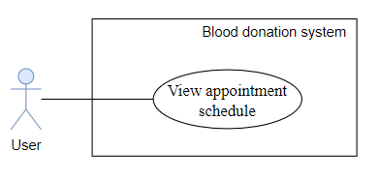

*Figure 2. 19 Use Case View appointment schedule for User*

*Table 2. 16 View appointment schedule for User Use Case*

| **USE CASE - BloodnHeart_UC_14** | | | |
| --- | --- | --- | --- |
| **Use Case No.** | BloodnHeart_UC_14 | **Use Case Version** | 1.0 |
| **Use Case Name** | View appointment schedule | | |
| **Author** | **Nguyen Thi Thu Hang** | | |
| **Date** | 15/06/2024 | **Priority** | Critical |
| **Actor:**   * User   **Summary:**   * User can view their appointment schedule   **Goal:**   * User successfully views their appointment schedule   **Trigger:**   * The user navigates to the "Appointment Schedule" section.   **Preconditions:**   * The user is currently logged in and has an active session.   **Post Conditions:**   * **Success:** * Successfully retrieves and displays the user's appointment schedule * **Fail:** * Display an error message to the user.   **Main Success Scenario:**   | **Step** | **Actor Action** | **System Response** | | --- | --- | --- | | 1 | User navigates to "Appointment Schedule" | System retrieves and displays the user's appointment schedule | | 2 | User views the displayed appointment schedule | System presents the user’s appointment schedule. |   **Exceptions:**   | **No** | **Cause** | **System Response** | | --- | --- | --- | | 1 | System encounters an error during retrieval. | The system responds with a status of 500 and a JSON object containing details of the error. | | | | |

**2.1.2.2.2.6. Change Schedule**

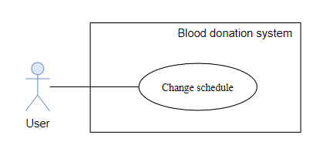

*Figure 2. 20 Use Case Change Schedule for User*

*Table 2. 17 Change Schedule for User Use Case*

| **USE CASE - BloodnHeart_UC_15** | | | |
| --- | --- | --- | --- |
| **Use Case No.** | BloodnHeart_UC_15 | **Use Case Version** | 1.0 |
| **Use Case Name** | Change Schedule | | |
| **Author** | **Nguyen Thi Thu Hang** | | |
| **Date** | 15/06/2024 | **Priority** | Critical |
| **Actor:**   * User   **Summary:**   * Users can edit the scheduled date for their blood donation.   **Goal:**   * User successfully edits the scheduled date for blood donation.   **Trigger:**   * The user navigates to the Appointment schedule page and edit the scheduled date.   **Preconditions:**   * The user is currently logged in and has an active session. * The user has a scheduled blood donation.   **Post Conditions:**   * **Success:** * Successfully updates the scheduled date for blood donation. * Notify the user of the successful update. * **Fail:** * Display an error message to the user.   **Main Success Scenario:**   | **Step** | **Actor Action** | **System Response** | | --- | --- | --- | | 1 | User navigates to the Appointment schedule page. | System displays the Appointment schedule page. | | 2 | User clicks on the icon pencil of the event they want to edit. | System displays the current scheduled date. | | 3 | User selects a new date for blood donation. | System updates the displayed scheduled date. | | 4 | User presses the "Lưu" button. | System saves changes to the scheduled date.  System notifies the user of a successful update. |   **Exceptions:**   | **No** | **Cause** | **System Response** | | --- | --- | --- | | 1 | User fails to save changes. | The system responds with a status of 500 and a JSON object containing details of the error. | | 2 | System encounters an error during the update. | The system responds with a status of 500 and a JSON object containing details of the error. | | 3 | User attempts to set an invalid date. | The system responds with a status of 500 and a JSON object containing details of the error. | | | | |

**2.1.2.2.2.7. Cancel schedule**

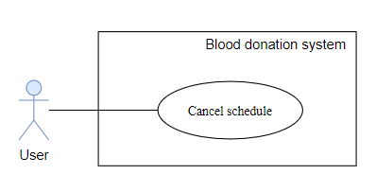

*Figure 2. 21 Use Case Cancel Schedule for User*

*Table 2. 18 Cancel Schedule for User Use Case*

| **USE CASE - BloodnHeart_UC_16** | | | |
| --- | --- | --- | --- |
| **Use Case No.** | BloodnHeart_UC_16 | **Use Case Version** | 1.0 |
| **Use Case Name** | Cancel schedule | | |
| **Author** | **Nguyen Thi Thu Hang** | | |
| **Date** | 15/06/2024 | **Priority** | Critical |
| **Actor:**   * User   **Summary:**   * Users can cancel their scheduled blood donation, removing themselves from the event registrant list and the event in their user profile.   **Goal:**   * The user successfully cancels the scheduled blood donation.   **Trigger:**   * The user navigates to the Appointment schedule page and cancels the scheduled blood donation.   **Preconditions:**   * The user is currently logged in and has an active session. * The user has a scheduled blood donation.   **Post Conditions:**   * **Success:** * Successfully removes the user from the event registrant list. * Successfully removes the event from the user's profile. * Notify the user of the successful cancellation. * **Fail:** * Display an error message to the user.   **Main Success Scenario:**   | **Step** | **Actor Action** | **System Response** | | --- | --- | --- | | 1 | User navigates to the Appointment schedule page. | System displays the Appointment schedule page. | | 2 | User clicks on the icon trash of the event they want to cancel. | System removes user from the event registrant list.  System removes the event from the user's profile.  System notifies the user of successful cancellation. |   **Exceptions:**   | **No** | **Cause** | **System Response** | | --- | --- | --- | | 1 | User fails to confirm cancellation. | Display an error message. | | 2 | System encounters an error during cancellation. | Display an error message. | | | | |

**2.1.2.2.2.8. Reset password**

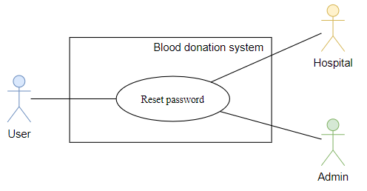

*Figure 2. 22 Use Case Reset Password for User/ Hospital/ Admin*

*Table 2. 19 Reset Password for User/ Hospital/ Admin Use Case*

| **USE CASE - BloodnHeart_UC_17** | | | |
| --- | --- | --- | --- |
| **Use Case No.** | BloodnHeart_UC_17 | **Use Case Version** | 1.0 |
| **Use Case Name** | Reset Password | | |
| **Author** | **Dang Mai Huong** | | |
| **Date** | 15/06/2024 | **Priority** | Critical |
| **Actor:**   * User, Hospital, Admin   **Summary:**   * User/Hospital/Admin initiates the process to reset their password.   **Goal:**   * The user's/hospital’s/admin’s password is successfully reset, and they gain access to their account with the new password   **Trigger:**   * User/Hospital/Admin click “Đặt lại mật khẩu” in profile   **Preconditions:**   * The user/hospital/admin is currently logged in.   **Post Conditions:**   * **Success:** * The password is reset. * The system responds with a success message. * **Fail:** * An issue during the password reset process that cannot reset password   **Main Success Scenario:**   | **Step** | **Actor Action** | **System Response** | | --- | --- | --- | | 1 | User/admin/hospital click “Đặt lại mật khẩu” | The system verifies the identity and generates a temporary reset token. The system sends the user/hospital/admin an email containing the reset token and instructions for resetting the password. | | 2 | User/Hospital/Admin follows the link in the email and enters a new password. | The system validates the new password and updates it in the system.  The system responds with a status of 200 and a JSON message indicating a successful password reset |   **Exceptions:**   | **No** | **Cause** | **System Response** | | --- | --- | --- | | 1 | An issue during the password reset process. | The system responds with a status of 500 and a JSON object containing details of the error. | | | | |

**2.1.2.2.2.9. View and download certificate**

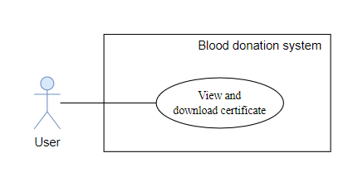

*Figure 2. 23 Use Case View and download certificate for User*

*Table 2. 20 View and download certificate for User Use Case*

| **USE CASE - BloodnHeart_UC_18** | | | |
| --- | --- | --- | --- |
| **Use Case No.** | BloodnHeart_UC_18 | **Use Case Version** | 1.0 |
| **Use Case Name** | View and download certificate | | |
| **Author** | **Dang Mai Huong** | | |
| **Date** | 15/06/2024 | **Priority** | Critical |
| **Actor:**   * User   **Summary:**   * Users can view and download their blood donation certificates.   **Goal:**   * The user successfully views and downloads their blood donation certificates.   **Trigger:**   * The user clicks on the button “Xem e-certificate” at the blood donation history page.   **Preconditions:**   * The user must be logged into their account. * The user must have participated in a blood donation event. * The user navigates to the blood donation page.   **Post Conditions:**   * **Success:** * The user views the e-certificate. * The user downloads the e-certificate as a PNG file. * **Fail:** * The system fails to generate the certificate. * The system fails to download the certificate.   **Main Success Scenario:**   | **Step** | **Actor Action** | **System Response** | | --- | --- | --- | | 1 | The user clicks on the "Xem e-Certificate" link for a specific event. | The system opens a modal window displaying the certificate for the selected event. | | 2 | The user clicks the "Download" button. | The system downloads the certificate as a PNG file. |   **Exceptions: No exception** | | | |

**2.1.2.2.2.10. View Reward**

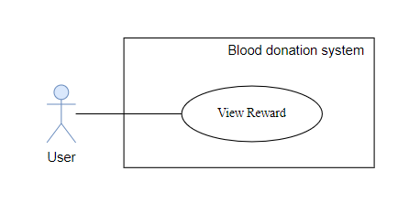

*Figure 2. 24 Use Case View Reward for User*

*Table 2. 21 View Reward for User Use Case*

| **USE CASE - BloodnHeart_UC_19** | | | |
| --- | --- | --- | --- |
| **Use Case No.** | BloodnHeart_UC_19 | **Use Case Version** | 1.0 |
| **Use Case Name** | View Reward | | |
| **Author** | **Nguyen Thi Thu Hang** | | |
| **Date** | 15/06/2024 | **Priority** | Critical |
| **Actor:**   * User   **Summary:**   * The user can view the reward points accumulated from blood donation activities.   **Goal:**   * The user successfully views their rewards earned from participating in blood donation events.   **Trigger:**   * The user clicks on the “Điểm thưởng” dropdown button at header page   **Preconditions:**   * The user must be logged into their account.   **Post Conditions:**   * **Success:** * The user views their reward points * **Fail:** * The system fails to retrieve the information.   **Main Success Scenario:**   | **Step** | **Actor Action** | **System Response** | | --- | --- | --- | | 1 | User clicks on the "Điểm thưởng" link in the dropdown | The system navigates to the rewards page and displays the user's reward points.  The API response status 200. |   **Exceptions:** No exception | | | |

**2.1.2.2.3. Use case of Hospital**

**2.1.2.2.3.1. View list of events**

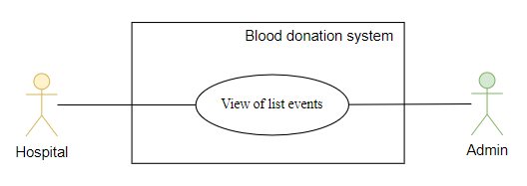

*Figure 2. 25 Use Case View List of Event for Hospital/ Admin*

*Table 2. 22 View List of Event for Hospital/ Admin Use Case*

| **USE CASE - BloodnHeart_UC_20** | | | |
| --- | --- | --- | --- |
| **Use Case No.** | BloodnHeart_UC_20 | **Use Case Version** | 1.0 |
| **Use Case Name** | View list of events | | |
| **Author** | **Nguyen Thi Thu Hang** | | |
| **Date** | 15/06/2024 | **Priority** | Critical |
| **Actor:**   * Hospital, Admin   **Summary:**   * Hospital/Admin can view the list of blood donation events.   **Goal:**   * Hospital successfully views the list of blood donation events.   **Trigger:**   * Hospital/ Admin navigate the event page by choosing on the menu.   **Preconditions:**   * Hospital/Admin is currently logged in and has an active session.   **Post Conditions:**   * **Success:** * Successfully retrieves and displays the list of blood donation events. * **Fail:** * Display an error message to the hospital.   **Main Success Scenario:**   | **Step** | **Actor Action** | **System Response** | | --- | --- | --- | | 1 | Hospital/ Admin navigate the event page by choosing on the menu. | System retrieves and displays the list of events. |   **Exceptions:**   | **No** | **Cause** | **System Response** | | --- | --- | --- | | 1 | System encounters an error during retrieval. | The system responds with a status of 500 and a JSON object containing details of the error. | | | | |

**2.1.2.2.3.2. Add new event**

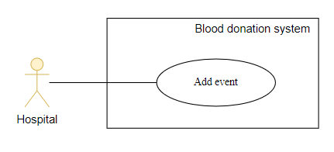

*Figure 2. 26 Use Case Add New Event for Hospital*

*Table 2. 23 Add New Event for Hospital Use Case*

| **USE CASE - BloodnHeart_UC_21** | | | |
| --- | --- | --- | --- |
| **Use Case No.** | BloodnHeart_UC_21 | **Use Case Version** | 1.0 |
| **Use Case Name** | Add new event | | |
| **Author** | **Nguyen Thi Thu Hang** | | |
| **Date** | 15/06/2024 | **Priority** | Critical |
| **Actor:**   * Hospital   **Summary:**   * Hospitals can add a new blood donation event to the system.   **Goal:**   * Hospital successfully added a new blood donation event.   **Trigger:**   * Hospital navigates to the event page, clicks “Thêm sự kiện” and provides event details.   **Preconditions:**   * Hospital is currently logged in and has an active session.   **Post Conditions:**   * **Success:** * Successfully adds the new event to the system. * Notify the hospital of successful addition. * **Fail:** * Display an error message to the hospital.   **Main Success Scenario:**   | **Step** | **Actor Action** | **System Response** | | --- | --- | --- | | 1 | Hospital navigates to the event page. | System displays the event page. | | 2 | Hospital clicks “Thêm sự kiện”. | System display form add new event. | | 3 | Hospital fills all information about the event and clicks “Lưu”. | System adds the new event to the system.  System notifies the hospital of successful addition |   **Exceptions:**   | **No** | **Cause** | **System Response** | | --- | --- | --- | | 1 | Hospital fails to provide required details. | The system responds with a status of 500 and a JSON object containing details of the error. | | 2 | Token is expired | The API responds with a status of 401.  The system display “Bạn không có quyền này” | | | | |

**2.1.2.2.3.3. Edit event**

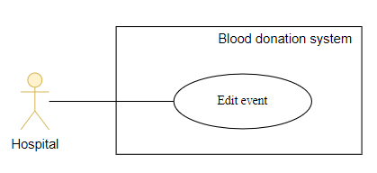

*Figure 2. 27 Use Case Edit Event*

*Table 2. 24 Edit Event for Hospital Use Case*

| **USE CASE - BloodnHeart_UC_22** | | | |
| --- | --- | --- | --- |
| **Use Case No.** | BloodnHeart_UC_22 | **Use Case Version** | 1.0 |
| **Use Case Name** | Edit event | | |
| **Author** | **Nguyen Thi Thu Hang** | | |
| **Date** | 15/06/2024 | **Priority** | Critical |
| **Actor:**   * Hospital   **Summary:**   * Hospitals can edit the details of a blood donation event in the system.   **Goal:**   * Hospital successfully edits the details of a blood donation event.   **Trigger:**   * Hospital navigates to the event page, clicks icon eye on the event they want to edit and modify information.   **Preconditions:**   * The hospital is currently logged in and has an active session. * The hospital has at least one blood donation event in the system.   **Post Conditions:**   * **Success:** * Successfully updates the details of the selected event. * Notify the hospital of a successful update. * **Fail:** * Display an error message to the hospital.   **Main Success Scenario:**   | **Step** | **Actor Action** | **System Response** | | --- | --- | --- | | 1 | Hospital navigates to the event page. | System displays the event page. | | 2 | Hospital clicks the icon eye on the event they want to edit. | System displays the detail event page. | | 3 | Hospital clicks the icon pencil. | System display form edit event. | | 4 | Hospital modifies the details of the selected event | System validates and saves the updated event details. | | 5 | Hospital presses the "Lưu" button. | System updates the event details in the system.  System notifies the hospital of a successful update. |   **Exceptions:**   | **No** | **Cause** | **System Response** | | --- | --- | --- | | 1 | Hospital fails to provide required details. | The system responds with a status of 500 and a JSON object containing details of the error. | | 2 | Token is expired | The API responds with a status of 401.  The system display “Bạn không có quyền này” | | | | |

**2.1.2.2.3.4. Close event**

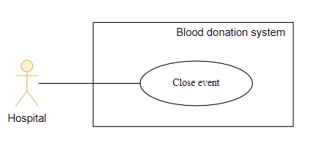

*Figure 2. 28 Use Case Close Event for Hospital*

*Table 2. 25 Close Event for Hospital Use Case*

| **USE CASE - BloodnHeart_UC_23** | | | |
| --- | --- | --- | --- |
| **Use Case No.** | BloodnHeart_UC_23 | **Use Case Version** | 1.0 |
| **Use Case Name** | Close event | | |
| **Author** | **Nguyen Thi Thu Hang** | | |
| **Date** | 15/06/2024 | **Priority** | Critical |
| **Actor:**   * Hospital   **Summary:**   * Hospitals can close a blood donation event, preventing further registrations.   **Goal:**   * Hospital successfully closes a blood donation event.   **Trigger:**   * Hospital navigates to the event page, clicks icon trash on the event they want to close.   **Preconditions:**   * The hospital is currently logged in and has an active session. * The hospital has at least one active blood donation event in the system.   **Post Conditions:**   * **Success:** * Successfully closes the selected event, preventing further registrations. * Notify the hospital of successful closure. * **Fail:** * Display an error message to the hospital.   **Main Success Scenario:**   | **Step** | **Actor Action** | **System Response** | | --- | --- | --- | | 1 | Hospital navigates to the event page. | System displays the event page. | | 2 | Hospital clicks the icon trash on the event they want to close. | System closes the event and reload page.  System notifies the hospital of successful closure. |   **Exceptions:**   | **No** | **Cause** | **System Response** | | --- | --- | --- | | 1 | Hospital fails to close the event. | The system responds with a status of 500 and a JSON object containing details of the error. | | 2 | Token is expired | The API responds with a status of 401.  The system display “Bạn không có quyền này” | | | | |

**2.1.2.2.3.5. View the list of registrants for each event**

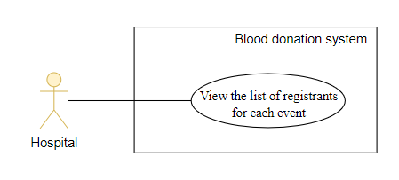

*Figure 2. 29 Use Case View the list of registrants for each event for Hospital*

*Table 2. 26 View the list of registrants for each event for Hospital Use Case*

| **USE CASE - BloodnHeart_UC_24** | | | |
| --- | --- | --- | --- |
| **Use Case No.** | BloodnHeart_UC_24 | **Use Case Version** | 1.0 |
| **Use Case Name** | View the list of registrants for each event | | |
| **Author** | **Nguyen Thi Thu Hang** | | |
| **Date** | 15/06/2024 | **Priority** | Critical |
| **Actor:**   * Hospital   **Summary:**   * The hospital views the list of registrants for each event.   **Goal:**   * The hospital successfully sees the list of people registered for a particular event.   **Trigger:**   * The hospital clicks on the eye icon button to go to the event detail page   **Preconditions:**   * Login as a hospital role is required. * The hospital will select the event which it wants to view on the event management page.   **Post Conditions:**   * **Success:** * The hospital views the list of registrants for each event. * **Fail:** * The system fails to retrieve the event details.   **Main Success Scenario:**   | **Step** | **Actor Action** | **System Response** | | --- | --- | --- | | 1 | The hospital staff logs into the system with hospital privileges. | The system authenticates the user and grants access to the management page. | | 2 | Hospital select event managements | The system navigates to the event management page. | | 3 | Hospital selects an event to view/edit from the list of events | The system fetches the event details and navigates to the event detail page. The API responses status 200 | | 4 | Hospital scroll page | The system displays the list of registrants for the event. |   **Exceptions:**   | **No** | **Cause** | **System Response** | | --- | --- | --- | | 1 | Event details fetch failure | The API responses status 500. The system displays an error message | | | | |

**2.1.2.2.3.6. Update user status**

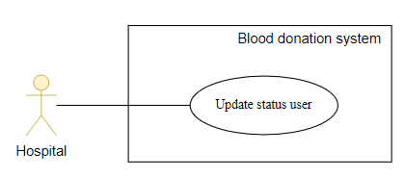

*Figure 2. 30 Use Case Update user Status for Hospital*

*Table 2. 27 Update user Status for Hospital Use Case*

| **USE CASE - BloodnHeart_UC_25** | | | |
| --- | --- | --- | --- |
| **Use Case No.** | BloodnHeart_UC_25 | **Use Case Version** | 1.0 |
| **Use Case Name** | Update user status | | |
| **Author** | **Nguyen Thi Thu Hang** | | |
| **Date** | 15/06/2024 | **Priority** | Critical |
| **Actor:**   * Hospital   **Summary:**   * Hospitals can update the status of users registering for events.   **Goal:**   * Hospital successfully updates the status of a user.   **Trigger:**   * The hospital redirects to the event details page, selects the user to update in the event registration list.   **Preconditions:**  **Post Conditions:**   * **Success:** * The hospital is currently logged in and has an active session. * The hospital has at least one blood donation event and at least 1 user in the registration list in the system. * **Fail:** * Display an error message to the hospital.   **Main Success Scenario:**   | **Step** | **Actor Action** | **System Response** | | --- | --- | --- | | 1 | Hospital redirects to the event details page | System displays the detail event page. | | 2 | Hospital clicks “Cập nhật” on the user they want to update in the event registration list. | System update status user in the event registration list and user profile.  System reload page and notifies the hospital of successful status update. |   **Exceptions:**   | **No** | **Cause** | **System Response** | | --- | --- | --- | | 1 | Hospital fails to update the status of the user. | The system responds with a status of 500 and a JSON object containing details of the error. | | 2 | Token is expired | The API responds with a status of 401.  The system display “Bạn không có quyền này” | | | | |

**2.1.2.2.3.7. Export to excel**

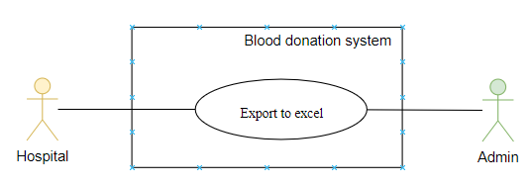

*Figure 2. 31 Use Case Export to excel for Hospital*

*Table 2. 28 Export to excel for Hospital Use Case*

| **USE CASE - BloodnHeart_UC_26** | | | |
| --- | --- | --- | --- |
| **Use Case No.** | BloodnHeart_UC_26 | **Use Case Version** | 1.0 |
| **Use Case Name** | Export to excel | | |
| **Author** | **Dang Mai Huong** | | |
| **Date** | 15/06/2024 | **Priority** | Critical |
| **Actor:**   * Hospital/ Admin   **Summary:**   * Allow Hospital/Admin to export data to Excel   **Goal:**   * Hospital/Admin successfully export data to Excel   **Trigger:**   * Hospital/Admin selects the export to Excel button   **Preconditions:**   * Login as a hospital/admin role is required. * The hospital/admin will select a type of management like : account management(for admin), event management (both admin and hospital), hospital management (for admin).   **Post Conditions:**   * **Success:** * Data is successfully exported to an Excel file. * **Fail:** * The system fails to export the data   **Main Success Scenario:**   | **Step** | **Actor Action** | **System Response** | | --- | --- | --- | | 1 | Hospital/Admin logs in to the system. | The system verifies login credentials and grants access. | | 2 | Hospital/Admin selects the type of management | The system displays the selected management screen. | |  | Hospital/Admin selects the export to Excel button | The system processes the request to export data and automatically downloads the file. |   **Exceptions:** No exception | | | |

**2.1.2.2.3.8. View statistics for each event organized by itself**

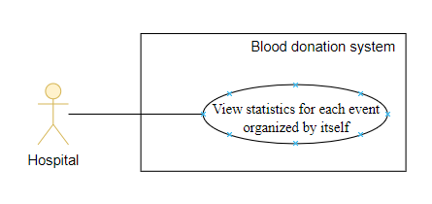

*Figure 2. 32 Use Case View statistics for each event organized by itself for Hospital*

*Table 2. 29 View statistics for each event organized by itself for Hospital Use Case*

| **USE CASE - BloodnHeart_UC_27** | | | |
| --- | --- | --- | --- |
| **Use Case No.** | BloodnHeart_UC_27 | **Use Case Version** | 1.0 |
| **Use Case Name** | View statistics for each event organized by itself | | |
| **Author** | **Dang Mai Huong** | | |
| **Date** | 15/06/2024 | **Priority** | Critical |
| **Actor:**   * Hospital   **Summary:**   * The hospital views the analytics of each event.   **Goal:**   * The hospital successfully sees the analytics of each event.   **Trigger:**   * The hospital clicks on the eye icon button at event management page to go to the event detail page   **Preconditions:**   * Login as a hospital role is required. * The hospital will select the event which it wants to view on the event management page.   **Post Conditions:**   * **Success:** * The hospital views the analytics of each event. * **Fail:** * The system fails to retrieve the event details.   **Main Success Scenario:**   | **Step** | **Actor Action** | **System Response** | | --- | --- | --- | | 1 | The hospital staff logs into the system with hospital privileges. | The system authenticates the user and grants access to the management page. | | 2 | Hospital select event managements | The system navigates to the event management page. | | 3 | Hospital selects an event to view/edit from the list of events | The system fetches the event details and navigates to the event detail page. The API responses status 200. The API fetch to get statics information and response data statistic and status 200 | | 4 | Hospital scroll page | The system displays the analytics for the event. |   **Exceptions:**   | **No** | **Cause** | **System Response** | | --- | --- | --- | | 1 | Event details fetch failure | The API responses status 500.  The system displays an error message | | 2 | Statistic data isn’t fetched | The API response status 500. The system set default for all values is 0. Display all values is 0 to the screen | | | | |

**2.1.2.2.4. Use case of Admin**

**2.1.2.2.4.1. View list of accounts**

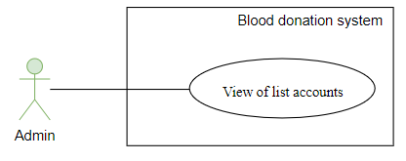

*Figure 2. 33 Use Case View List of Accounts forAdmin*

*Table 2. 30 View List of Accounts forAdmin Use Case*

| **USE CASE - BloodnHeart_UC_28** | | | |
| --- | --- | --- | --- |
| **Use Case No.** | BloodnHeart_UC_28 | **Use Case Version** | 1.0 |
| **Use Case Name** | View list of accounts | | |
| **Author** | **Dang Mai Huong** | | |
| **Date** | 15/06/2024 | **Priority** | Critical |
| **Actor:**   * Admin   **Summary:**   * The Administrator views a list of user accounts within the system.   **Goal:**   * The Administrator gains an overview of the existing user accounts.   **Trigger:**   * The Administrator accesses the "Người dùng" feature in the sidebar menu.   **Preconditions:**   * The Administrator is logged into the system with appropriate permissions   **Post Conditions:**   * **Success:** * The Administrator successfully views the list of user accounts. * **Fail:** * The list of accounts is not displayed.   **Main Success Scenario:**   | **Step** | **Actor Action** | **System Response** | | --- | --- | --- | | 1 | The Administrator logs into the system. | The system displays dashboard Admin | | 2 | The Administrator accesses the "Người dùng" feature. | The system will redirect the user to the “Quản lý người dùng” page. | | 3 | The system retrieves and displays a paginated list of user accounts with relevant information. | The system displays a list of accounts. |   **Exceptions:**   | **No** | **Cause** | **System Response** | | --- | --- | --- | | 1 | An issue during the process. | The system responds with a status of 500 and a JSON object containing details of the error. | | | | |

**2.1.2.2.4.2. Add new account**

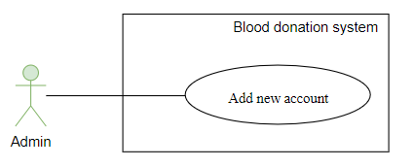

*Figure 2. 34 Use Case Add New Account for Admin*

*Table 2. 31 Add New Account for Admin Use Case*

| **USE CASE - BloodnHeart_UC_29** | | | |
| --- | --- | --- | --- |
| **Use Case No.** | BloodnHeart_UC_29 | **Use Case Version** | 1.0 |
| **Use Case Name** | Add new account | | |
| **Author** | **Dang Mai Huong** | | |
| **Date** | 15/06/2024 | **Priority** | Critical |
| **Actor:**   * Admin   **Summary:**   * The Administrator adds a new user account to the system.   **Goal:**   * The new user account is successfully created and added to the system   **Trigger:**   * The Administrator accesses the "Người dùng" feature in the sidebar menu. * The Administrator accesses the "Thêm tài khoản" feature in the system   **Preconditions:**   * The Administrator is logged into the system with appropriate permissions.   **Post Conditions:**   * **Success:** * The new user account is successfully created and added to the system. * **Fail:** * TThe new account is not added, and an error message is displayed   **Main Success Scenario:**   | **Step** | **Actor Action** | **System Response** | | --- | --- | --- | | 1 | The Administrator logs into the system. | The system displays dashboard Admin | | 2 | The Administrator accesses the "Người dùng" feature. | The system will redirect the user to the “Quản lý người dùng” page. | | 3 | The Administrator click "Thêm tài khoản” button | The system will show a modal for adding a new account | | 4 | The Administrator initiates the process to add a new user account by providing user information and click “Lưu lại” | - The system will validate if the provided information if validation is successful, the system generates a salt and hashes the user's password using bcrypt.  -The system creates a new Account instance with the hashed password and user information.  -The new account is saved to the database.  The system retrieves the newly created account's ID.  -The system creates a new UserProfile linked to the account, including relevant profile information.  -The user profile is saved to the database.  -The system responds with a status of 200 and a JSON object containing the newly created account information. |   **Exceptions:**   | **No** | **Cause** | **System Response** | | --- | --- | --- | | 1 | Validation fails, indicating invalid user information. | The system responds with a status of 400 and a JSON object containing an error message. | | 2 | Token is expired | The API responds with a status of 401.  The system display “Bạn không có quyền này” | | | | |

**2.1.2.2.4.3. Edit account**

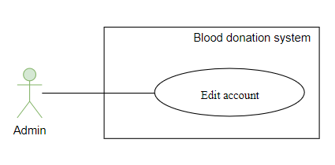

*Figure 2. 35 Use Case Edit account*

*Table 2. 32 Edit account for Admin Use Case*

| **USE CASE - BloodnHeart_UC_30** | | | |
| --- | --- | --- | --- |
| **Use Case No.** | BloodnHeart_UC_30 | **Use Case Version** | 1.0 |
| **Use Case Name** | Edit account | | |
| **Author** | **Dang Mai Huong** | | |
| **Date** | 15/06/2024 | **Priority** | Critical |
| **Actor:**   * Admin   **Summary:**   * The Administrator initiates the process to edit an existing user account in the system, excluding special roles (hospital, admin)   **Goal:**   * The user account information is successfully updated by the admin, excluding changes to special roles.   **Trigger:**   * The Administrator click edit icon at “Quản lý người dùng” panel.   **Preconditions:**   * The Administrator is logged into the system with appropriate administrative permissions.   **Post Conditions:**   * **Success:** * The user account information is successfully updated, excluding changes to special roles * **Fail:** * The user account information remains unchanged   **Main Success Scenario:**   | **Step** | **Actor Action** | **System Response** | | --- | --- | --- | | 1 | The Administrator logs into the system. | The system displays dashboard Admin | | 2 | The Administrator accesses the "Người dùng" feature. | The system will redirect the admin to the  “Quản lý người dùng” page. | | 3 | The Administrator click edit icon | The system will redirect the admin to the  “Chỉnh sửa người dùng” page. | | 4 | The Administrator click “Upload” button to upload avatar and click “Lưu lại” | The system will upload images to Cloudinary. If success, the system display a success toast notification | | 5 | The administrator edits that form is begin shown and click “Lưu lại” to save changes | The system will update information and display a success message. |   **Exceptions:**   | **No** | **Cause** | **System Response** | | --- | --- | --- | | 1 | Validation fails, indicating invalid changes. | The system responds with a status of 400 and a JSON object containing an error message. | | 2 | An error occurs during the update process. | The system responds with a status of 500 and a JSON object containing details of the error. | | 3 | Token is expired | The API responds with a status of 401.  The system display “Bạn không có quyền này” | | | | |

**2.1.2.2.4.4. Close account**

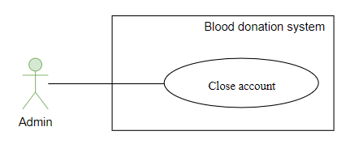

*Figure 2. 36 Use Case Close Account**Table 2. 33 Close Account for Admin Use Case*

| **USE CASE - BloodnHeart_UC_31** | | | |
| --- | --- | --- | --- |
| **Use Case No.** | BloodnHeart_UC_31 | **Use Case Version** | 1.0 |
| **Use Case Name** | Close account | | |
| **Author** | **Dang Mai Huong** | | |
| **Date** | 15/06/2024 | **Priority** | Critical |
| **Actor:**   * Admin   **Summary:**   * This case will allow the administrator to close the account in the system   **Goal:**   * Administrators can close accounts in the system   **Trigger:**   * The Administrator click Close icon at “Quản lý người dùng” panel.   **Preconditions:**   * The Administrator is logged into the system with appropriate administrative permissions.   **Post Conditions:**   * **Success:** * The system notices that the customer account has been successfully close on the system * Account is disabled in the system * Update the list of customer account lists * **Fail:** * The system notifies account closing failure * The selected account will not be disabled in the system   **Main Success Scenario:**   | **Step** | **Actor Action** | **System Response** | | --- | --- | --- | | 1 | The Administrator logs into the system. | The system displays dashboard Admin | | 2 | The Administrator accesses the "Người dùng" feature. | The system will redirect the admin to the “Quản lý người dùng” page. | | 3 | The Administrator click Close icon | The system will display a message of successful account disable. The system disables the account in the system |   **Exceptions:** No exception | | | |

**2.1.2.2.4.5. View of list hospitals**

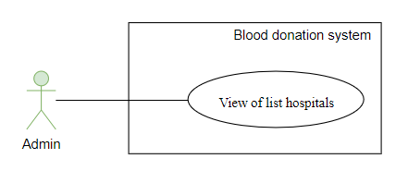

*Figure 2. 37 Use Case View of List Hospital*

*Table 2. 34 View of List Hospital for Admin Use Case*

| **USE CASE - BloodnHeart_UC_32** | | | |
| --- | --- | --- | --- |
| **Use Case No.** | BloodnHeart_UC_32 | **Use Case Version** | 1.0 |
| **Use Case Name** | View of list hospitals | | |
| **Author** | **Dang Mai Huong** | | |
| **Date** | 15/06/2024 | **Priority** | Critical |
| **Actor:**   * Admin   **Summary:**   * The Administrator views a list of hospital within the system   **Goal:**   * The Administrator gains an overview of the existing hospital   **Trigger:**   * The Administrator accesses the "Bệnh viện" feature in the sidebar menu.   **Preconditions:**   * The Administrator is logged into the system with appropriate permissions   **Post Conditions:**   * **Success:** * The Administrator successfully views the list of hospital. * **Fail:** * The list of hospitals is not displayed.   **Main Success Scenario:**   | **Step** | **Actor Action** | **System Response** | | --- | --- | --- | | 1 | The Administrator logs into the system. | The system displays dashboard Admin | | 2 | The Administrator accesses the "Bệnh viện" feature. | The system will redirect the user to the  “Quản lý bệnh viện” page. | | 3 | The system retrieves and displays a paginated list of collaborator hospitals with relevant information. | The system displays a list of collaborations. |   **Exceptions:**   | **No** | **Cause** | **System Response** | | --- | --- | --- | | 1 | an issue during the process. | The system responds with a status of 500 and a JSON object containing details of the error. | | | | |

**2.1.2.2.4.6. Add new hospital**

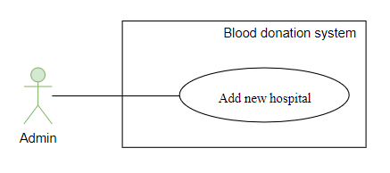

*Figure 2. 38 Use Case Add New Hospital*

*Table 2. 35 Add New Hospital for Admin Use Case*

| **USE CASE - BloodnHeart_UC_33** | | | |
| --- | --- | --- | --- |
| **Use Case No.** | BloodnHeart_UC_33 | **Use Case Version** | 1.0 |
| **Use Case Name** | Add new hospital | | |
| **Author** | **Dang Mai Huong** | | |
| **Date** | 15/06/2024 | **Priority** | Critical |
| **Actor:**   * Admin   **Summary:**   * The Administrator adds a new collaborator hospital to the system.   **Goal:**   * The new collaborator hospital is successfully created and added to the system   **Trigger:**   * The Administrator accesses the "Bệnh viện" feature in the sidebar menu. * The Administrator accesses the "Thêm bệnh viện" feature in the system   **Preconditions:**   * The Administrator is logged into the system with appropriate permissions.   **Post Conditions:**   * **Success:** * The new collaborator hospital was successfully created and added to the system. * **Fail:** * The new collaborator hospital is not added, and an error message is displayed   **Main Success Scenario:**   | **Step** | **Actor Action** | **System Response** | | --- | --- | --- | | 1 | The Administrator logs into the system. | The system displays dashboard Admin | | 2 | The Administrator accesses the "bệnh viện" feature. | The system will redirect the user to the  “Quản lý bệnh viện” page. | | 3 | The Administrator click "Thêm bệnh viện” button | The system will show a modal for adding a new hospital. | | 4 | The Administrator initiates the process to add a new hospital by providing information and click “Lưu lại” | -The system creates a new hospital if validate is true  -The new hospital is saved to the database.  -The system responds with a status of 200 |   **Exceptions:**   | **No** | **Cause** | **System Response** | | --- | --- | --- | | 1 | Validation fails, indicating invalid hospital information. | The system responds with a status of 400 and a JSON object containing an error message. | | 2 | Token is expired | The API responds with a status of 401.  The system display “Bạn không có quyền này” | | | | |

**2.1.2.2.4.7. Edit hospital**

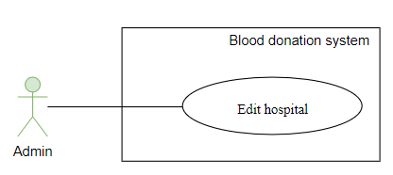

*Figure 2. 39 Use Case Edit Hospital*

*Table 2. 36 Edit Hospital for Admin Use Case*

| **USE CASE - BloodnHeart_UC_34** | | | |
| --- | --- | --- | --- |
| **Use Case No.** | BloodnHeart_UC_34 | **Use Case Version** | 1.0 |
| **Use Case Name** | Edit hospital | | |
| **Author** | **Dang Mai Huong** | | |
| **Date** | 15/06/2024 | **Priority** | Critical |
| **Actor:**   * Admin   **Summary:**   * The Administrator initiates the process to edit an existing collaborator hospital in the system, excluding special roles (hospital, admin)   **Goal:**   * The collaborator hospital information is successfully updated by the admin, excluding changes to special roles.   **Trigger:**   * The Administrator click edit icon at “Quản lý bệnh viện” panel.   **Preconditions:**   * The Administrator is logged into the system with appropriate administrative permissions.   **Post Conditions:**   * **Success:** * The collaborator hospital information is successfully updated, excluding changes to special roles * **Fail:** * The collaborator hospital information remains unchanged   **Main Success Scenario:**   | **Step** | **Actor Action** | **System Response** | | --- | --- | --- | | 1 | The Administrator logs into the system. | The system displays dashboard Admin | | 2 | The Administrator accesses the "Bệnh viện" feature. | The system will redirect the admin to the “Quản lý bệnh viện” page. | | 3 | The Administrator click edit icon | The system will redirect the admin to the “Chỉnh sửa bệnh viện” page. | |  | The Administrator click “Upload” button to upload avatar and click “Lưu lại” | The system will upload images to Cloudinary. If successful, the system displays a success toast notification. | | 4 | The administrator edits that form is begin shown and click “Lưu lại” to save changes | The system will update information and display a success message. |   **Exceptions:**   | **No** | **Cause** | **System Response** | | --- | --- | --- | | 1 | Validation fails, indicating invalid changes. | The system responds with a status of 400 and a JSON object containing an error message. | | 2 | An error occurs during the update process. | The system responds with a status of 500 and a JSON object containing details of the error. | | 3 | Token is expired | The API responds with a status of 401.  The system display “Bạn không có quyền này” | | | | |

**2.1.2.2.4.8. Statistics**

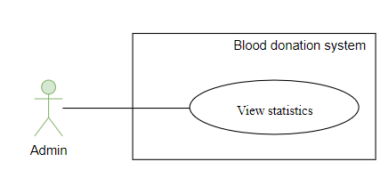

*Figure 2. 40 Use Case View statistics*

*Table 2. 37 View statistics for Admin Use Case*

| **USE CASE - BloodnHeart_UC_35** | | | |
| --- | --- | --- | --- |
| **Use Case No.** | BloodnHeart_UC_35 | **Use Case Version** | 1.0 |
| **Use Case Name** | Statistics | | |
| **Author** | **Dang Mai Huong** | | |
| **Date** | 15/06/2024 | **Priority** | Critical |
| **Actor:**   * Admin   **Summary:**   * The process of collecting statistics about users, events, and participating hospitals for analysis and monitoring is started by the Administrator.   **Goal:**   * The Administrator retrieves statistical data for a comprehensive overview of user activities, events, and collaboration with hospitals.   **Trigger:**   * The Administrator accesses the "Statistics" functionality through an admin panel.   **Preconditions:**   * The Administrator is logged into the system with appropriate administrative permissions.   **Post Conditions:**   * **Success:** * The Administrator successfully retrieves statistical information related to users, events, and collaborating hospitals. * **Fail:** * The statistical information is not displayed.   **Main Success Scenario:**   | **Step** | **Actor Action** | **System Response** | | --- | --- | --- | | 1 | The Administrator logs into the system. | The system displays dashboard Admin | | 2 | The Administrator accesses the "Bệnh viện" feature. | The system will redirect to the “Thống kê” page. The system display data on “Thống kê” page, |   **Exceptions:**   | **No** | **Cause** | **System Response** | | --- | --- | --- | | 1 | an issue during the process. | The system responds with a status of 500 | | | | |

**2.1.2.2.4.9. Approve cooperation request**

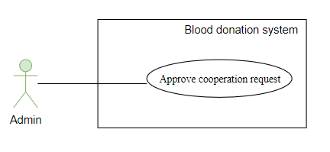

*Figure 2. 41 Use Case Approve cooperation request for Admin*

*Table 2. 38 Approve cooperation request for Admin Use Case*

| **USE CASE - BloodnHeart_UC_36** | | | |
| --- | --- | --- | --- |
| **Use Case No.** | BloodnHeart_UC_36 | **Use Case Version** | 1.0 |
| **Use Case Name** | Approve cooperation request | | |
| **Author** | **Dang Mai Huong** | | |
| **Date** | 15/06/2024 | **Priority** | Critical |
| **Actor:**   * Admin   **Summary:**   * The Admin can approve a cooperation request from a hospital   **Goal:**   * The request is successfully reviewed and approved by the Administrator.   **Trigger:**   * The Administrator accesses the "Hợp tác" functionality through an admin panel.   **Preconditions:**   * The Administrator is logged into the system with appropriate administrative permissions. * A cooperation request is pending approval   **Post Conditions:**   * **Success:** * The cooperation request is successfully approved * **Fail:** * The cooperation request remains pending or is not approved.   **Main Success Scenario:**   | **Step** | **Actor Action** | **System Response** | | --- | --- | --- | | 1 | The Administrator logs into the system. | The system displays dashboard Admin | | 2 | The Administrator accesses the "Hợp tác" feature. | The system will redirect the admin to the “Hợp tác” page.  The system displays a list of pending cooperation requests. | | 3 | The Administrator approves the request by click icon Approve and submit password form | The system will redirect the admin to the “cấp mật khẩu” page.  The system will send email approved and send password for hospital to login in email. The system will clear that approve from pending list and display a message |   **Exceptions:**   | **No** | **Cause** | **System Response** | | --- | --- | --- | | 1 | An issue during the process | The system responds with a status of 500 | | 2 | The cooperation request is not approved. | The system responds with a status of 400 and a JSON object containing an error message. | | | | |

## **2.2. Non-functional requirement**

*Table 2. 39 Non-functional requirements*

| **Non-functional requirements** | **Description** |
| --- | --- |
| Usability | * The application needs to be designed with a simple and accessible to user. * The UX flow needs to be clear, simple, and effective. * The UX of the app should be simple. |
| In terms of compatibility | * The web application must be   compatible on chrome, edge, firefox. |

### **2.2.1.Performance requirements**

The response time of an application request must be minimized. The amount of additional memory and hard drive that the application uses needs to be optimized to ensure the performance of the application

### **2.2.2. Security requirements**

Encrypt user passwords to safeguard against potential security breaches, ensuring that even in the event of a database attack, hackers cannot access the user's actual password.

Implement business rules to prevent unauthorized access.

# **CHAPTER 3: SYSTEM DESIGN**

## **3.1. System Architecture**

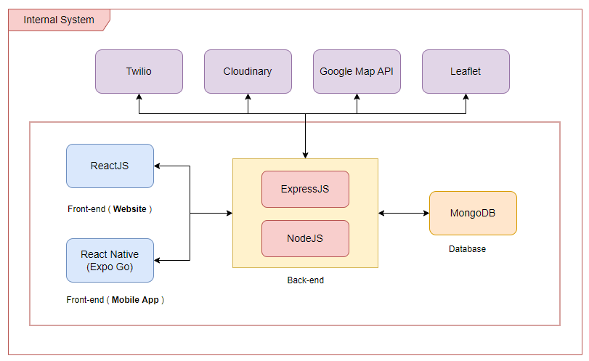

*Figure 3. 1 System Architecture*

The figure above illustrates our system architecture. When a user consumes functionality from the Web Application/Mobile Application, calls the Component Web API or the data goes through the Web API component. The Web API component accesses the MongoDB database to get data returned to the Web Application or data retrieved from the Web Application/Mobile Application via the Web API component is saved in the MongoDB database. For image data is uploaded on Cloudinary first to get the url and then saved to the database. Google Map API provides mapping services for the application, used for displaying maps and routes, especially for locating blood donation sites. Leaflet, an open-source JavaScript library, is integrated to enhance geographic data visualization and interactive mapping functionalities.

*Table 3. 1 Component description*

| **Component’ name** | **Component’ responsibility** |
| --- | --- |
| Web Application | Web interface:   * Allow guest to use function such as: * Register a new account, log in, recover password * View a list of events, search events by event name and filter events by time range and organize hospitals. * View a route on a map to the blood donation location. * Send collaboration requests to become hospitals managing event organizations. * View detailed information about the hospital. * Allow user to use function such as: * Reset password, manage personal information and contact details. * View event details, search event, appointments, and routes to blood donation location. * Register for an event, edit or cancel registered events. * Review donation history and download e-Certificates, view award points. * Send collaboration requests. * Allow hospitals to manage their events such as: manage registrants, manage information, statistics,... * Allow admin to manage such as: * Account management * Hospital management * View a list of events. * Approve cooperation. * Individual information management |
| Mobile Application | Provides the mobile interface for users to interact with the application. |
| Web API | This component is at the center of the system. Its responsibility interacting with MongoDB database and handle  logic of the system. |
| Cloudinary | Upload the image to Cloudinary then return the image url to the API. |
| Leaflet | Provides mapping functionalities within the application. |
| Google Map API | Integrates Google Maps services for various location-based functionalities within the application. |
| Twilio | Manages communication services, likely for email, SMS or other messaging functionalities. |

## 

## **3.2. Entity Relation Diagram**

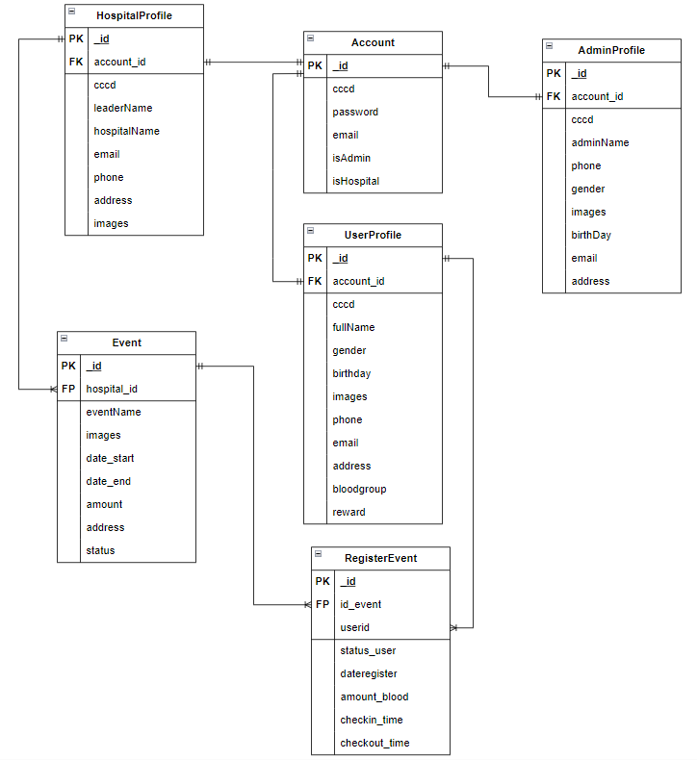

*Figure 3. 2 Entity Relation Diagram*

## **3.3. Database Design**

From the group entity relationship diagram, we designed the database on mongodb into 5 collections and embedded the Register Event object into 2 collections Event and UserProfile. For Event it will be the listusers object and UserProfile will be the history.

### **3.3.1. Account Collection**

*Table 3. 2 Account Collection*

| **No** | **Field** | **Type** | **Description** |
| --- | --- | --- | --- |
| **1** | _id | ObjectId |  |
| **2** | cccd | String | The identification number that acts as the username |
| **3** | password | String |  |
| **4** | isAdmin | Boolean | Used to check admin rights |
| **5** | isHospital | Boolean | Used to check hospital rights |

### **3.3.2. UserProfile Collection**

*Table 3. 3 UserProfile Collection*

| **No** | **Field** | **Type** | **Description** |
| --- | --- | --- | --- |
| **1** | _id | ObjectId |  |
| **2** | account_id | String | id from the corresponding account |
| **3** | cccd | String | cccd from the corresponding account |
| **4** | fullName | String | User full name |
| **5** | gender | String | User gender |
| **6** | image | String | User image |
| **7** | birthday | String | User birthday |
| **8** | email | String | User email |
| **9** | address | String | User address |
| **10** | bloodgroup | String | User blood group |
| **11** | reward | Number | User reward points |
| **12** | history | Array | Save list event user register |
| [Objects] in Array   | id_event | String | id for event | | --- | --- | --- | | eventName | String | Event name | | address_event | String | Event address | | date | Date | Date user register to donate blood | | status_user | String | Status before and after user donate blood | | amount_blood | Number | The amount of blood that the user registers to donate | | checkin_time | Date | The time the user arrives to start donating | | checkout_time | Date | The time the user has successfully donated blood | | | |

### **3.3.3. HospitalProfile Collection**

*Table 3. 4 HospitalProfile Collection*

| **No** | **Field** | **Type** | **Description** |
| --- | --- | --- | --- |
| **1** | _id | ObjectId |  |
| **2** | account_id | String | id from the corresponding account |
| **3** | cccd | String | cccd from the corresponding account |
| **4** | hospitalName | String | Hospital Name |
| **5** | leaderName | String | Name of the person leading the hospital |
| **6** | images | String | Hospital image |
| **7** | phone | String | Hospital phone |
| **8** | email | String | Hospital email |
| **9** | address | String | Hospital address |

### **3.3.4. AdminProfile Collection**

*Table 3. 5 AdminProfile Collection*

| **No** | **Field** | **Type** | **Description** |
| --- | --- | --- | --- |
| **1** | _id | ObjectId |  |
| **2** | account_id | String | id of the corresponding account |
| **3** | cccd | String | cccd of the corresponding account |
| **4** | adminName | String | Admin Name |
| **5** | birthday | String | Admin birthday |
| **6** | images | String | Admin image |
| **7** | phone | String | Admin phone |
| **8** | email | String | Admin email |
| **9** | address | String | Admin address |

### **3.3.5. Event Collection**

*Table 3. 6 Event Collection*

| **No** | **Field** | **Type** | **Description** |
| --- | --- | --- | --- |
| **1** | _id | ObjectId |  |
| **2** | hospital_id | String | id from the corresponding hospital |
| **3** | eventName | String | Event Name |
| **4** | images | String | Event image |
| **5** | date_start | Date | Date start event |
| **6** | date_end | Date | Date end event |
| **7** | amount | Number | Maximum number of user register event |
| **8** | address | String | Event address |
| **9** | status | String | Event status |
| **10** | listusers | Object | Object listusers contain: count and user |
| count | Number | Number of people registered for the event |
| user | Array | Save list user register event |
| [Object] in Array   | userid | String | id for user register | | --- | --- | --- | | username | String | Name for user register | | bloodgroup | String | Blood group of registered user | | status_user | String | Status before and after user donate blood | | dateregister | Date | Date user register to donate blood | | amout_blood | Number | The amount of blood that the user registers to donate | | | |

## **3.4. Sequence Diagram**

**3.4.1. Login Sequence Diagram**

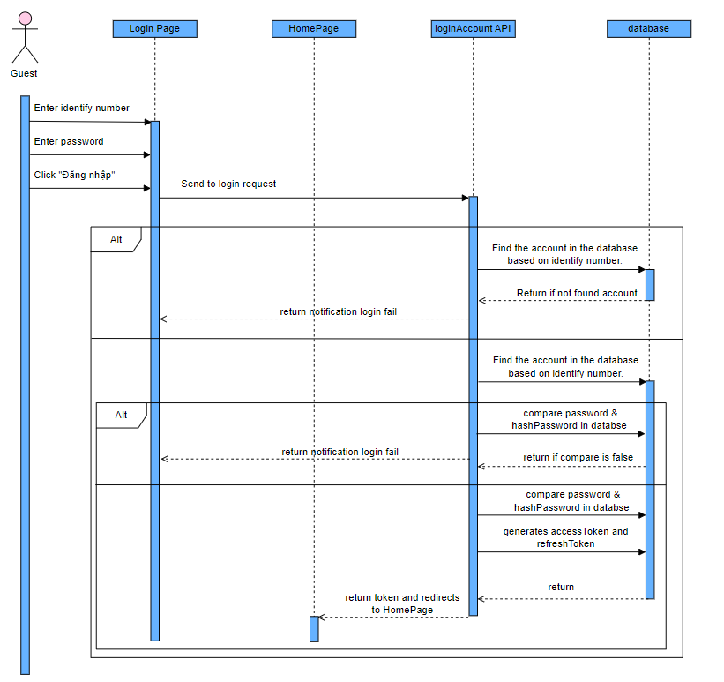

*Figure 3. 3 Login Sequence Diagram*

**3.4.2. Sign up Sequence Diagram**

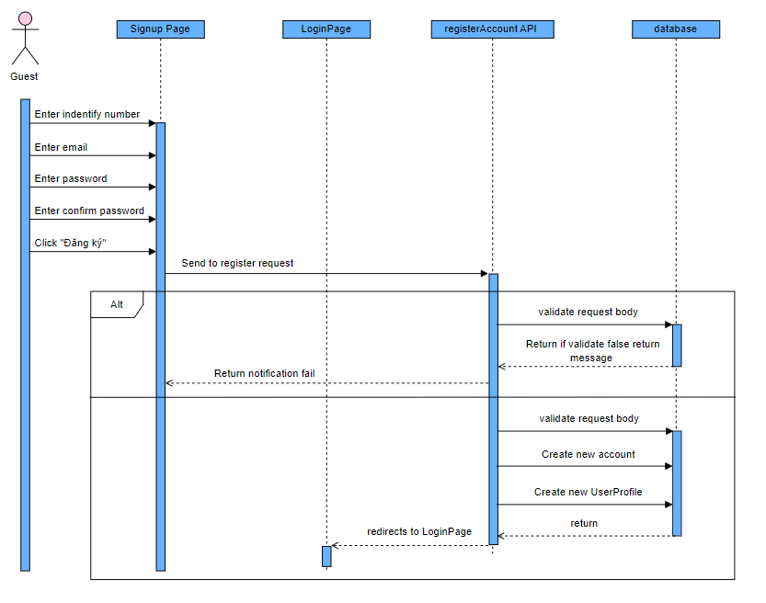

*Figure 3. 4 Sign up Sequence Diagram*

**3.4.3. ForgotPassword Sequence Diagram**

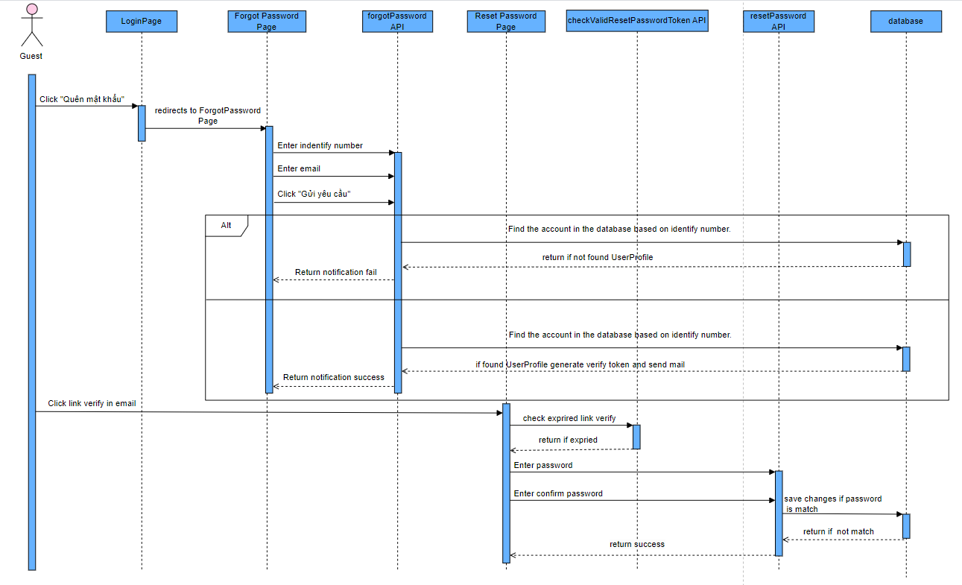

*Figure 3. 5 ForgotPassword Sequence Diagram*

**3.4.4. Profile update (for user, hospital and admin) Sequence Diagram**

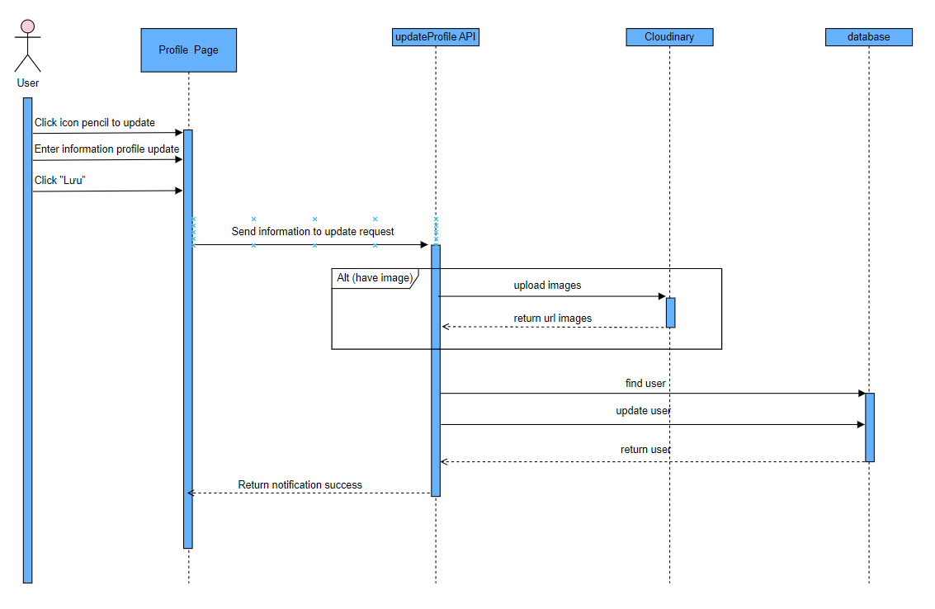  
 *Figure 3. 6 Profile update (for user, hospital and admin) Sequence Diagram*

**3.4.5. User register event Sequence Diagram**

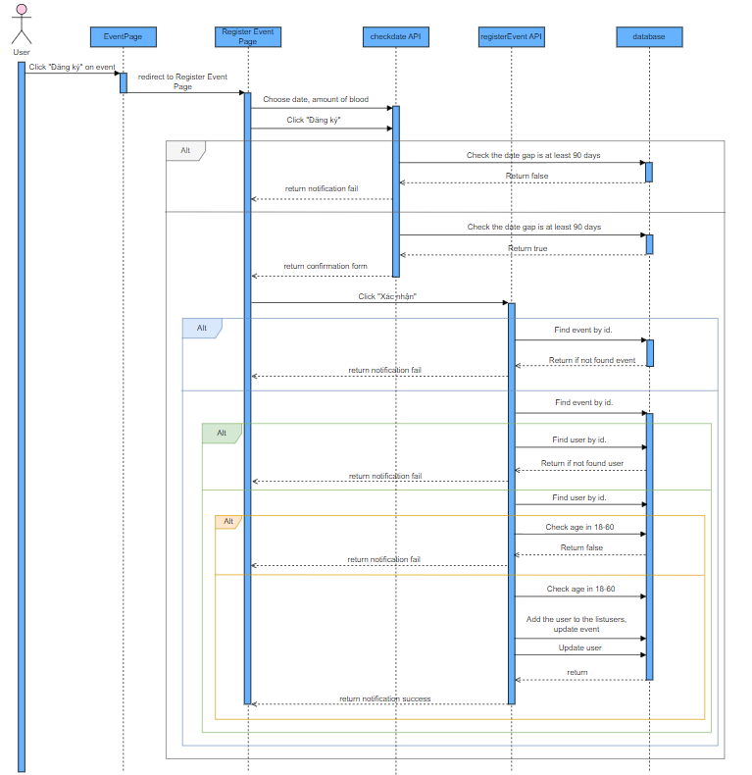

*Figure 3. 7 User register event Sequence Diagram*

**3.4.6. Update User schedule Sequence Diagram**

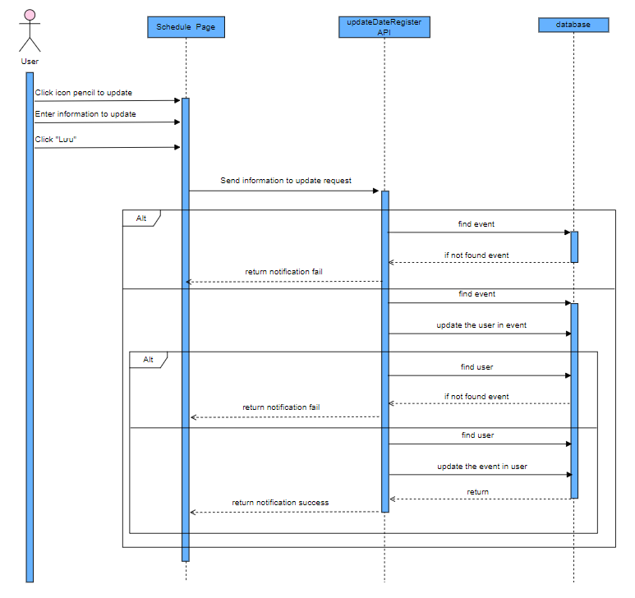

*Figure 3. 8 Update User schedule Sequence Diagram*

**3.4.7. View history and download e-Certification Sequence Diagram**

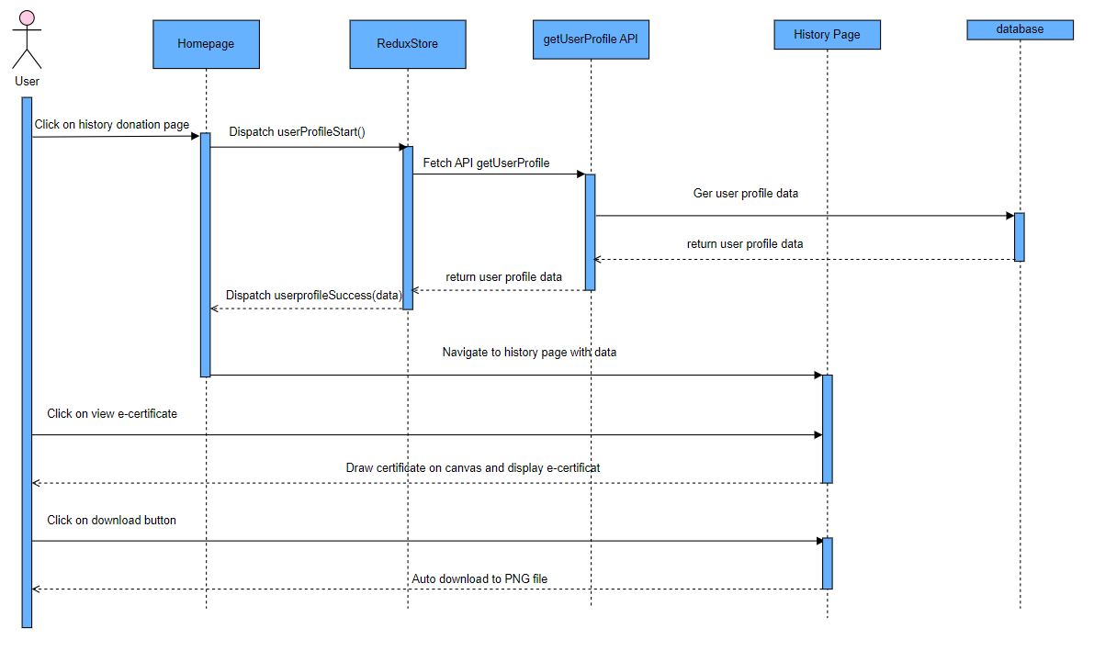

*Figure 3. 9 View history and download e-Certification Sequence Diagram*

**3.4.8. Update Password Sequence Diagram**

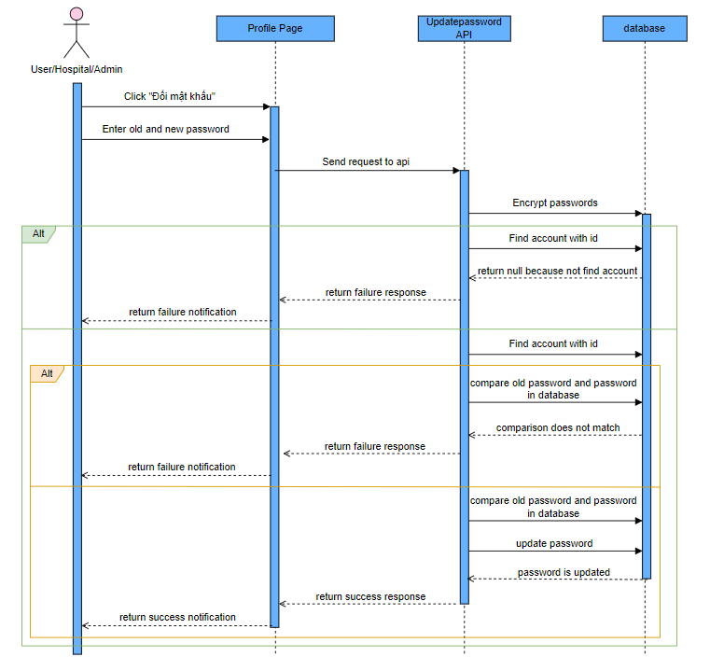

*Figure 3. 10 Update Password Sequence Diagram*

**3.4.9. Search event Sequence Diagram**

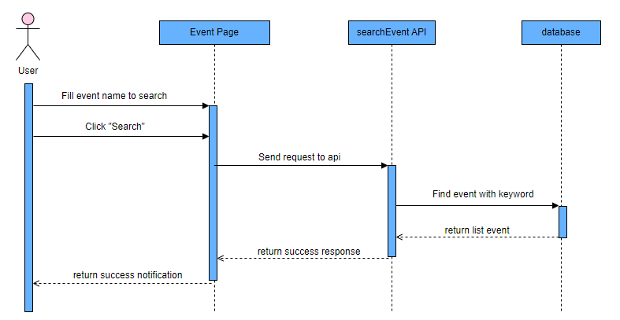

*Figure 3. 11 Search event Sequence Diagram*

**3.4.10. Filter event Sequence Diagram**

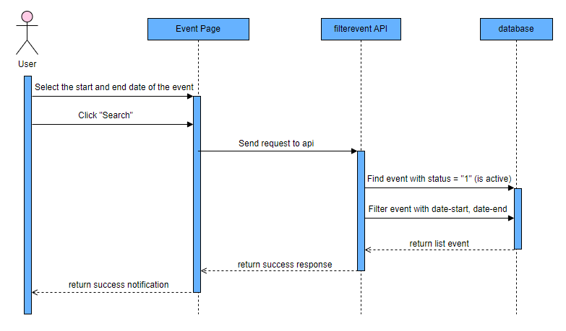

*Figure 3. 12 Filter event Sequence Diagram*

**3.4.11. Add New event Sequence Diagram**

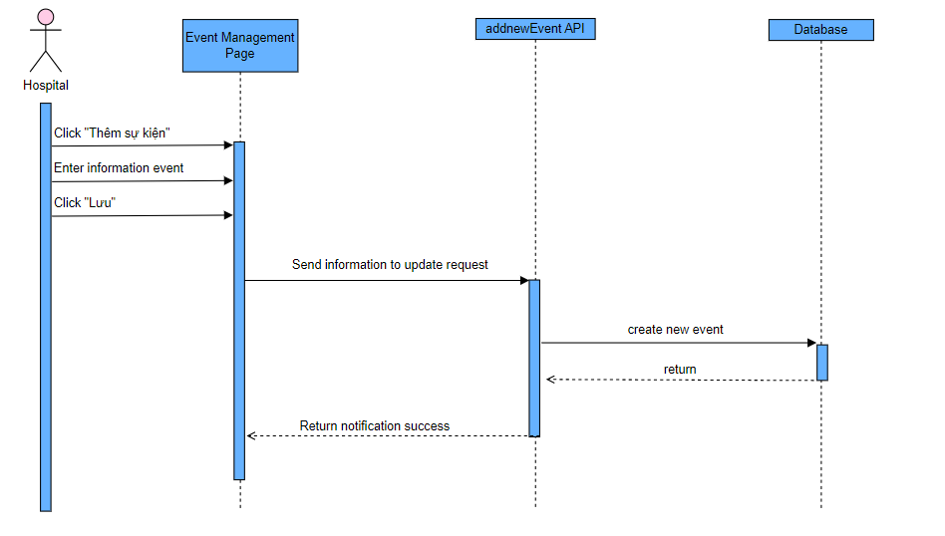  
*Figure 3. 13 Add New event Sequence Diagram*

**3.4.12. Update event Sequence Diagram**

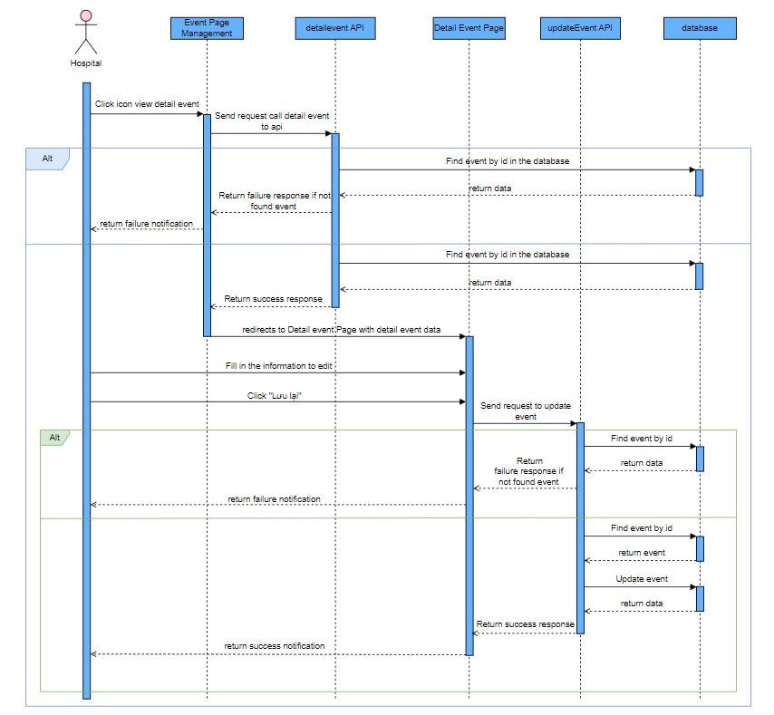

*Figure 3. 14 Update event Sequence Diagram*

**3.4.13. Update status user for each event Sequence Diagram**

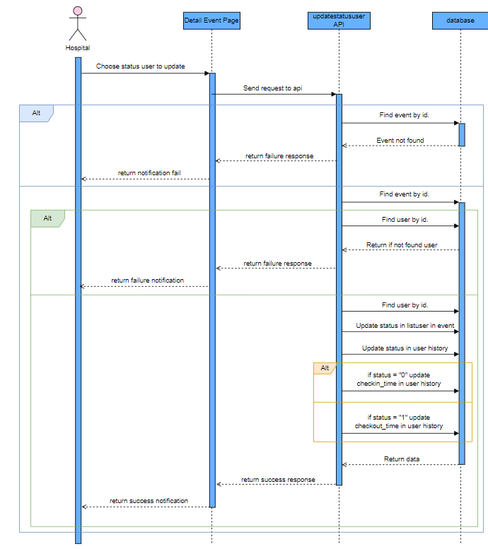

*Figure 3. 15 Update status user for each event Sequence Diagram*

**3.4.14. Search event by hospital Sequence Diagram**

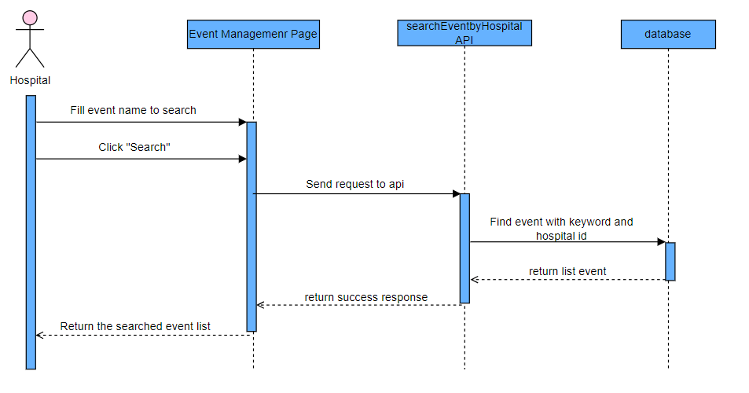

*Figure 3. 16 Search event by hospital Sequence Diagram*

**3.4.15. List Management Sequence Diagram**

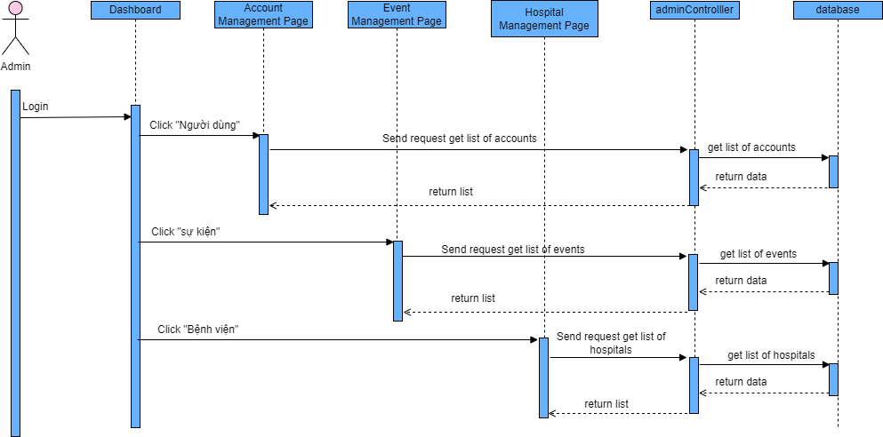  
*Figure 3. 17 List Management Sequence Diagram*

**3.4.16. Search account Sequence Diagram**

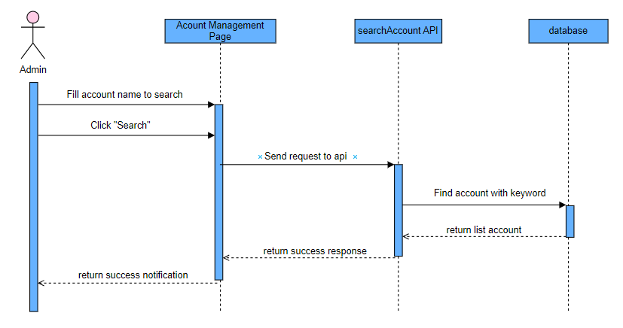

*Figure 3. 18 Search account Sequence Diagram*

**3.4.17. Statistic Sequence Diagram**

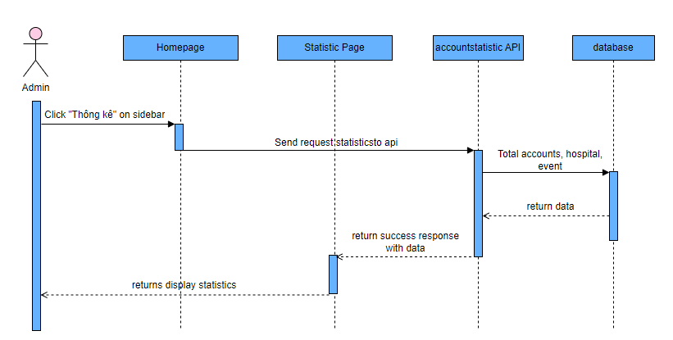

*Figure 3. 19 Statistic Sequence Diagram*

**3.4.18. Export to excel Sequence Diagram**

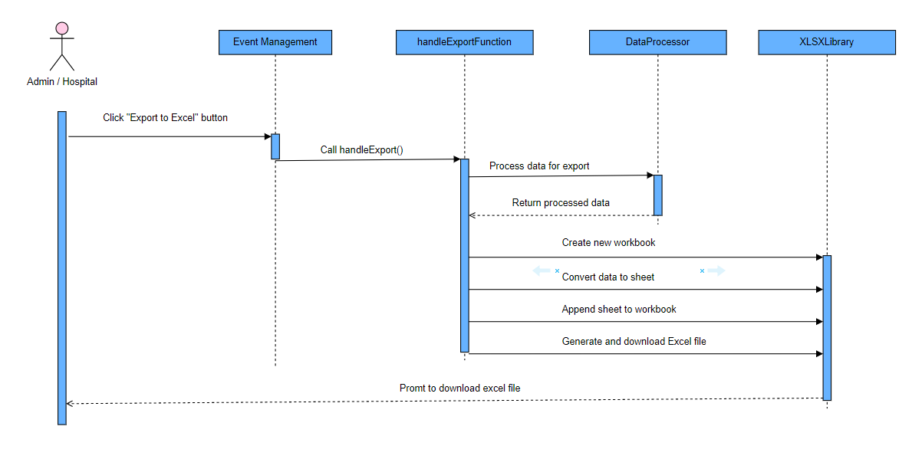

*Figure 3. 20 Export to excel Sequence Diagram*

**3.4.19. Register for cooperation become Hospital Sequence Diagram**

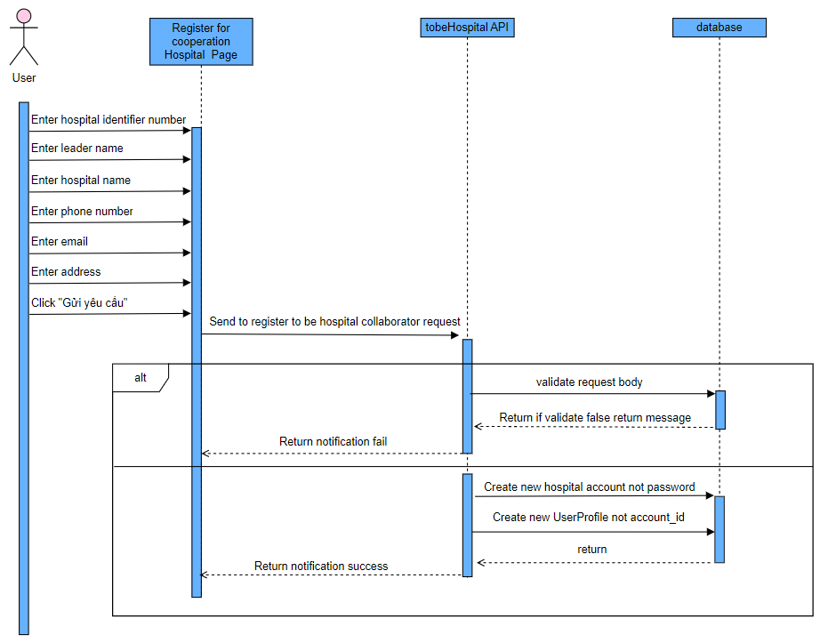

*Figure 3. 21 Register for cooperation become Hospital Sequence Diagram*

**3.4.20. Accept/Decline Request Cooperation Sequence Diagram**

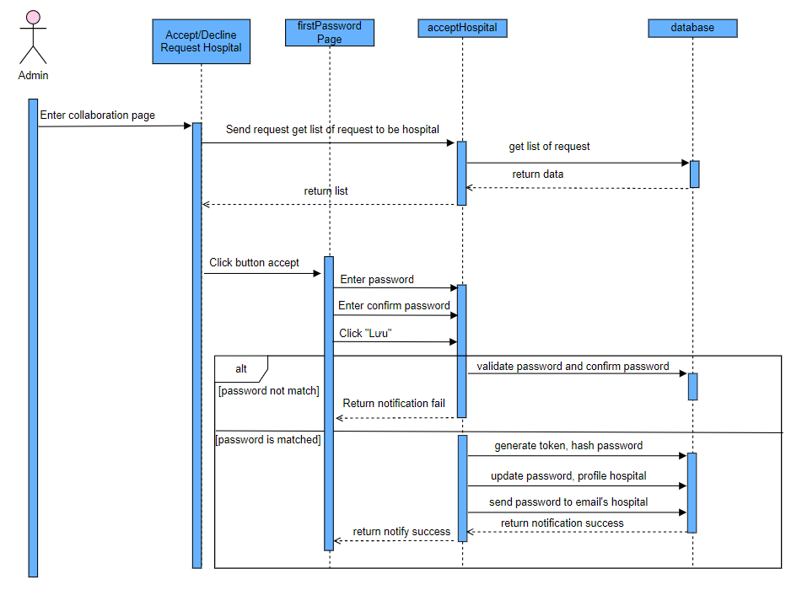

*Figure 3. 22 Accept/Decline Request Cooperation Sequence Diagram*

## **3.5. User Interfaces Design**

### **3.5.1. Screens Description**

* Screens for Guest

*Table 3. 7 User interface for Guest*

| No. | Screen | Purpose | Note |
| --- | --- | --- | --- |
| 1 | Sign up Screen | This page to perform the function of register new account |  |
| 2 | Login Screen | This page to perform the function of logging into the system |  |
| 3 | Forgot password Screen | This page to perform the function of forgot password, confirm email, reset password |  |
| 4 | Homepage Screen |  |  |
| 5 | List Event Screen | This page displays a list of events, search and filter list events. |  |
| 6 | Cooperation Screen | This page to perform the function of request cooperation becomes a hospital. |  |
| 7 | Detail Hospital Screen | This page displays detailed hospitals. |  |

* Screens for User

*Table 3. 8 User interface for User*

| **No.** | **Screen** | **Purpose** | **Note** |
| --- | --- | --- | --- |
| 1 | Homepage Screen |  | Same Guest |
| 2 | List Event Screen |  | Same Guest |
| 3 | Cooperation Screen |  | Same Guest |
| 4 | Detail Hospital Screen |  | Same Guest |
| 5 | Profile Screen | The page displays detailed information of the profile, edit profile, reset password. |  |
| 6 | Register Event Screen | The page to perform the function of register event and confirm register. |  |
| 7 | Schedule Screen | The interface displays the appointment schedule of events the user registers for in the future. |  |
| 8 | History donation Screen | The interface displays the user's blood donation history, where the user can view and download the certificate. |  |
| 9 | Reward Screen | The interface displays the rules for reward points, reward point redemption, and the user's current reward points. |  |

* Screens for Hospital

*Table 3. 9 User interface for Hospital*

| No. | Screen | Purpose | Note |
| --- | --- | --- | --- |
| 1 | Login Screen | This page to perform the function of logging into the system |  |
| 2 | Dashboard Screen |  |  |
| 3 | Event Management Screen | The page displays a list of events, performs the function of adding a new event, edit event, close event, search event, update user status. |  |
| 4 | Profile Management Screen | The page displays detailed information of the profile, edit profile. |  |

* Screens for Admin

*Table 3. 10 User interface for Admin*

| No. | Screen | Purpose | Note |
| --- | --- | --- | --- |
| 1 | Login Screen |  | Same Hospital |
| 2 | Dashboard Screen |  | Same Hospital |
| 3 | View list of Events Screen |  | Same Hospital |
| 4 | Account Management Screen | The page displays a list of accounts, performs the function of adding a new account, edit account, close account, search account. |  |
| 5 | Hospital Management Screen | The page displays a list of hospitals, performs the function of adding a new hospital and modifies the hospital. |  |
| 6 | Approve Cooperation Screen | This page performs the function of approving cooperation to send an account to the hospital. |  |
| 7 | Profile Management Screen |  | Same Hospital |

### **3.5.2. Screens Design**

#### **3.5.2.1. Website Screens**

**Screen 01: Guest Login**

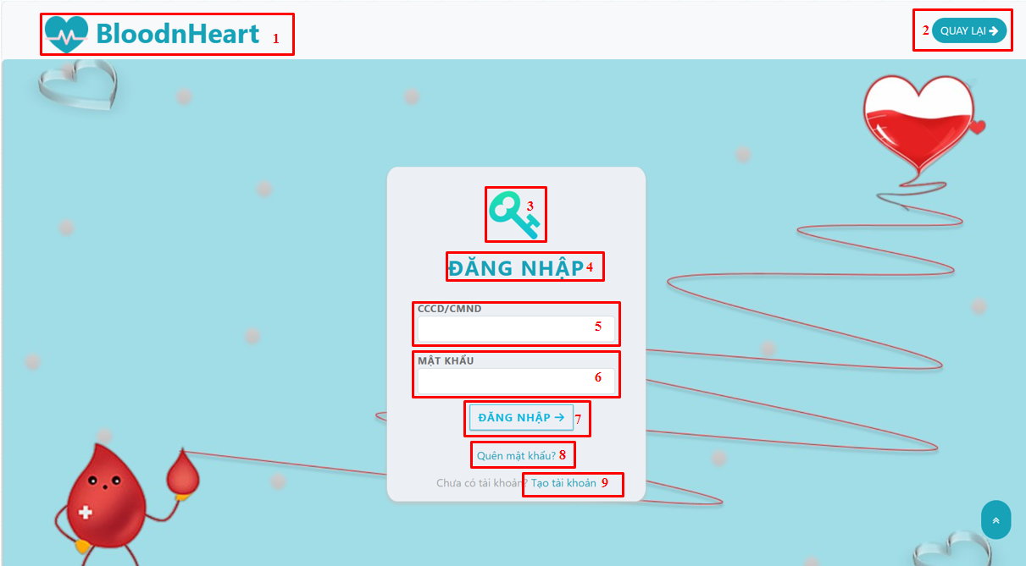

*Figure 3. 23 Screen Guest Login*

*Table 3. 11 Screen Guest Login description*

| **No.** | **Name** | **Type** | **Description** | **Action result** |
| --- | --- | --- | --- | --- |
| 1 | Logo web | Image | Display a logo of website |  |
| 2 | Button “Quay lại” | Button | Back to the homepage |  |
| 3 | Image Key | Image | Display a icon of the form |  |
| 4 | Title “Đăng ký” | Text | Display title  “Đăng ký” |  |
| 5 | Input email | Input | Enter email | Check validates  value email |
| 6 | Input password | Input | Enter password | Check validates  value password |
| 7 | Button  “Đăng nhập” | Button | Sign in |  |
| 8 | Text “Quên mật khẩu” | a tag | Redirect to Forgot Password page |  |
| 9 | Text “Đăng nhập ngay” | a tag | Redirect to Login Page |  |

**Screen 02: Guest Sign Up**

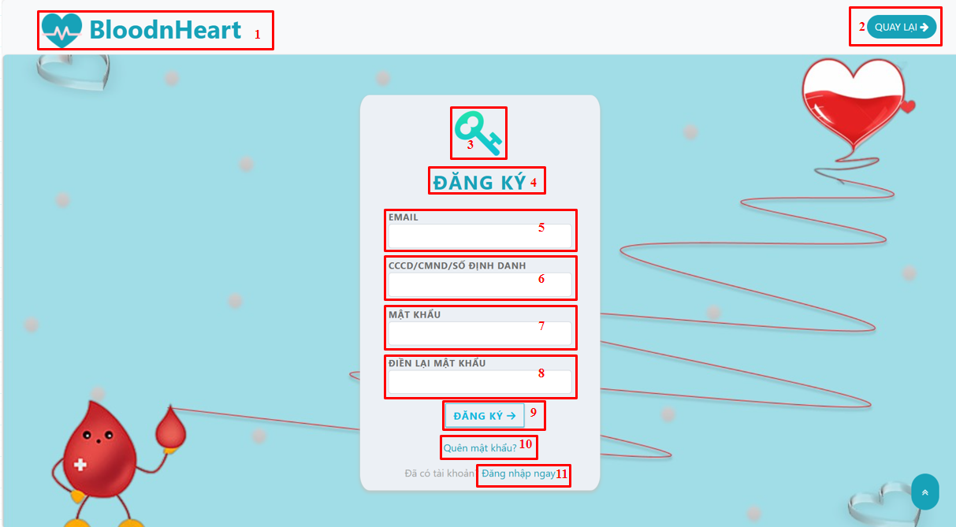

*Figure 3. 24 ScreenGuest Sign Up*

*Table 3. 12 Screen Guest Sign Up description*

| **No.** | **Name** | **Type** | **Description** | **Action result** |
| --- | --- | --- | --- | --- |
| 1 | Logo web | Image | Display a logo of website |  |
| 2 | Button “Quay lại” | Button | Back to the homepage |  |
| 3 | Image Key | Image | Display a icon of the form |  |
| 4 | Title “Đăng ký” | Text | Display title “Đăng ký” |  |
| 5 | Input email | Input | Enter email | Check validates  value email |
| 6 | Input citizen identify | Input | Enter citizen identify | Check validates  value citizen identify |
| 7 | Input password | Input | Enter password | Check validates  value password |
| 8 | Input confirm password | Input | Enter confirm password | Check validates  value confirm password |
| 9 | Button “Đăng ký” | Button | Sign up |  |
| 10 | Text “Quên mật khẩu” | a tag | Redirect to Forgot Password page |  |
| 11 | Text “Đăng nhập ngay” | a tag | Redirect to Login Page |  |

**Screen 03: Guest Forgot Password**



*Figure 3. 25 Screen Guest Forgot Password*

*Table 3. 13 Screen Forgot Password description*

| **No.** | **Name** | **Type** | **Description** | **Action result** |
| --- | --- | --- | --- | --- |
| 1 | Title “Quên mật khẩu” | text | Display a state of forgot password |  |
| 2 | Title “LẤY LẠI MẬT KHẨU” | text | Display a form to reset password |  |
| 3 | Input citizen identify | Input | Enter citizen identify | Check validates  value citizen identify |
| 4 | Input email | Input | Enter email | Check validates  value email |
| 5 | Button “Gửi yêu cầu|” | Button | Check valid and send to email verify link |  |

**Screen 04: Guest Reset Password**



*Figure 3. 26 Screen Guest / User Reset Password*

*Table 3. 14 Screen Guest / User Reset Password description*

| **No.** | **Name** | **Type** | **Description** | **Action result** |
| --- | --- | --- | --- | --- |
| **1** | Title “Quên mật khẩu” | text | Display a state of forgot password |  |
| **2** | Title “Cập nhật mật khẩu mới” | text | Display a form to reset password |  |
| **3** | Input password | Input | Enter password | Check validates  value password |
| **4** | Input confirm password | Input | Enter confirm password | Check validates  value confirm password |
| **5** | Button “Xác nhận|” | Button | Check valid and update password |  |
| **6** | Text “Đăng ký tài khoản mới” | a tag | Redirect to Sign up page |  |
| **7** | Text “Đăng nhập ngay” | a tag | Redirect to Login Page |  |

**Screen 05: Guest / User Homepage**

* **Screen Header:**
* Before login:



*Figure 3. 27 Screen Header before login*

* After login:

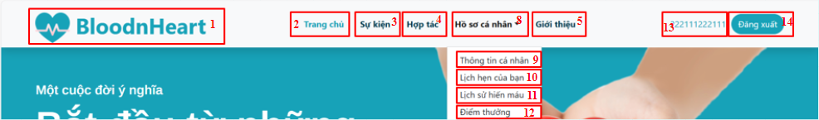

*Figure 3. 28 Screen Header after login*

*Table 3. 15 Screen Header description*

| **No.** | **Name** | **Type** | **Description** | **Action result** |
| --- | --- | --- | --- | --- |
| **1** | Logo web | Image | Display a logo of website |  |
| **2** | Title “Trang chủ” | Link | Display title “Trang chủ” |  |
| **3** | Title “Sự kiện” | Link | Display title “Sự kiện” |  |
| **4** | Title “Hợp tác” | Link | Display title “Hợp tác” |  |
| **5** | Title “Giới thiệu” | Link | Display title “Giới thiệu” |  |
| **6** | Button “Đăng nhập” | Button | Using for sign in |  |
| **7** | Button “Đăng ký| | Button | Using for sign up |  |
| **8** | Title “Hồ sơ cá nhân” | Link | Display title “Hồ sơ cá nhân” |  |
| **9** | Title “Thông tin cá nhân” | Link | Display title “Thông tin cá nhân” |  |
| **10** | Title “Lịch hẹn của bạn” | Link | Display title “Lịch hẹn của bạn” |  |
| **11** | Title “Lịch sử hiến máu” | Link | Display title “Lịch sử hiến máu” |  |
| **12** | Title “Điểm thưởng” | Link | Display title “Điểm thưởng” |  |
| **13** | Label citizen identify number | label | Display label citizen identify number |  |
| **14** | Button “Đăng xuất” | Button | Logout the system |  |

* **Screen Footer:**

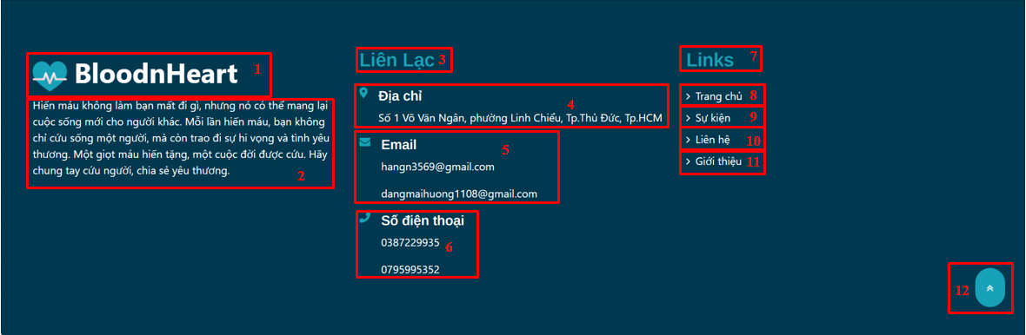

*Figure 3. 29 Screen Footer*

*Table 3. 16 Screen Footer description*

| **No.** | **Name** | **Type** | **Description** | **Action result** |
| --- | --- | --- | --- | --- |
| **1** | Logo web | Image | Display a logo of website |  |
| **2** | Text introduction | text | Display an introduction |  |
| **3** | Title “Liên lạc” | Text | Display title “Liên lạc” |  |
| **4** | Info “Địa chỉ” | Text | Display info “Địa chỉ” |  |
| **5** | Info “Email” | Text | Display info “Email” |  |
| **6** | Info “Số điện thoại” | Text | Display info “Số điện thoại” |  |
| **7** | Title “Link” | Text | Display tittle “Link” |  |
| **8** | Title “Trang chủ”” | Link | Display title “Trang chủ” |  |
| **9** | Title “Sự kiện” | Link | Display title “Sự kiện” |  |
| **10** | Title “Hợp tác” | Link | Display title “Hợp tác” |  |
| **11** | Title “Giới thiệu” | Link | Display title “Giới thiệu” |  |

**Screen 06: Guest / User Event Page**

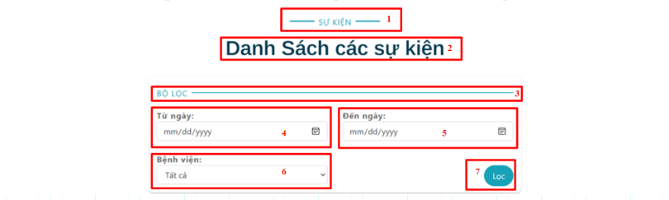

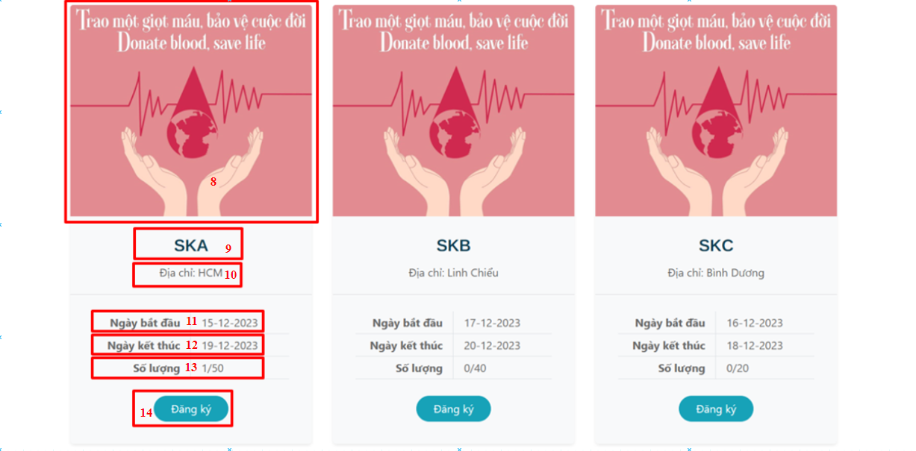

*Figure 3. 30 Screen Guest / User Event Page*

*Table 3. 17 Screen Guest / User Event Page description*

| **No.** | **Name** | **Type** | **Description** | **Action result** |
| --- | --- | --- | --- | --- |
| 1 | Title “Sự kiện” | Title | Display title “Sự kiện” |  |
| 2 | Title “Danh sách sự kiện” | Title | Display title “Danh sách sự kiện” |  |
| 3 | Title “Bộ lọc” | Title | Display title “Bộ lọc” |  |
| 4 | Input date start | Input | Input the starting date of the time period you want to search |  |
| 5 | Input date end | Input | Input the end date within the time period you want to search |  |
| 6 | Select hospital | Select | Select the hospital you want to filter events |  |
| 7 | Button “Lọc” | Button | Send request to filter event |  |
| 8 | Image event | Image | Display event image |  |
| 9 | Title event name | Title | Display event name |  |
| 10 | Title event address | Title | Display event address |  |
| 11 | Title date event start | Title | Display event start |  |
| 12 | Title date event end | Title | Display event end |  |
| 13 | Title amount | Title | Display the number of event registrants compared to the maximum number of registrations |  |
| 14 | Button “Đăng ký” | Button | Send request to register event |  |

**Screen 07: Guest / User Collaborator Hospital Page**

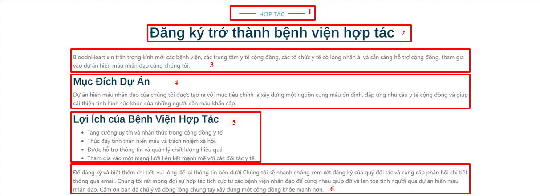

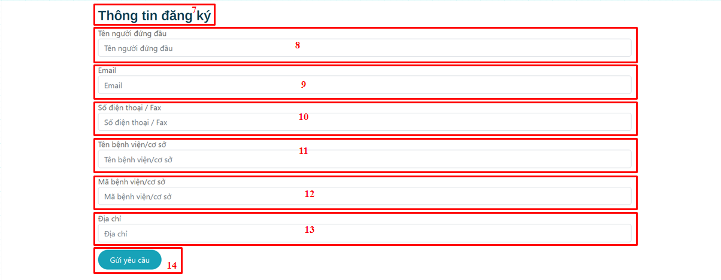

*Figure 3. 31 Screen Guest / User Collaborator Hospital Page*

*Table 3. 18 Screen Guest / User Collaborator Hospital Page description*

| **No.** | **Name** | **Type** | **Description** | **Action result** |
| --- | --- | --- | --- | --- |
| 1 | Title “Hợp tác” | text | Display “Hợp tác” title |  |
| 2 | Title “Đăng ký trở thành bệnh viện hợp tác” | text | Display title “Đăng ký trở thành bệnh viện hợp tác” |  |
| 3 | Info introduction | text | Display introduction |  |
| 4 | Info “Mục đích dự án”| | text | Display information about purpose of system |  |
| 5 | Info “Lợi ích” | text | Display helpful of collaborator hospital |  |
| 6 | information | text | Display information |  |
| 7 | Title “Thông tin đăng ký” | text | Display the form to be collaborator |  |
| 8 | Input “Tên người đứng đầu” | Input | Enter “Tên người đứng đầu” | Check validate Input “Tên người đứng đầu” |
| 9 | Input “Email” | Input | Enter email | Check validate input “email” |
| 10 | Input “Số điện thoại” | Input | Enter “Số điện thoại” | Check validate input “Số điện thoại” |
| 11 | Input “Tên bệnh viện” | Input | Enter “Tên bệnh viện” | Check validate Input “Tên bệnh viện” |
| 12 | Input “mã bệnh viện” | Input | Enter “Mã bệnh viện| | Check validate Input “Mã bệnh viện” |
| 13 | Input “|Địa chỉ” | Input | Enter “Địa chỉ” | Check validate input “Địa chỉ” |
| 14 | Button  “Gửi yêu cầu” | Button | Send request to admin |  |

**Screen 08: Detail Hospital Page**

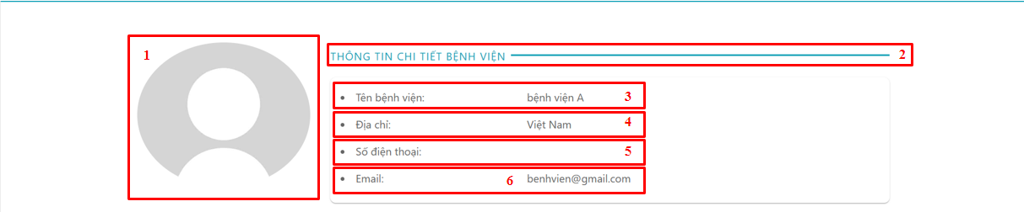

*Figure 3. 32 Screen Detail Hospital Page*

*Table 3. 19 Screen Detail Hospital Page description*

| **No.** | **Name** | **Type** | **Description** | **Action result** |
| --- | --- | --- | --- | --- |
| 1 | Image hospital | image | Display avatar hospital |  |
| 2 | Title “Thông tin chi tiết bệnh viện” | text | Display the title on |  |
| 3 | Title  “Tên bệnh viện” | text | Display title  “Tên bệnh viện” |  |
| 4 | Title “Địa chỉ” | text | Display title “Địa chỉ” |  |
| 5 | Title  “Số điện thoại” | text | Display title  “Số điện thoại” |  |
| 6 | Title “Email” | text | Display title “Email” |  |

**Screen 09: User Profile**

* **Screen: Detail Profile:**

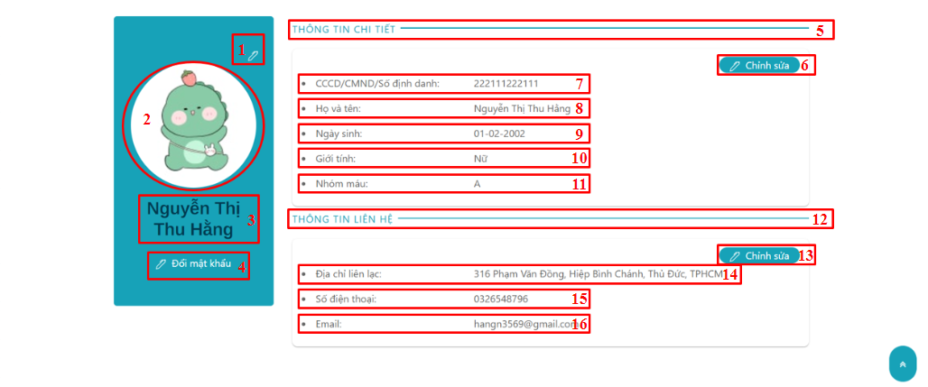

*Figure 3. 33 Screen Detail Profile*

*Table 3. 20 Screen Detail Profile description*

| **No.** | **Name** | **Type** | **Description** | **Action result** |
| --- | --- | --- | --- | --- |
| 1 | Button edit | Button | Edit avatar user |  |
| 2 | Image avatar | Image | Display user avatar |  |
| 3 | Title “Thông tin chi tiết” | Text | Display title “Thông tin chi tiết” |  |
| 4 | Button edit information | Button | Edit information profile |  |
| 5 | Label identify | Label | Display citizen identify number |  |
| 6 | Label “Họ và tên” | Label | Display full name |  |
| 7 | Label “Ngày sinh” | Label | Display birthday |  |
| 8 | Label “Giới tính” | Label | Display gender |  |
| 9 | Label “Nhóm máu” | Label | Display blood group |  |
| 10 | Title  “Thông tin liên hệ” | Text | Display title  “Thông tin liên hệ” |  |
| 11 | Button “Chỉnh sửa” | Button | Edit contact information |  |
| 12 | Label  “Địa chỉ liên lạc” | Label | Display address |  |
| 13 | Label “Số điện thoại” | Label | Display phone number |  |
| 14 | Label Email | Label | Display email |  |

* **Screen: Edit Profile**

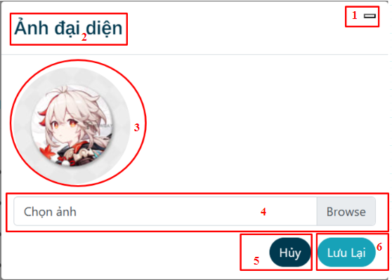

*Figure 3. 34 Screen Edit Profile*

*Table 3. 21 Screen Edit Profile description*

| **No.** | **Name** | **Type** | **Description** | **Action result** |
| --- | --- | --- | --- | --- |
| 1 | Button Close | Button | Close modal edit |  |
| 2 | Title “Ảnh đại diện” | Text | Display title “Ảnh đại diện” |  |
| 3 | Image avatar | Image | Display user avatar |  |
| 4 | Input file | Input | Input user avatar |  |
| 5 | Button “Hủy” | Button | Close modal edit |  |
| 6 | Button “Lưu lại” | Button | Save image avatar |  |

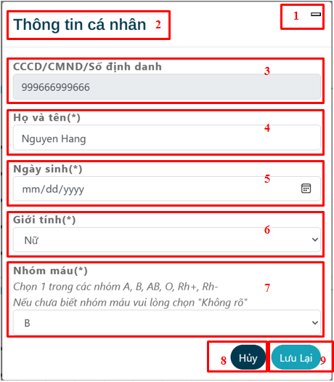

*Figure 3. 35 Screen Modal Edit Information*

*Table 3. 22 Screen Modal Edit Information description*

| **No.** | **Name** | **Type** | **Description** | **Action result** |
| --- | --- | --- | --- | --- |
| **1** | Button Close | Button | Close modal edit |  |
| **2** | Title “Thông tin cá nhân” | Text | Display title “Thông tin cá nhân” |  |
| **3** | Input identify | Input | Enter citizen identify number |  |
| **4** | Input “Họ và tên” | Input | Enter full name |  |
| **5** | Input “Ngày sinh” | Input | Enter birthday |  |
| **6** | Input “Giới tính” | Input | Enter gender |  |
| **7** | Input “Nhóm máu” | Input | Enter blood group |  |
| **8** | Button “Hủy” | Button | Close modal edit |  |
| **9** | Button “Lưu lại” | Button | Save user information |  |

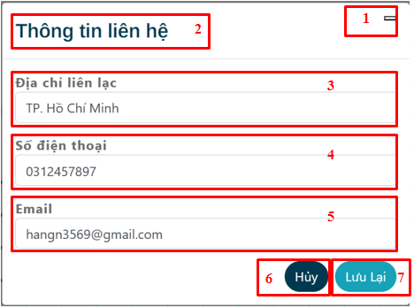

*Figure 3. 36 Screen Modal Edit Contact Information*

*Table 3. 23 Screen Modal Edit Contact Information description*

| **No.** | **Name** | **Type** | **Description** | **Action result** |
| --- | --- | --- | --- | --- |
| 1 | Button Close | Button | Close modal edit |  |
| 2 | Title “Ảnh đại diện” | Text | Display title  “Ảnh đại diện” |  |
| 3 | Input“Địa chỉ liên lac” | Input | Enter address |  |
| 4 | Input“Số điện thoại” | Input | Enter phone number |  |
| 5 | Input Email | Input | Enter email |  |
| 6 | Button “Hủy” | Button | Close modal edit |  |
| 7 | Button “Lưu lại” | Button | Save image avatar |  |

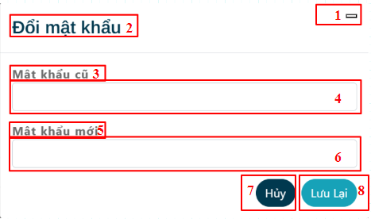

*Figure 3. 37 Screen Edit password*

*Table 3. 24 Screen Edit password description*

| **No.** | **Name** | **Type** | **Description** | **Action result** |
| --- | --- | --- | --- | --- |
| 1 | Button Close | Button | Close modal |  |
| 2 | Title “Đổi mật khẩu” | Text | Display title  “Đổi mật khẩu” |  |
| 3 | Title “Mật khẩu cũ” | Text | Display title  “Mật khẩu cũ” |  |
| 4 | Input old password | Input | Enter old password |  |
| 5 | Title “Mật khẩu mới” | Text | Display title  “Mật khẩu mới” |  |
| 6 | Input new password | Input | Enter new password |  |
| 7 | Button “Hủy” | Button | Close modal |  |
| 8 | Button “Lưu lại” | Button | Save new password |  |

**Screen 10: Schedule page**

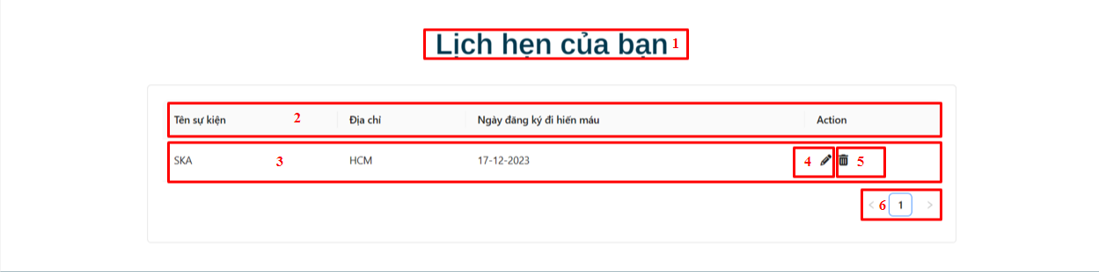

*Figure 3. 38 Screen Schedule page*

*Table 3. 25 Screen Schedule page description*

| **No.** | **Name** | **Type** | **Description** | **Action result** |
| --- | --- | --- | --- | --- |
| 1 | Title “Lịch hẹn của bạn” | Text | Display title “Lịch hẹn của bạn| |  |
| 2 | Label information | Text | Display information will show on screen |  |
| 3 | User schedule | Text | Display user schedule |  |
| 4 | Button edit | Button | Edit schedule |  |
| 5 | Button delete | Button | Delete schedule |  |
| 6 | Number of page | Text | Pagination user schedule |  |

**Screen 11: Blood donation history page**

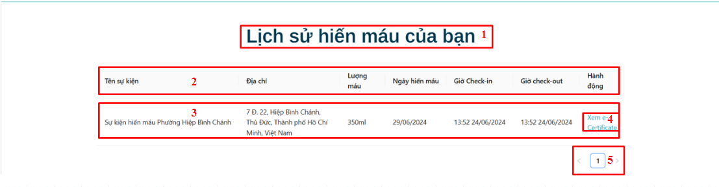

*Figure 3. 39 Screen Blood donation history page*

*Table 3. 26 Screen Blood donation history page description*

| **No.** | **Name** | **Type** | **Description** | **Action result** |
| --- | --- | --- | --- | --- |
| 1 | Title  “Lịch hẹn của bạn” | Text | Display title  “Lịch hẹn của bạn| |  |
| 2 | Label information | Text | Display information will show on screen |  |
| 3 | Button delete | Button | Delete schedule |  |
| 4 | Text  “Xem e-certificate” | Link | Click to show e-certificate with modal |  |
| 5 | Number of page | Text | Pagination user schedule |  |

**Screen: View and download Certificate**

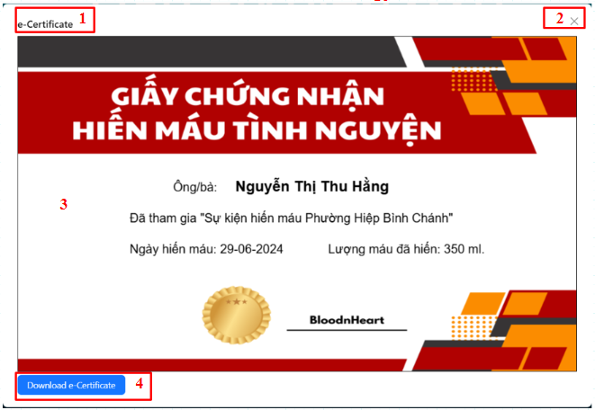

*Figure 3. 40 Screen View and download Certificate*

*Table 3. 27 Screen View and download Certificate description*

| **No.** | **Name** | **Type** | **Description** | **Action result** |
| --- | --- | --- | --- | --- |
| 1 | Title “e-Certificate” | Text | Display title “e-Certificate” |  |
| 2 | Button Close | Button | Close Modal |  |
| 3 | e-certificate | Image | Display e - Certificate |  |
| 4 | Button “Download e-Certificate” | Button | Download e-certificate |  |

**Screen 12: User Register Event Page**

* **Screen: Event Detail, register date and amount of blood**

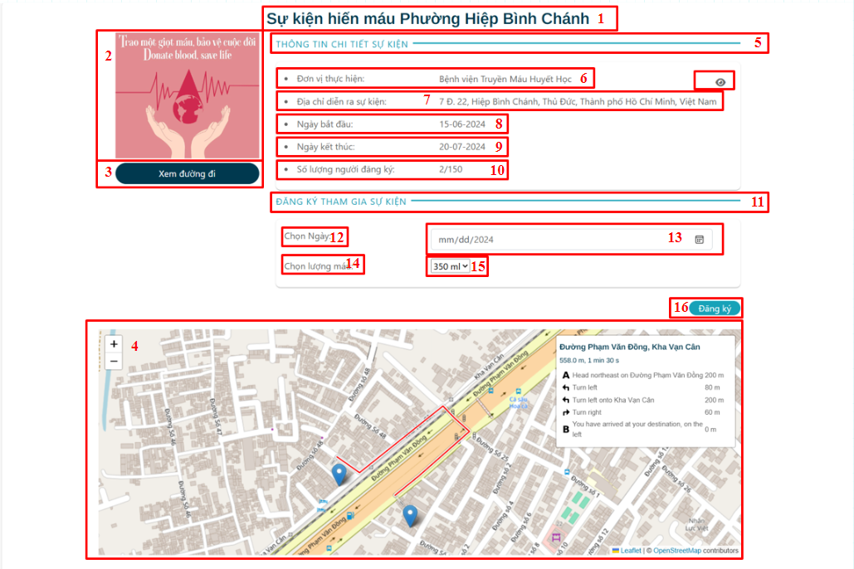

*Figure 3. 41 Screen Event Detail, register date and amount of blood*

*Table 3. 28 Screen Event Detail, register date and amount of blood description*

| **No.** | **Name** | **Type** | **Description** | **Action result** |
| --- | --- | --- | --- | --- |
| 1 | Image event | Image | Display image event |  |
| 2 | Title event name | Text | Display event name |  |
| 3 | Button  “Xem đường đi” | Button | Display button “Xem đường đi” |  |
| 4 | Map route | Map | Display route from now location to blood donation location |  |
| 5 | Title “Thông tin chi tiết sự kiện” | Text | Display information of event |  |
| 6 | Title “Đơn vị thực hiện” | Text | Display implement unit |  |
| 7 | Title “Địa chỉ diễn ra sự kiện” | Text | Display address of event |  |
| 8 | Title “Ngày bắt đầu|” | Text | Display start day |  |
| 9 | Title “Ngày kết thúc” | Text | Display end day |  |
| 10 | Title “Số lượng người đăng ký” | Text | Display number of people apply to join that event |  |
| 11 | Title “Đăng ký tham gia sự kiện” | Text | Display title “Đăng ký tham gia sự kiện” |  |
| 12 | Title  “Chọn ngày” | Text | Display title “Chọn ngày” |  |
| 13 | Input choose day | Text | Enter the day can join the event |  |
| 14 | Title “Chọn lượng máu” | Text | Display title “Chọn lượng máu” |  |
| 15 | Dropdown select “Lượng máu” | Dropdown | Display amount blood can choose |  |
| 16 | Button “Đăng ký” | Button | Join in the event |  |

* **Screen: Confirm register**

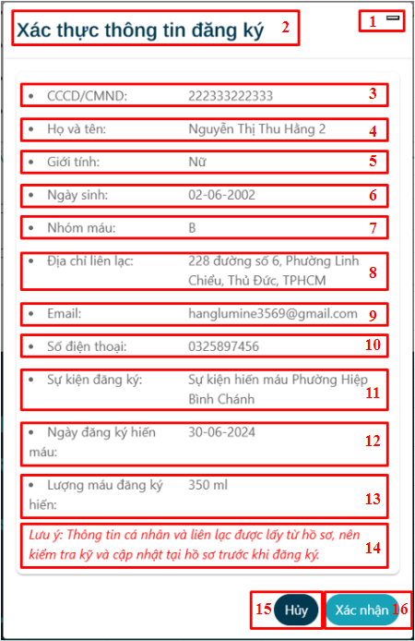

*Figure 3. 42 Screen Confirm register*

*Table 3. 29 Screen Confirm register description*

| **No.** | **Name** | **Type** | **Description** | **Action result** |
| --- | --- | --- | --- | --- |
| 1 | Title “Xác thực thông tin đăng ký” | Text | Display title confirm information |  |
| 2 | Button Close | Button | Close modal |  |
| 3 | Title citizen identify | Text | Display citizen identify number |  |
| 4 | Title “Họ và tên” | Text | Display full name |  |
| 5 | Title “Giới tính” | Text | Display gender |  |
| 6 | Title “Ngày sinh” | Text | Display birthday |  |
| 7 | Title”Nhóm máu” | Text | Display blood group |  |
| 8 | Title  “Địa chỉ liên lạc” | Text | Display address |  |
| 9 | Title  “Số điện thoại” | Text | Display phone number |  |
| 10 | Title “Email| | Text | Display email |  |
| 11 | Title  “Sự kiện đăng ký” | Text | Display registered event |  |
| 12 | Title “Ngày đăng ký hiến máu” | Text | Display blood donation registration date |  |
| 13 | Title “Lượng máu đăng ký” | Text | Display amount blood |  |
| 14 | Label information | Label | Display information |  |
| 15 | Button “Hủy” | Button | Close the modal |  |
| 16 | Button “Xác nhận” | Button | Confirm registered event |  |

**Screen 13: Reward page**

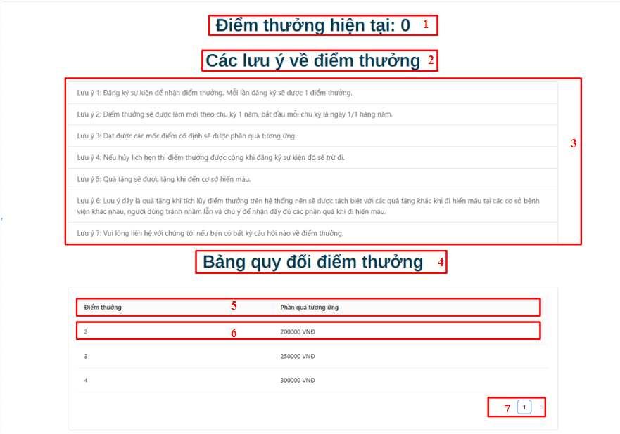

*Figure 3. 43 Screen Reward page*

*Table 3. 30 Screen Reward page description*

| **No.** | **Name** | **Type** | **Description** | **Action result** |
| --- | --- | --- | --- | --- |
| 1 | Title “Điểm thưởng hiện tại” | Text | Display title:  “Điểm thưởng hiện tại” |  |
| 2 | Title “Các lưu ý về điểm thưởng” | Text | Display title : “Các lưu ý về điểm thưởng” |  |
| 3 | Table information notice | Text | Display the notice |  |
| 4 | Title “Bảng quy đổi điểm thưởng” | Text | Display title “Bảng quy đổi điểm thưởng” |  |
| 5 | Table header rewards information | Text | Displays the header of the rewards table |  |
| 6 | Table contents reward information | Text | Displays the content of the rewards table |  |
| 7 | Pagination | Button | Displays pagination |  |

**Screen 14: Hospital/ Admin login page**

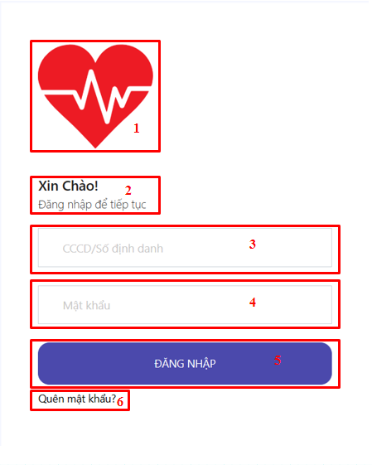

*Figure 3. 44 Screen Hospital/ Admin login page*

*Table 3. 31 Screen Hospital/ Admin login page description*

| **No.** | **Name** | **Type** | **Description** | **Action result** |
| --- | --- | --- | --- | --- |
| 1 | Image logo | Image | Display image |  |
| 2 | Title hello | Text | Display hello |  |
| 3 | Input citizen identify | Input | Enter citizen identify |  |
| 4 | Input password | Input | Enter password |  |
| 5 | Button “Đăng nhập” | Button | Login to admin or hospital page |  |
| 6 | Label “Quên mật khẩu” | Label | Display “quên mật khẩu” |  |

**Screen 15: Hospital/ Admin Dashboard Page**

* **Screen: Sidebar**

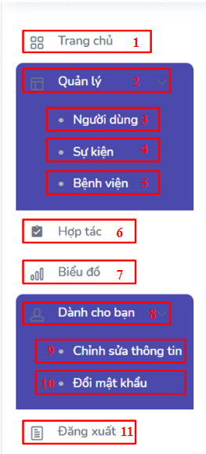

*Figure 3. 45 Screen Sidebar*

*Table 3. 32 Screen Sidebar description*

| **No.** | **Name** | **Type** | **Description** | **Action result** |
| --- | --- | --- | --- | --- |
| 1 | Link Dashboard | Link | Display “Dashboard” text and redirect to Dashboard Page when clicked |  |
| 2 | Link “Quản lý” | Link | Display “Quản lý” text and show dropdown when clicked |  |
| 3 | Link “Người dùng” | Link | Display “Người dùng” text and redirect to Account Management Page when clicked |  |
| 4 | Link “Sự kiện” | Link | Display “Sự kiện” text and redirect to Event Management Page when clicked |  |
| 5 | Link “Bệnh viện” | Link | Display “Bệnh viện” text and redirect to Hospital Management Page when clicked |  |
| 6 | Link “Hợp tác” | Link | Display “Hợp tác” text and redirect to Collaborator Hospital Management Page when clicked |  |
| 7 | Link “Dành cho bạn” | Link | Display “Dành cho bạn” text and show dropdown when clicked |  |
| 8 | Link “Chỉnh sửa thông tin” | Link | Display “Chỉnh sửa thông tin” text and redirect to Individual Page when clicked |  |
| 9 | Link “Đổi mật khẩu” | Link | Display “Đổi mật khẩu” text and redirect to Change Password Page when clicked |  |
| 10 | Link “Đăng xuất” | Link | Log out the system |  |

* **Screen Dashboard:**

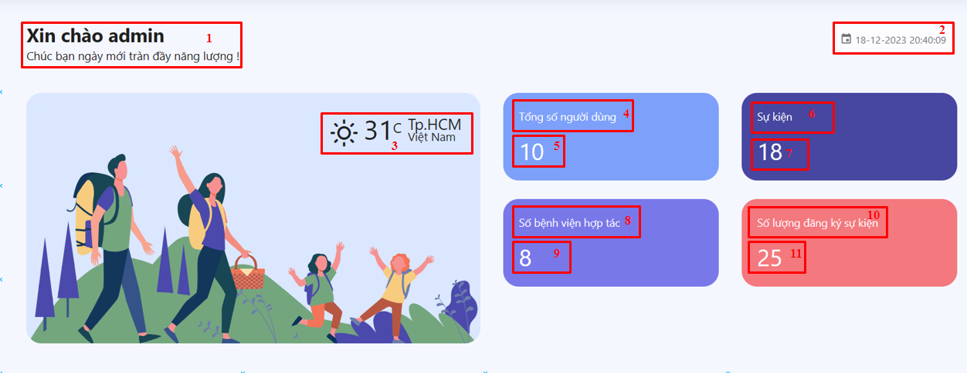

*Figure 3. 46 Screen Dashboard*

*Table 3. 33 Screen Dashboard description*

| **No.** | **Name** | **Type** | **Description** | **Action result** |
| --- | --- | --- | --- | --- |
| 1 | Title hello | Text | Display hello |  |
| 2 | Time and date | Datetime | Display current date time |  |
| 3 | Image introduction | Image | Display image |  |
| 4 | Title total of accounts | Text | Display title number of accounts |  |
| 5 | Number of accounts | Text | Display number of accounts |  |
| 6 | Title number of events | Text | Display title number of events |  |
| 7 | Number of events | Text | Display number of events |  |
| 8 | Title number of hospital collaborators | Text | Display title number of hospitals collaborators |  |
| 9 | Number of hospital collaborators | Text | Display number of hospital collaborators |  |
| 10 | Title number of users who registered event | Text | Display title number of users who registered event |  |
| 11 | Number of users who registered event | Text | Display number of users who registered event |  |

**Screen 16: Hospital Event Management**

* **Screen: List Events**

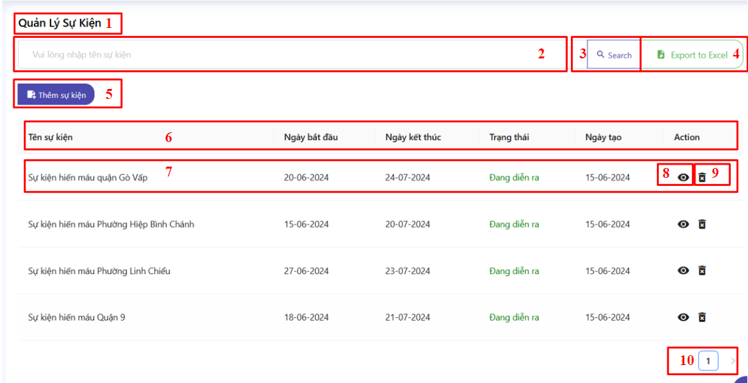

*Figure 3. 47 Screen List Events*

*Table 3. 34 Screen List Events description*

| **No.** | **Name** | **Type** | **Description** | **Action result** |
| --- | --- | --- | --- | --- |
| 1 | Title “Quản lý sự kiện” | Text | Display the title |  |
| 2 | Input search text | Input | Enter search text |  |
| 3 | Button Search | Button | Search event by name |  |
| 4 | Button import | Button | Display import button |  |
| 5 | Button “Thêm sự kiện” | Button | Add new event |  |
| 6 | Table menu | Table | Display information |  |
| 7 | Event information | Text | Display event information |  |
| 8 | Button view | Button | Display button and redirect to edit page when clicked |  |
| 9 | Button delete | Button | Display button and delete event when clicked |  |
| 10 | Number of page event | Text | Display pagination |  |

* **Screen: Add new Event**

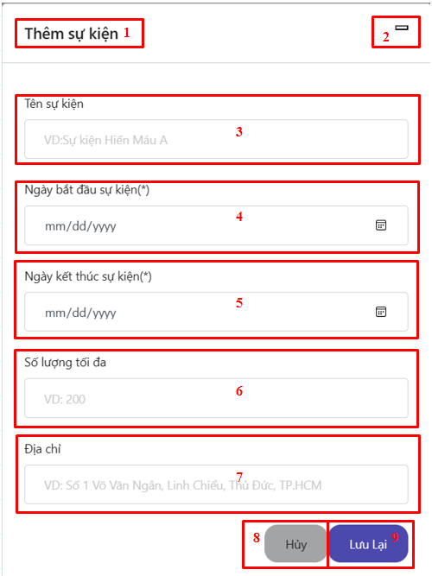

*Figure 3. 48 Screen Add new Event*

*Table 3. 35 Screen Add new Event description*

| **No.** | **Name** | **Type** | **Description** | **Action result** |
| --- | --- | --- | --- | --- |
| 1 | Title “Thêm sự kiện” | Text | Display the title |  |
| 2 | Button close | Button | Close modal add event |  |
| 3 | Input “Tên sự kiện” | Input | Enter event name |  |
| 4 | Input “Ngày bắt đầu sự kiện” | Input | Enter date start event |  |
| 5 | Input “Ngày kết thúc sự kiện” | Input | Enter date end event |  |
| 6 | Input “Số lượng tối đa” | Input | Enter maximum number of event registrants |  |
| 7 | Input “Địa chỉ” | Input | Enter event address |  |
| 8 | Button “Hủy” | Button | Close modal add event, cancel add event |  |
| 9 | Button “Lưu lại” | Button | Add event |  |

* **Screen: Edit event**

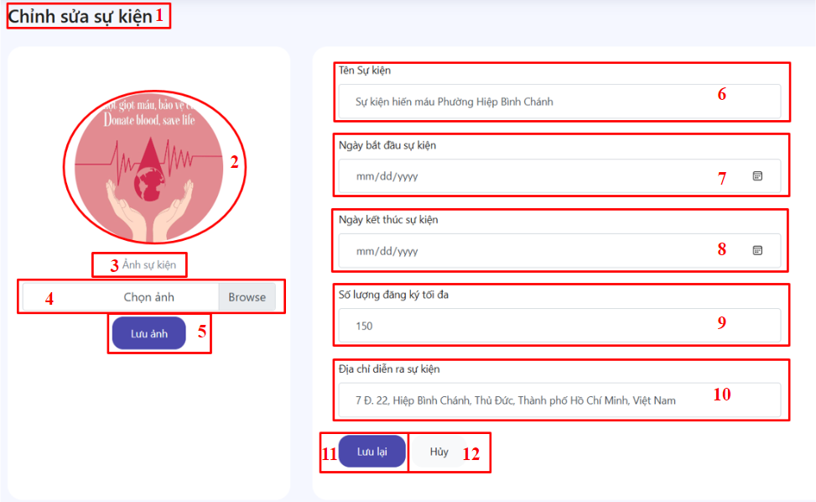

*Figure 3. 49 Screen Edit Event*

*Table 3. 36 Screen Edit description*

| **No.** | **Name** | **Type** | **Description** | **Action result** |
| --- | --- | --- | --- | --- |
| 1 | Title “Chỉnh sửa sự kiện” | Text | Display the title :“Chỉnh sửa sự kiện” |  |
| 2 | Image event | Image | Display event image |  |
| 3 | Label  “Ảnh sự kiện” | Label | Display label “Ảnh sự kiện” |  |
| 4 | Input image with file | Input | Enter the image |  |
| 5 | Button “Lưu ảnh” | Button | Display button |  |
| 6 | Input “Tên sự kiện” | Input | Enter event name |  |
| 7 | Input “Ngày bắt đầu sự kiện” | Input | Enter date start event |  |
| 8 | Input “Ngày kết thúc sự kiện” | Input | Enter date end event |  |
| 9 | Input “Số lượng tối đa” | Input | Enter maximum number of event registrants |  |
| 10 | Input “Địa chỉ” | Input | Enter event address |  |
| 11 | Button “Lưu lại” | Button | Edit event information |  |
| 12 | Button “Hủy” | Button | Close |  |

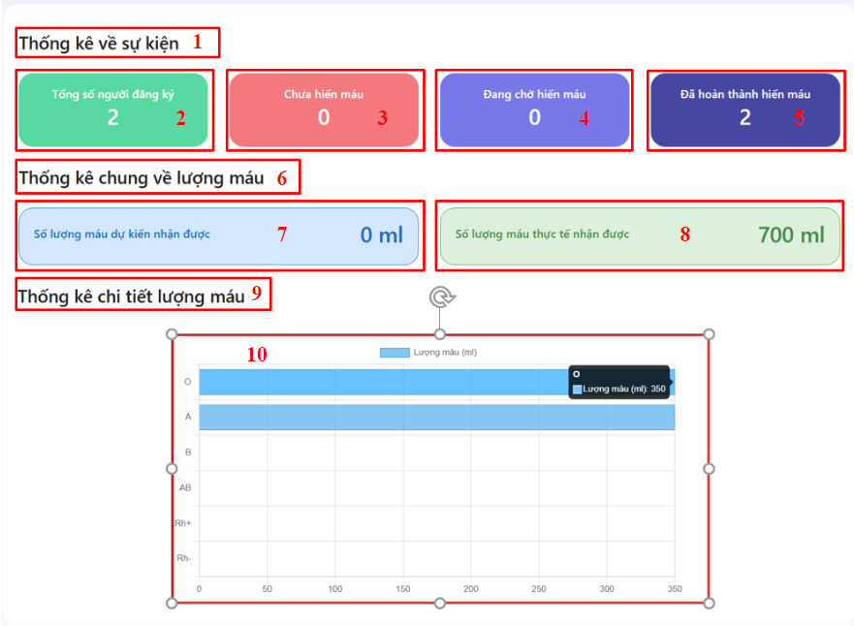

*Figure 3. 50 Screen Event statistics*

*Table 3. 37 Screen Event statistics description*

| **No.** | **Name** | **Type** | **Description** | **Action result** |
| --- | --- | --- | --- | --- |
| 1 | Title “Thống kê về sự kiện” | Text | Display title “ Thống kê về sự kiện” |  |
| 2 | Text “Tổng số người dùng” | Text | Display statistics about the total number of users who registered for this event. |  |
| 3 | Text “Chưa hiến máu” | Text | Display statistics about the number of users who have registered for the event but have not yet donated blood |  |
| 4 | Text “Đang chờ hiến máu | Text | Display statistics about the number of users registered for the event but waiting to donate blood |  |
| 5 | Text “Đã hoàn thành hiến máu” | Text | Display statistics on the number of event registrants who completed blood donations |  |
| 6 | Title “Thống kê chung về lượng máu” | Text | Display title “ Thống kê chung về lượng máu” |  |
| 7 | Text “Số lượng máu dự kiến nhận được” | Text | Displays the expected amount of blood received |  |
| 8 | Text “Số lượng máu thực tế nhận được” | Text | Displays the actual amount of blood received |  |
| 9 | Title “Thống kê chi tiết lượng máu nhận được” | Text | Display actual details of amount bloood |  |
| 10 | Chart | Text | Display a chart about detail amount blood that actual received |  |

**Screen 17: Admin Account Management**

* **Screen: List Accounts**

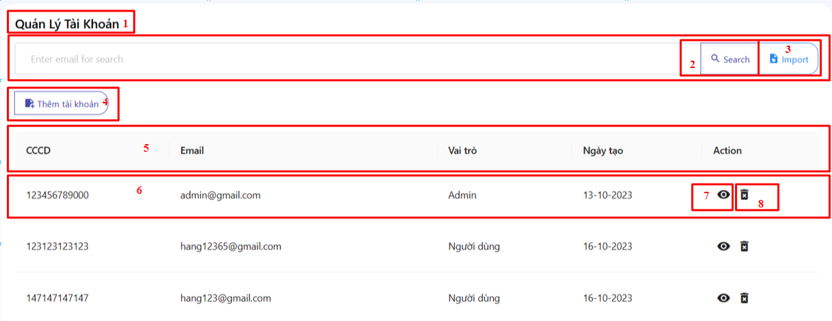

*Figure 3. 51 Screen List Accounts*

*Table 3. 38 Screen List Accounts description*

| **No.** | **Name** | **Type** | **Description** | **Action result** |
| --- | --- | --- | --- | --- |
| 1 | Title “Quản lý tài khoản” | Text | Display the title |  |
| 2 | Button Search | Button | Search event by name |  |
| 3 | Button import | Button | Display import button |  |
| 4 | Button “Thêm tài khoản” | Button | Add new account |  |
| 5 | Table menu | Table | Display information |  |
| 6 | Account information | Text | Display about account information |  |
| 7 | Button view | Button | Display button and redirect to edit page when clicked |  |
| 8 | Button delete | Button | Display button and delete account when clicked |  |

* **Screen: Add new account**

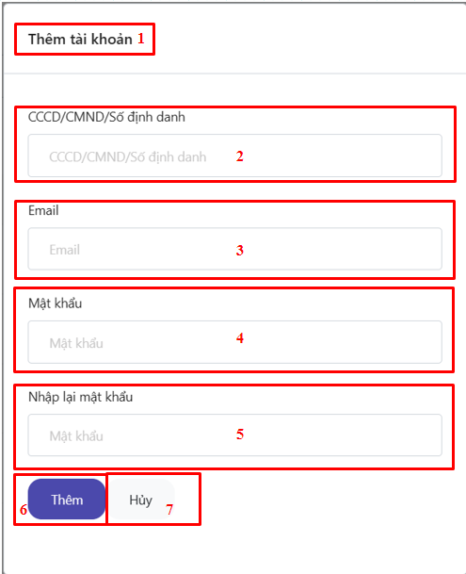

*Figure 3. 52 Screen Add new account*

*Table 3. 39 Screen Add new account description*

| **No.** | **Name** | **Type** | **Description** | **Action result** |
| --- | --- | --- | --- | --- |
| 1 | Title “Thêm tài khoản” | Text | Display the title |  |
| 2 | Input “CCCD/CMND” | Input | Enter the identification code |  |
| 3 | Input “Email” | Input | Enter email |  |
| 4 | Input “Mật khẩu” | Input | Enter the password |  |
| 5 | Input “Nhập lại mật khẩu” | Input | Enter the password |  |
| 6 | Button “Hủy” | Button | Close modal add account, cancel account |  |
| 7 | Button “Lưu lại” | Button | Add account |  |

* **Screen: Edit account**

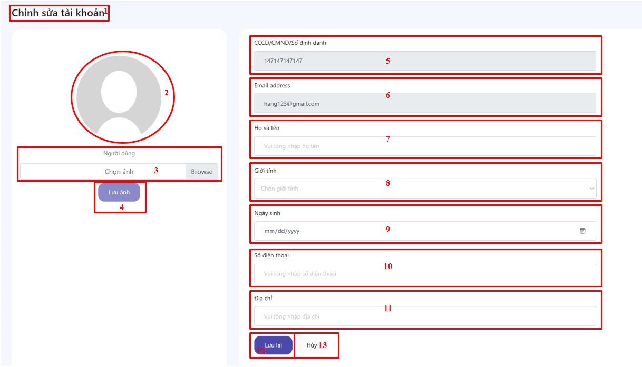

*Figure 3. 53 Screen Edit account*

*Table 3. 40 Screen Edit account description*

| **No.** | **Name** | **Type** | **Description** | **Action result** |
| --- | --- | --- | --- | --- |
| 1 | Title “Chỉnh sửa tài khoản” | Text | Display the title |  |
| 2 | Image avatar | Image | Display account avatar |  |
| 3 | Input file | Input | Input account avatar |  |
| 4 | Button “Lưu ảnh” | Button | Save account image |  |
| 5 | Input “CCCD/CMND” | Input | Only displays the identification code |  |
| 6 | Input “Email” | Input | Only displays the account's email |  |
| 7 | Input “Họ và tên” | Input | Enter full name |  |
| 8 | Input “Giới tính” | Input | Enter gender |  |
| 9 | Input “Ngày sinh” | Input | Enter birthday |  |
| 10 | Input “Số điện thoại” | Input | Enter the phone |  |
| 11 | Input “Địa chỉ” | Input | Enter address |  |
| 12 | Button “Lưu lại” | Button | Edit account |  |
| 13 | Button “Hủy” | Button | Close modal add account, cancel account |  |

**Screen 18: Admin Hospital Management**

* **Screen: List Hospitals**

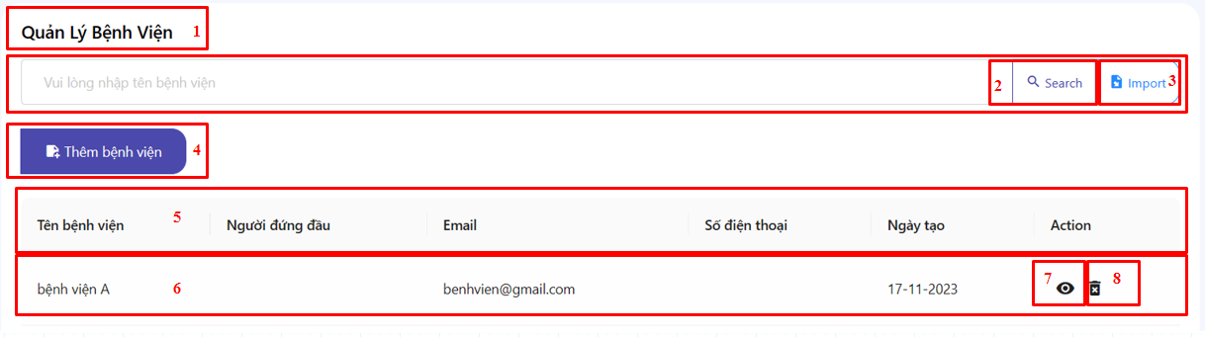

*Figure 3. 54 Screen List Hospitals*

*Table 3. 41 Screen List Hospitals description*

| **No.** | **Name** | **Type** | **Description** | **Action result** |
| --- | --- | --- | --- | --- |
| 1 | Title “Quản lý bệnh viện” | Text | Display the title |  |
| 2 | Button Search | Button | Search event by name |  |
| 3 | Button import | Button | Display import button |  |
| 4 | Button “Thêm bệnh viện” | Button | Add new hospital |  |
| 5 | Table menu | Table | Display information |  |
| 6 | Hospital information | Text | Display hospital information |  |
| 7 | Button view | Button | Display button and redirect to edit page when clicked |  |
| 8 | Button delete | Button | Display button and delete hospital when clicked |  |

* **Screen: Edit Hospital**

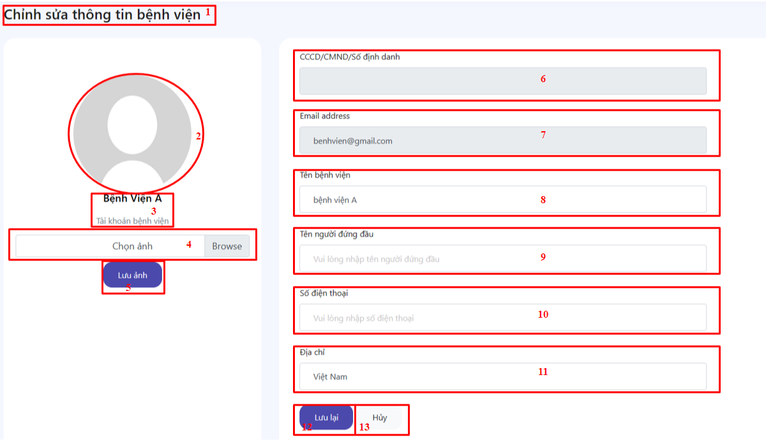

*Figure 3. 55 Screen Edit Hospital*

*Table 3. 42 Screen Edit Hospital description*

| **No.** | **Name** | **Type** | **Description** | **Action result** |
| --- | --- | --- | --- | --- |
| 1 | Title “Chỉnh sửa thông tin bệnh viện” | Text | Display the title |  |
| 2 | Image avatar | Image | Display account avatar |  |
| 3 | Title “Bệnh viện A” | Text | Display the title hospital name |  |
| 4 | Input file | Input | Input hospital avatar |  |
| 5 | Button “Lưu ảnh” | Button | Save hospital image |  |
| 6 | Input “CCCD/ CMND/ Số định danh” | Input | Only displays the identification code |  |
| 7 | Input “Email” | Input | Only displays the account's email |  |
| 8 | Input “Tên bệnh viện” | Input | Enter hospital name |  |
| 9 | Input “Tên người đứng đầu” | Input | Enter name of the head of the hospital |  |
| 10 | Input “Số điện thoại” | Input | Enter the phone |  |
| 11 | Input “Địa chỉ” | Input | Enter address |  |
| 12 | Button “Lưu lại” | Button | Edit hospital |  |
| 13 | Button “Hủy” | Button | Close modal add hospital , cancel hospital |  |

#### **3.5.2.2. Mobile Screens**

**Screen 1: Login User**

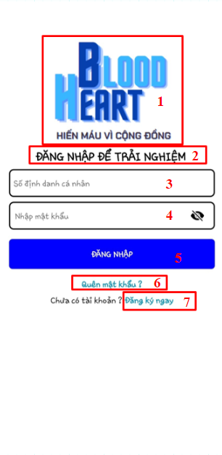

*Figure 3. 56 Screen Login User Mobile*

*Table 3. 43 Screen Login User Mobile description*

| **No.** | **Name** | **Type** | **Description** | **Action result** |
| --- | --- | --- | --- | --- |
| 1 | Image logo | Image | Display logo image |  |
| 2 | Title “Đăng nhập để trải nghiệm” | Text | Display title “Đăng nhập để trải nghiệm” |  |
| 3 | Input identify number | Input | Enter identify number |  |
| 4 | Input password | Input | Enter password |  |
| 5 | Button “Đăng nhập” | Button | Login to the system |  |

**Screen 2: Register User Mobile**

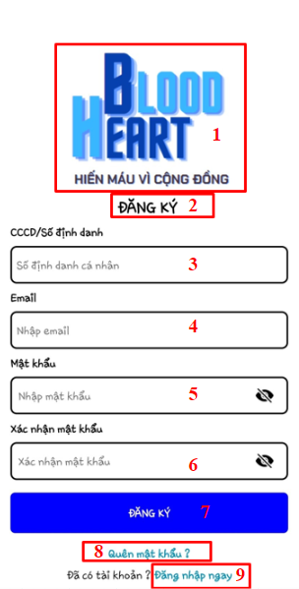

*Figure 3. 57 Screen Register User Mobile*

*Table 3. 44 Screen Register User Mobile description*

| **No.** | **Name** | **Type** | **Description** | **Action result** |
| --- | --- | --- | --- | --- |
| 1 | Image logo | Image | Display logo image |  |
| 2 | Title “Đăng nhập để trải nghiệm” | Text | Display title “Đăng nhập để trải nghiệm” |  |
| 3 | Input identify number | Input | Enter identify number |  |
| 4 | Input Email | Input | Enter email |  |
| 5 | Input password | Input | Enter password |  |
| 6 | Input confirm password | Input | Enter confirm password |  |
| 7 | Button “Đăng ký” | Button | Sign up |  |

**Screen 3: Forgot Password**

|  |  |  |
| --- | --- | --- |

*Figure 3. 58 Screen Forgot Password Mobile*

*Table 3. 45 Screen Forgot Password Mobile description*

| **No.** | **Name** | **Type** | **Description** | **Action result** |
| --- | --- | --- | --- | --- |
| 1 | Title “Quên mật khẩu” | Text | Display title “Quên mật khẩu” |  |
| 2 | Input identify number | Input | Enter identify number |  |
| 3 | Input Email | Input | Enter email |  |
| 4 | Button “Gửi mã” | Button | Send verify code to email |  |
| 5 | Input verify code | Input | Enter verify code |  |
| 6 | Button “Xác nhận mã” | Button | Navigate to the change password page if correct and show message if not |  |
| 7 | Title “Đặt lại mật khẩu” | Text | Display title “Đặt lại mật khẩu”. |  |
| 8 | Input new password | Input | Enter new password |  |
| 9 | Input confirm new password | Input | Re-enter the new password |  |
| 10 | Button “Xác nhận” | Button | Change password |  |

**Screen 4: Home Page User**

|  |  |  |
| --- | --- | --- |

*Figure 3. 59 Screen Home Page User Mobile*

*Table 3. 46 Screen Home Page User Mobile description*

| **No.** | **Name** | **Type** | **Description** | **Action result** |
| --- | --- | --- | --- | --- |
| 1 | Image logo | Image | Display image logo |  |
| 2 | Input search text | Input | Enter search text |  |
| 3 | Button Next | Button | Search with enter text |  |
| 4 | Slider Image | Slider | Display image in Slider |  |
| 5 | Title “Quyền lợi của người hiến máu” | Text | Display title “Quyền lợi của người hiến máu” |  |
| 6 | Information on blood donor privileges | Text, Image | Display information on the privileges of people who donate blood |  |
| 7 | Title “ Tiêu chuẩn tham gia hiến máu” | Text | Display title “Tiêu chuẩn tham gia hiến máu” |  |
| 8 | Minimum requirements to donate blood | Text | Display the requirements for donating blood |  |
| 9 | Title “Sự kiện nổi bật” | Text | Display title “Sự kiện nổi bật” |  |
| 10 | Image of the best event | Image | Display image of the best event |  |
| 11 | Event information | Text, Button | Display the best event information |  |
| 12 | Button Home | Button | Navigate to the home page when clicking |  |
| 13 | Button Event | Button | Navigate to the event page when clicking |  |
| 14 | Button Hospital | Button | Navigate to the hospital page when clicking |  |
| 15 | Button Personal | Button | Navigate to the personal page when clicking |  |

**Screen 5: Event Page User**

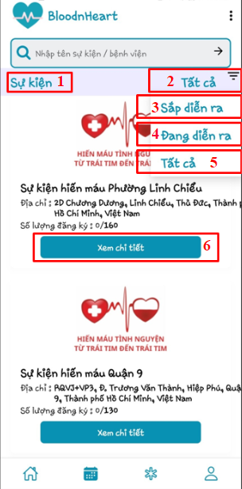

*Figure 3. 60 Screen Event Page User Mobile*

*Table 3. 47 Screen Event Page User Mobile description*

| **No.** | **Name** | **Type** | **Description** | **Action result** |
| --- | --- | --- | --- | --- |
| 1 | Title” Sự kiện” | Text | Display title  “Sự kiện” |  |
| 2 | Text selected “Tất cả” | Text | Display the options was selected | Shows all events |
| 3 | Dropdown option “Sắp diễn ra” | Dropdown | Button to display upcoming events |  |
| 4 | Dropdown option  “Đang diễn ra” | Dropdown | Button to display ongoing events | Shows events that are scheduled to occur soon |
| 5 | Dropdown option “Tất cả” | Dropdown | Button to display all events  (duplicate of No. 2) | Shows events that are currently happening |
| 6 | Button “Xem chi tiết” | Button | Button to view detailed information about a specific event | Opens event detailed page for the selected event |

**Screen 6: Cooperation Page**

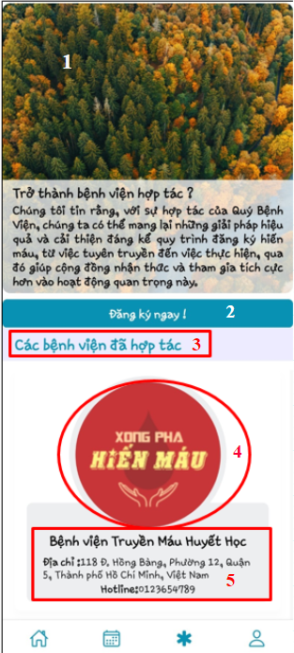

*Figure 3. 61 Screen Cooperation Page Mobile*

*Table 3. 48 Screen Cooperation Page Mobile description*

| **No.** | **Name** | **Type** | **Description** | **Action result** |
| --- | --- | --- | --- | --- |
| 1 | Banner image with information | Image | A banner image displaying an appealing visual related to the content |  |
| 2 | Button  “ Đăng ký ngay” | Button | Open registration form or page for partnership |  |
| 3 | Title “Các bệnh viện đã hợp tác” | Text | Display title “Các bệnh viện đã hợp tác” |  |
| 4 | Image hospital | Image | Display hospital image |  |
| 5 | Hospital information | Text | Display information about hospital collaboration |  |

**Screen 7: Register Event**

* **Screen: Detail event**

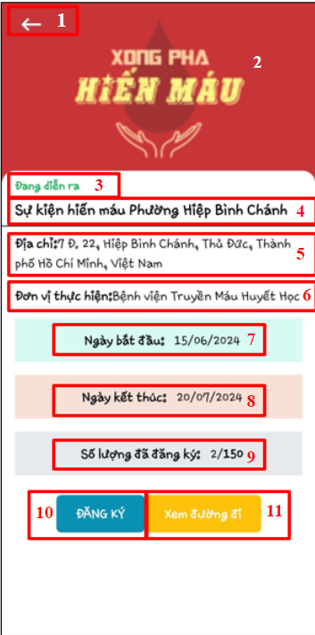

*Figure 3. 62 Screen Detail event Mobile*

*Table 3. 49 Screen Detail event Mobile description*

| **No.** | **Name** | **Type** | **Description** | **Action result** |
| --- | --- | --- | --- | --- |
| 1 | Button BACK | Button | Button to navigate back to the previous screen |  |
| 2 | Blood donation event image | Image | Display blood donation event image |  |
| 3 | Status of the event | Label | The label indicates the status of the event |  |
| 4 | Event Title | Text | Title of the blood donation event |  |
| 5 | Event Address | Text | Address where the blood donation event is being held |  |
| 6 | Organizing Unit | Text | Information about the unit organizing the event |  |
| 7 | Start Date | Text | Start date of the event |  |
| 8 | End Date | Text | End date of the event |  |
| 9 | Registered Participants | Text | Number of participants registered and total capacity |  |
| 10 | Button  “Đăng ký” | Button | Register for the event |  |
| 11 | Button “Xem đường đi” | Map | Button to view directions to the event location |  |

* **Screen: Register event**

|  |  |  |
| --- | --- | --- |

*Figure 3. 63 Screen Register event Mobile*

*Table 3. 50 Screen Register event Mobile description*

| **No.** | **Name** | **Type** | **Description** | **Action result** |
| --- | --- | --- | --- | --- |
| 1 | Title “Chọn lượng máu và ngày hiến máu” | Text | Display title |  |
| 2 | Donation Date | Date Picker | Select a donation date from the calendar |  |
| 3 | Amount blood | Dropdown | Select amount blood |  |
| 4 | Button “Tiếp tục” | Button | Proceed to the next step |  |
| 5 | Button “Hủy” | Button | Cancel and return to the previous step |  |
| 6 | Title “Xác nhận thông tin đăng ký” | Text | Display title “Xác nhận thông tin đăng ký” |  |
| 7 | Identify number | Text | Display identify number |  |
| 8 | Full Name | Text | Display full name |  |
| 9 | Gender | Text | Display gender |  |
| 10 | Date of Birth | Text | Display date of birth |  |
| 11 | Blood type | Text | Display blood type |  |
| 12 | Contact Address | Text | Display contact address |  |
| 13 | Email | Text | Display email address |  |
| 14 | Phone number | Text | Display phone number |  |
| 15 | Registered event | Text | Display registered event |  |
| 16 | Blood donation registration date | Text | Display registration date |  |
| 17 | Amount blood to donate | Text | Display amount blood to donate |  |
| 18 | Note | Text | Display note about information verification |  |
| 19 | Button “Xác nhận” | Button | Confirm information and proceed to the next step |  |
| 20 | Button “Hủy” | Button | Cancel and return to the previous step |  |
| 21 | Confirm completion of registration | Text | Display information to confirm completion |  |
| 22 | Button “Có” | Button | Confirm completion of registration |  |
| 23 | Button “Không” | Button | Not confirm completion and return to the previous step |  |

**Screen 8: Profile Page**

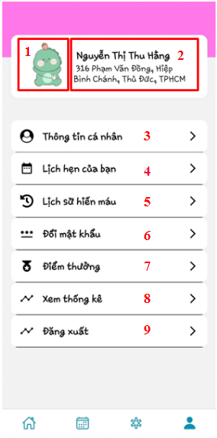

*Figure 3. 64 Screen Profile Page Mobile*

*Table 3. 51 Screen Profile Page Mobile description*

| **No.** | **Name** | **Type** | **Description** | **Action result** |
| --- | --- | --- | --- | --- |
| 1 | Avatar | Image | Displays the user's avatar |  |
| 2 | User Info | Text | Displays name and address |  |
| 3 | Personal information | Button | Go to personal information page |  |
| 4 | Your appointments | Button | Go to the user's appointment page |  |
| 5 | Blood donation history | Button | Go to the blood donation history page |  |
| 6 | Change password | Button | Go to the change password page |  |
| 7 | Rewards | Button | Go to bonus page |  |
| 8 | View statistics | Button | Go to statistics page |  |
| 9 | Log Out | Button | Sign out of your account |  |

**Screen 9: Individual Information Page**

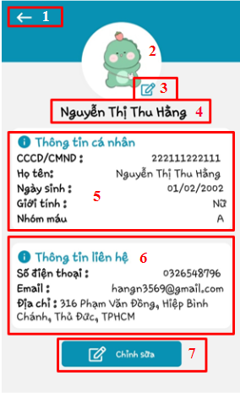

*Figure 3. 65 Screen Individual Information Page Mobile*

*Table 3. 52 Screen Individual Information Page Mobile description*

| **No.** | **Name** | **Type** | **Description** | **Action result** |
| --- | --- | --- | --- | --- |
| 1 | Back Button | Button | Return to the previous page |  |
| 2 | Avatar | Image | Displays the user's avatar |  |
| 3 | Edit Avatar | Button | Open the page to edit avatar |  |
| 4 | User Name | Text | Displays the user name |  |
| 5 | Personal Information  - Identify number  - Full Name  - Date of Birth  - Gender  - Blood Type | Section | Displays user's personal information:   * Display identify number * Displays full name * Show date of birth * Show gender * Show blood group |  |
| 6 | Contact Information  - Phone Number  - Email  - Address | Section | Displays the user's contact information   * Display phone number * Show emails * Show contacts * Open the page to edit information |  |
| 7 | Edit Button | Button | Open modal to edit individual information |  |

* **Screen: Edit Individual Information**

|  |  |
| --- | --- |

*Figure 3. 66 Screen Edit Individual Information Mobile*

*Table 3. 53 Screen Edit Individual Information Mobile description*

| **No.** | **Name** | **Type** | **Description** | **Action result** |
| --- | --- | --- | --- | --- |
| 1 | Profile picture label | Label | Show label "Avatar photo" |  |
| 2 | Profile picture | Image | Displays the user's avatar |  |
| 3 | Choose image button | Button | Open the browser to select an avatar |  |
| 4 | Save button | Button | Save changes |  |
| 5 | Cancel button | Button | Cancel changes and return to the previous page |  |
| 6 | Edit personal information | Text | Show title "Edit personal information" |  |
| 7 | Identify number | Text | Display identify number |  |
| 8 | Full Name | Text | Displays first and last name |  |
| 9 | Date of Birth | Text | Show date of birth |  |
| 10 | Gender | Dropdown | Choose gender |  |
| 11 | Blood type | Dropdown | Choose your blood type |  |
| 12 | Email | Text | Show emails |  |
| 13 | Phone number | Text | Display phone number |  |
| 14 | Address | Text | Show contacts |  |
| 15 | Save changes button | Button | Save changes |  |

**Screen 10: Schedule Page**

|  |  |
| --- | --- |

*Figure 3. 67 Screen Schedule Page Mobile*

*Table 3. 54 Screen Schedule Page Mobile description*

| **No.** | **Name** | **Type** | **Description** | **Action result** |
| --- | --- | --- | --- | --- |
| 1 | Back Button | Button | Return to the previous page |  |
| 2 | Title “Lịch hẹn của bạn” | Label | Display title “Lịch hẹn của bạn” |  |
| 3 | Warning message | Label | Show notification alerts |  |
| 4 | Table header | Header | Display column headers: event name, address, blood donation date, action |  |
| 5 | Event information | Table Row | Display event information: event name, address, blood donation date |  |
| 6 | Edit button | Button | Open the modal to edit event information |  |
| 7 | Delete button | Button | Remove events from the calendar |  |
| 8 | Label “Chọn ngày hiến máu” | Label | Display label “Chọn ngày hiến máu” |  |
| 9 | Donation date picker | Date Picker | Allows users to choose blood donation day |  |
| 10 | Update Button | Button | Update blood donation day selection |  |

**Screen 11: History donation and Certification Page**

|  |  |
| --- | --- |

*Figure 3. 68 Screen History donation and Certification Page Mobile*

*Table 3. 55 Screen History donation and Certification Page Mobile description*

| **No.** | **Name** | **Type** | **Description** | **Action result** |
| --- | --- | --- | --- | --- |
| 1 | Back Button | Button | Return to the previous page |  |
| 2 | Title “Lịch hẹn của bạn” | Label | Display title “Lịch hẹn của bạn” |  |
| 3 | Table header | Header | Display column titles: event name, address, blood donation date, view e-Certificate |  |
| 4 | Event information | Table row | Display row contents: event name, address, blood donation date, view e-Certificate |  |
| 5 | View e-Certificate button | Button | Open e-certificate screen |  |
| 6 | E-certificate image | Image | Show e-certificate |  |
| 7 | Download button | Button | Download e-certificate |  |
| 8 | Button cancel view e-certificate | Button | Code e-certificate screens |  |

**Screen 12: Reward Page**

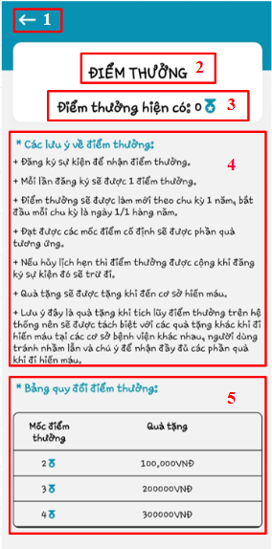

*Figure 3. 69 Screen Reward Page Mobile*

*Table 3. 56 Screen Reward Page Mobile description*

| **No.** | **Name** | **Type** | **Description** | **Action result** |
| --- | --- | --- | --- | --- |
| 1 | Back Button | Button | Return to the previous page |  |
| 2 | Title “Điểm thưởng” | Text | Display title “Điểm thưởng” |  |
| 3 | Label:“Điểm thưởng hiện có” | Text | Display bonus points available |  |
| 4 | Notes on reward points | Text | Show information about rewards notes |  |
| 5 | Reward points conversion table | Table | Show bonus point conversion table |  |

**Screen 13: Home Page Hospital**

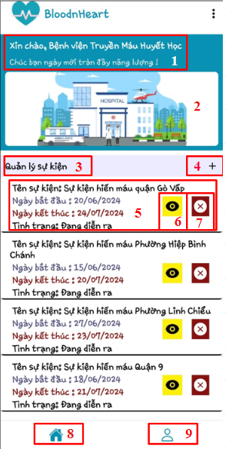

*Figure 3. 70 Screen Home Page Hospital Mobile*

*Table 3. 57 Screen Home Page Hospital Mobile description*

| **No.** | **Name** | **Type** | **Description** | **Action result** |
| --- | --- | --- | --- | --- |
| 1 | Welcome message | Text | Display welcome message |  |
| 2 | Main image | Image | Display main image |  |
| 3 | Text “Quản lý sự kiện” | Text | Display title “Quản lý sự kiện” |  |
| 4 | Button add event | Button | Open modal to add a new event |  |
| 5 | Detail events | Text | Details of the event, including name, start date, end date, and status. |  |
| 6 | Button view event | Button | Open detail event |  |
| 7 | Button delete | Button | Delete the event from the lists |  |
| 8 | Button home | Button | Redirects to the home page |  |
| 9 | Button user profile | Button | Redirects to the user profile |  |

**Screen 14: Add new Event**

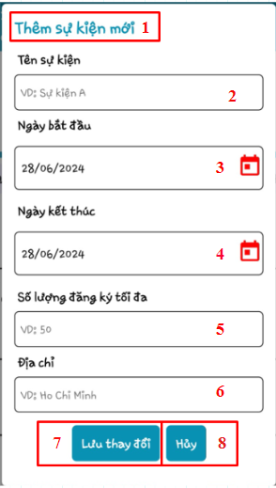

*Figure 3. 71 Screen Add new Event Mobile*

*Table 3. 58 Screen Add new Event Mobile description*

| **No.** | **Name** | **Type** | **Description** | **Action result** |
| --- | --- | --- | --- | --- |
| 1 | Add new event label | Label | Display add new event label |  |
| 2 | Input event name | Input | Enter the name of the event. |  |
| 3 | Input start date | Input | Select the start date of the event. |  |
| 4 | Input end date | Input | Select the enddate of the event. |  |
| 5 | Input max registrations | Input | Enter the maximum number of registrations. |  |
| 6 | Input address | Input | Enter address of the event |  |
| 7 | Button “Lưu lại” | Button | Saves the event details |  |
| 8 | Button “Hủy” | Button | Discards changes and goes back. |  |

**Screen 15: Detail, Edit Event and Update Status User**

|  |  |  |
| --- | --- | --- |

*Figure 3. 72 Screen Detail, Edit Event and Update Status User Mobile*

*Table 3. 59 Screen Detail, Edit Event and Update Status User Mobile description*

| **No.** | **Name** | **Type** | **Description** | **Action result** |
| --- | --- | --- | --- | --- |
| 1 | Back Button | Button | Return to the previous page |  |
| 2 | Title “Thông tin sự kiện” | Text | Display title “Thông tin sự kiện” |  |
| 3 | Blood donation event image | Image | Display blood donation event image |  |
| 4 | Event title | Text | Title of the blood donation event |  |
| 5 | Event address | Text | Address where the blood donation event is being held |  |
| 6 | Start Date | Text | Start date of the event |  |
| 7 | End Date | Text | End date of the event |  |
| 8 | Registered participants | Text | Number of participants registered and total capacity |  |
| 9 | Button Edit | Button | Opens the event edit form. |  |
| 10 | Label : “Danh sách đăng ký sự kiện” | Label | Display label “Danh sách đăng ký sự kiện” |  |
| 11 | Table content | Table row | Display table content : detail of individual registrations including name, time, and status. |  |
| 12 | Edit button | Button | Edit status of registrants |  |
| 13 | Edit event label | Label | Display label |  |
| 14 | Input event name | Input | Enter the name of the event. |  |
| 15 | Input start date | Input | Select the start date of the event. |  |
| 16 | Input end date | Input | Select the enddate of the event. |  |
| 17 | Input max registrations | Input | Enter the maximum number of registrations. |  |
| 18 | Input address | Input | Enter address of the event |  |
| 19 | Button “Lưu lại” | Button | Saves the event details |  |
| 20 | Button “Hủy” | Button | Discards changes and goes back. |  |
| 21 | Update status label | Label | Display update status label |  |
| 22 | Status dropdown | Dropdown | Allows the hospital to select the event status. |  |
| 23 | Cancel status update button | Button | Discards status update and goes back. |  |
| 24 | Save status update button | Button | Saves the status update. |  |

# **CHAPTER 4: SYSTEM IMPLEMENTATION**

## **4.1. Environment**

Technologies and environments used by the system:

* Programming languages: JavaScript
* Backend Framework:Node.js with Express.js
* Frontend Framework: ReactJs, React Native
* Database: MongoDB.
* Working environment: Visual Studio Code,
* Operating system: Windows 10, Window 11

## **4.2. Technology**

### **4.2.1. ReactJs**

*****Figure 4. 1 ReactJs*

ReactJS is JavaScript library used for building reusable UI components. [1] React is a library for building composable user interfaces. It encourages the creation of reusable UI components, which present data that changes over time. Lots of people use React as the V in MVC. React abstracts away the DOM from you, offering a simpler programming model and better performance. React can also render on the server using Node, and it can power native apps using React Native. React implements one-way reactive data flow, which reduces the boilerplate and is easier to reason about than traditional data binding. [1]

The declarative model used by ReactJS enables applications to be both efficient and adaptable. Every state in your application is given a basic view, and as your data changes, it quickly updates and renders the appropriate component. Your code is easier to debug and more predictable when written in a declarative perspective. In a React application, every component is in charge of displaying a distinct yet reusable HTML code segment. Simple building blocks may be used to create complicated applications because to the ability to stack components inside other components. A TabList component, for instance, can store a variable for the active tab in memory. A component can also maintain track of its internal state. [2]

### **4.2.2.MongoDB**



*Figure 4. 2 MongoDb*

One kind of NoSQL database is document-oriented databases, like mongoDB. MongoDB uses a very flexible architecture called BSON in place of a relational database's table-based structure in order to accommodate documents like JSON. MongoDB stores data in documents that resemble JSON, allowing collections of varying sizes and numbers of documents. Because the data is saved in a JSON document format, queries may be completed quickly.

Advantages of MongoDB:

* Schema migration is required for MongoDB, is a database without schemas.
* Document queries are used because it is a document-oriented language, which is important for allowing dynamic queries.
* In comparison to other relational databases, performance optimization is simple.
* Due to the way it uses internal memory for data storage, it enables quick access to data.

Disadvantages of MongoDB:

* It does not support joins the way a relational database does. But join capability may be manually added to the page with the proper code. But it could cause execution to slow and impact performance.
* MongoDB stores the key names of each value pair. Also, data redundancy occurs as a result of joins’ limitations. As a result, memory is seen more often than is required. [3]

### **4.2.3. Express**



*Figure 4. 3 Express*

Express.js is a web application framework for Node.js, a server-side JavaScript runtime. It is designed to simplify the process of building web applications and APIs by providing a set of features and tools for handling common web development tasks. Express is known for being minimalist, unopinionated, and highly flexible, allowing developers to structure their applications in a way that makes sense for their specific needs.Express.js was created to make it easier to create reliable, scalable, and maintainable web apps. The following are some benefits and drawbacks of utilizing Express.js [4]

Benefits of ExpressJs

* Flexibility: Express.js is minimalistic, providing developers with the flexibility to structure their applications as they see fit.
* Middleware Support: The middleware architecture allows for modular and reusable code for tasks like authentication, logging, and error handling.
* Robust Routing: Express provides a powerful and flexible routing system, making it easy to define routes for different HTTP methods and handle various request patterns.
* Active Community: A large and active community provides abundant documentation, tutorials, and third-party modules, contributing to a rich ecosystem.
* Performance: Known for its lightweight nature, Express.js offers good performance suitable for both small and large-scale applications.

Drawbacks of Express.js:

* Lack of Structure: The minimalistic approach can result in inconsistent project structures for larger applications if not carefully managed.
* Learning Curve: Beginners may face challenges understanding concepts like middleware, routing, and asynchronous programming, leading to a learning curve.
* Callback Hell (Async Callbacks): Asynchronous programming with callbacks can lead to nested structures, requiring careful management to avoid callback hell.

### **4.2.4. NodeJs**



*Figure 4. 4 NodeJs*

Node, sometimes referred to as Node.js, is an open-source, cross-platform runtime environment that enables programmers to create a variety of server-side JavaScript tools and applications. The runtime is not intended for usage in a browser, but rather for direct use on a PC or server operating system. As such, the environment does not offer browser-specific JavaScript APIs, but instead supports more traditional OS APIs like file system libraries and HTTP. Owing to its architecture, Node.js is comparatively light-weight and efficient, making it a great tool for distributed applications handling real-time, data-intensive activities. Building ad servers, Websocket servers, fast file upload clients, RESTful APIs, cloud services, and any real-time data application are among the many uses for Node.js.

The advantage of NodeJs :

* better efficiency and overall developer productivity
* code sharing and reuse
* speed and performance
* easy knowledge sharing within a team
* a huge number of free tools

The disadvantage of NodeJs:

* Reduces performance when handling Heavy Computing Tasks
* Node.js invites a lot of code changes due to Unstable API
* Node.js Asynchronous Programming Model makes it difficult to maintain code
* Choose Wisely – Lack of Library Support can Endanger your Code
* High demand with a few Experienced Node.js Developers [5]

### **4.2.5. React Native**



*Figure 4. 5 React Native*

React Native is an open-source framework developed by Facebook that allows developers to build mobile applications using JavaScript and React. It enables code reuse across platforms, minimizing the time and effort required for mobile app development on both iOS and Android platforms.

React Native was first introduced in 2015 by Facebook as an extension of React, a popular JavaScript library for building user interfaces. Since then, it has become one of the most widely used mobile app development tools in the market. React Native is continuously updated and improved to meet increasing demands for performance and features.

React Native provides a flexible approach to mobile app development. It allows the use of native UI components of the operating system while maintaining a shared codebase across platforms. This optimizes the development and maintenance process, while minimizing issues related to maintaining source code for different platforms.

The advantage of React Native:

* Cross-platform development saves time and resources.
* Reusable components enhance consistency and efficiency.
* Hot reloading speeds up development and debugging.
* Large community and ecosystem provide ample resources and support.
* Good performance for most typical mobile applications.

The disadvantage of React Native:

* Limited access to some native features may require custom native code.
* Performance may be limited for complex or high-performance apps.
* Platform-specific issues may arise, requiring additional effort.
* Dependency on third-party modules introduces risks and maintenance overhead.

# **CHAPTER 5: VALIDATION AND DEPLOYMENT**

## **5.1. Test case Design**

### **5.1.1. Admin**

**5.1.1.1. TestCase login at admin page with user role**

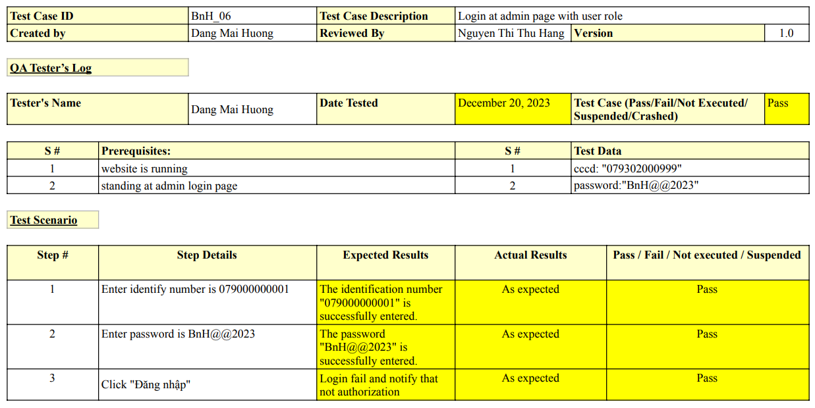

*Figure 5. 1 TestCase login at admin page with user role*

**5.1.1.2. TestCase admin view list of accounts**

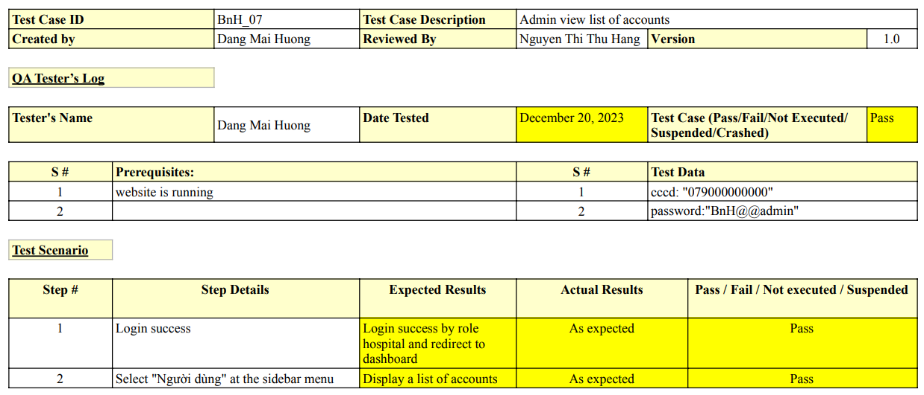

*Figure 5. 2 TestCase admin view list of accounts*

**5.1.1.3. TestCase hospital view list of accounts**

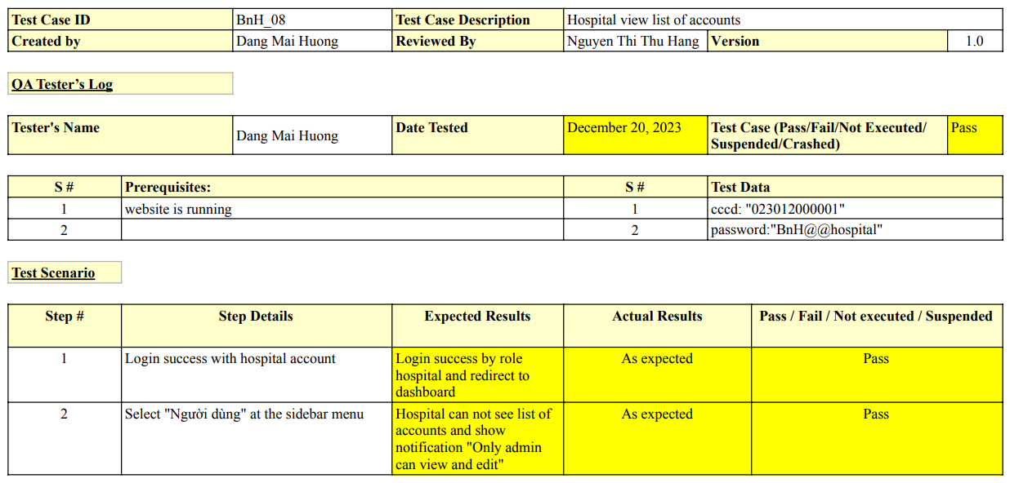

*Figure 5. 3 TestCase hospital view list of accounts*

### **5.1.2. Hospital**

**5.1.2.1. TestCase hospital add new event**

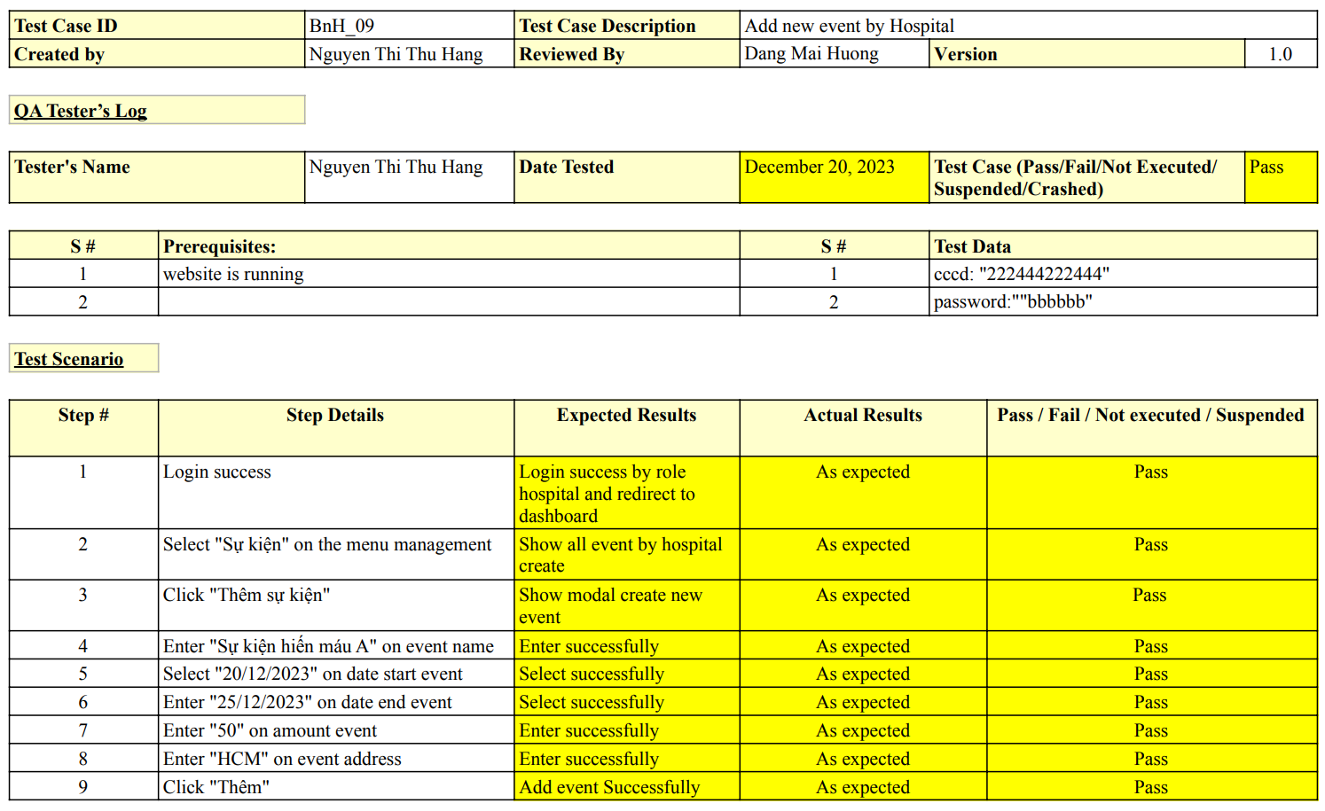

*Figure 5. 4 TestCase hospital add new event*

### **5.1.3. User**

**5.1.3.1. TestCase login user**

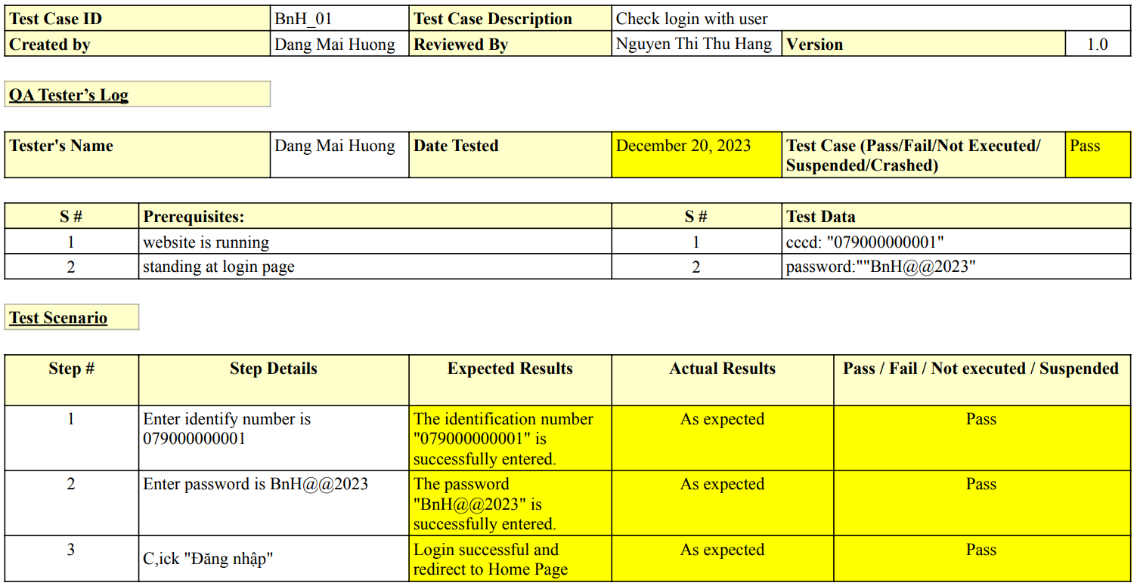

*Figure 5. 5 TestCase login user*

**5.1.3.2. TestCase register new user account**

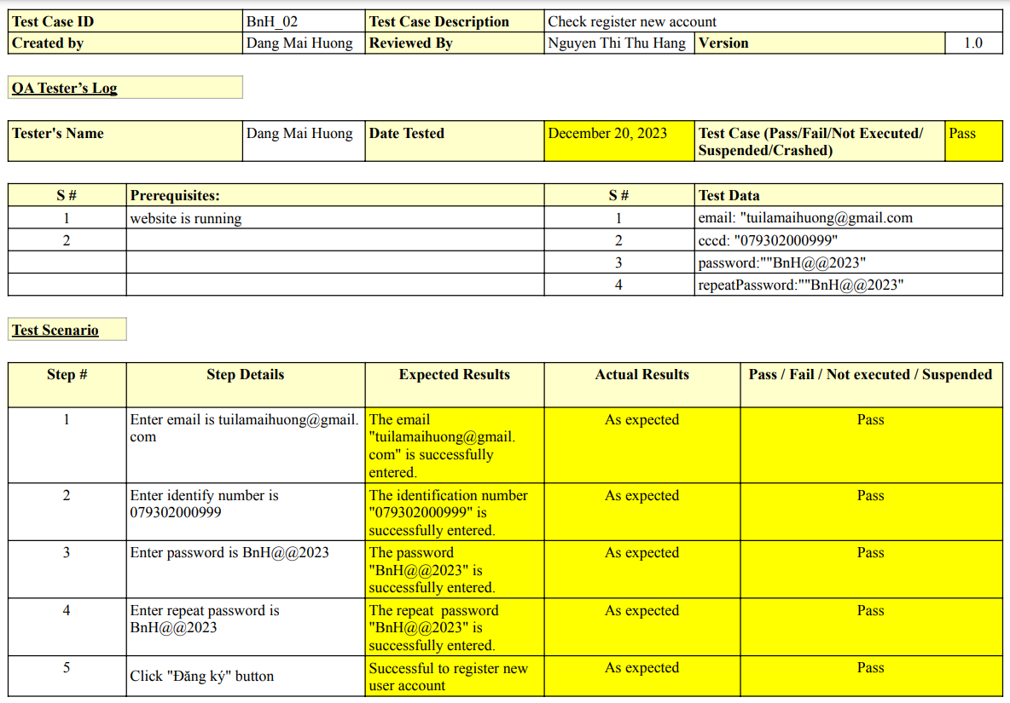

*Figure 5. 6 TestCase register new user account*

**5.1.3.3. TestCase register for an event without being logged in**

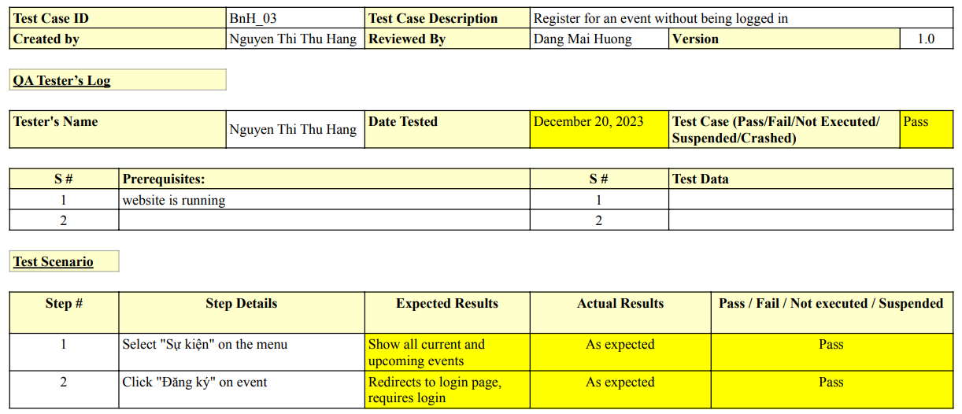

*Figure 5. 7 TestCase register for an event without being logged in*

**5.1.3.4. TestCase register for an event being logged in**

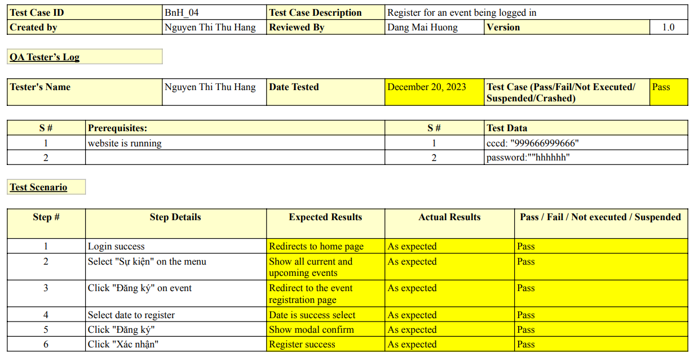

*Figure 5. 8 TestCase register for an event being logged in*

**5.1.3.5. Test case update schedule register donation blood**

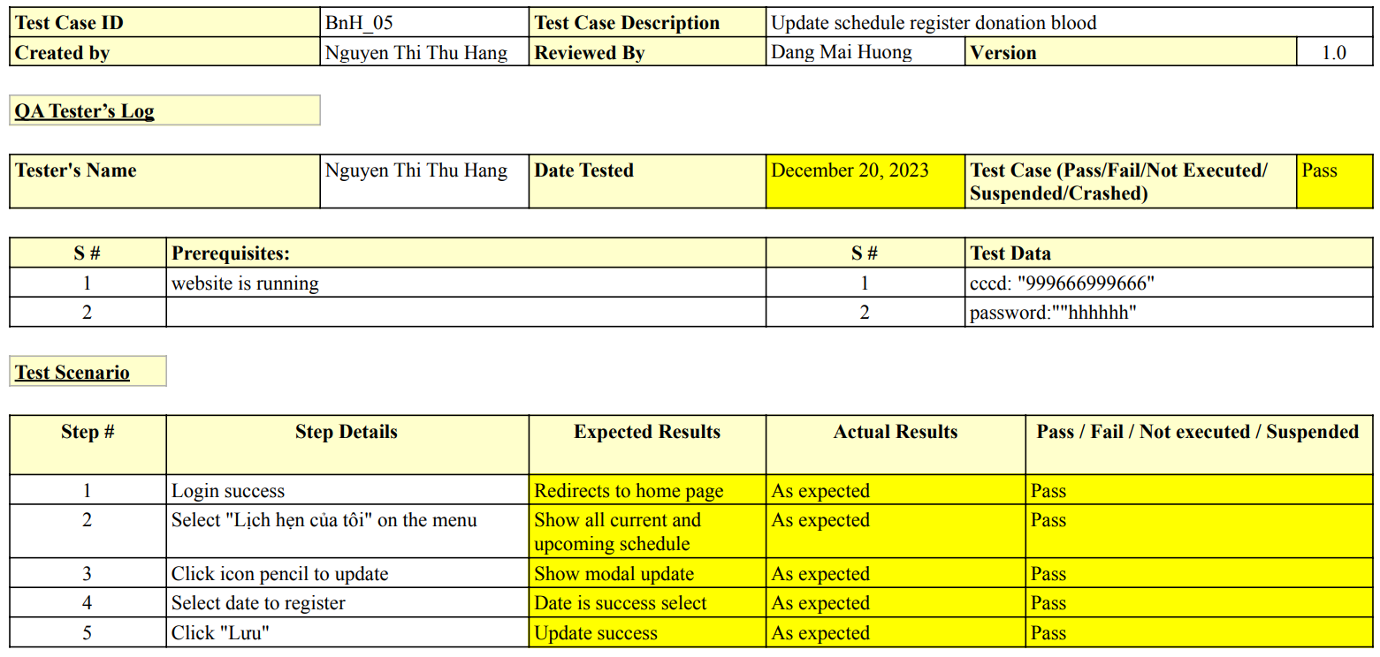

*Figure 5. 9 Test case update schedule register donation blood*

## **5.2. Deployment**

### **5.2.1. Hardware requirements**

*Table 5. 1 Hardware requirements*

| **Server** | **Minimum Requirements** | **Recommended** |
| --- | --- | --- |
| **Internet Connection** | Cable, Wi-Fi (20 Mbps) | Cable, Wi-Fi (50 Mbps or more) |
| **Operating System** | Debian 9 x64 | Debian 10 x64 |
| **Computer Processor** | Intel® Core i3 1.4GHz | Intel® Core i5 2.5GHz |
| **Computer Memory** | 1GB RAM | 4GB or more |
| **Storage space** | 15GB | 25GB or more |

### **5.2.2. Software requirements**

*Table 5. 2 Software requirements*

| **Name** | **Name/Version** | **Description** |
| --- | --- | --- |
| **Environment** | Node.js v20.5.0 | Specification for developing web application |
| **Operating System** | Linux | Operating system and platform for development |
| **Database management** | mongoDb | Used to create & manage the database for system |
| **Web server** | Express.js | Deployment environment |
| **Web browser** | Chrome | Testing browser |

### **5.2.3. System installation**

#### **5.3.2.1. Run web application mobile application**

To run the web application, your computer must meet the following requirements:

- Install npm.

- Install ReactJS

- Install MongoDB.

- Install Git.

- Install Visual Studio Code.

- Install Expo on your mobile

- Have Windows Terminal or Command Prompt.

**Steps to implement the project:**

**Step 1:** Clone or download project from github link:

Web source code: <https://github.com/maihuongg/BloodnHeart.git>

API : <https://github.com/maihuongg/BnH_API>

**Step 2**: Run server

* Open the server folder in the terminal: **cd server**
* Install npm: **npm install**
* Install account admin:

+ **cd utils**

+ **node generateAdmin.js**

* Start the server: **npm start**

**Step 3:** Run client

* Open the client folder in the terminal: **cd client**
* Install npm: **npm install**
* Start the client: **npm start**

**Step 4:** Run admin

* Open the admin folder in the terminal: **cd** admin
* Install npm: **npm install**
* Start the admin: **npm start**

#### **5.3.2.2. Run mobile applications.**

**To run the application, your computer must meet the following equirements:**

**-** Install Redux in browse.

- Install npm.

- Install ReactJS.

- Install MongoDB.

- Install Git.

- Install Visual Studio Code.

- Install Expo in Android or IOS

- Have Windows Terminal or Command Prompt.

**Steps to implement the project:**

**Step 1:** Clone or download project from github link:

[https://github.com/maihuongg/BnHApp.git](https://github.com/maihuongg/BloodnHeart.git)

**Step 2**: Run server

* Open the server folder in the terminal: **cd server**
* Install npm: **npm install**
* Install account admin:

+ **cd utils**

+ **node generateAdmin.js**

* Start the server: **npm start**

**Step 3:** Run application for User

* At the root folder in the terminal:
* Install npm: **npm install**
* Start the application : **npm start**
* Use Expo in Android or IOS to scan QR code

**Step 4:** Run Hospital Application for Hospital

* Clone repository at [https://github.com/maihuongg/BloodnHeartHospital.git](https://github.com/maihuongg/BloodnHeart.git)
* Install npm: **npm install**
* Start the hospital’s role: **npm start**
* Use Expo in Android or IOS to scan QR code

**Step 5:** Run Admin Application

* Clone repository at <https://github.com/maihuongg/BloodnHeart.git>
* Go to admin folder: **cd admin**
* Install npm: **npm install**
* Start the admin (only on Website): **npm start**

### **5.2.4. Deploy web with Vercel**

- Deploy front-end and back-end using VERCEL.

**5.2.4.1. Deploy Back-end.**

**Step 1:** Create and config file vercel.json in folder Backend following with image below

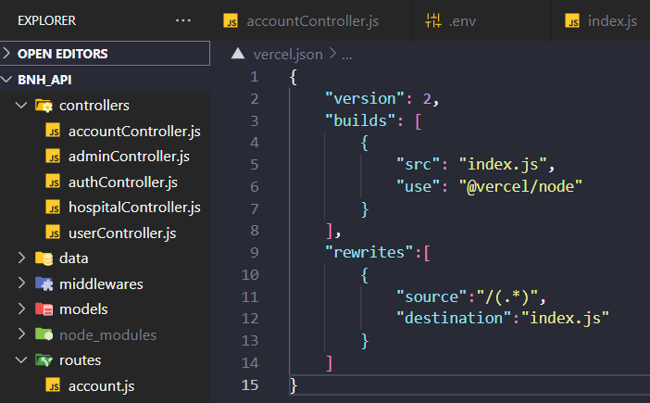

*Figure 5. 10 Config vercel.json*

**Step 2: Log in to Vercel: Go to Vercel and log in**

**Step 3**: Start a New Project: Select "Import Project" or "New Project" from the dashboard to start a new project.

**Step 4:** Select the Project to Be Deployed: On GitHub, the import project is stored.

**Step 5:** Set Up the Deployment :

* Project Name: bn-h-api
* Framework Preset: Other
* Root Directory: ./
* Git Repository:
* User: maihuongg
* Repository: BnH_API
* Branch: main
* Path: ./
* Environment Variables: copy all environment variables on .env

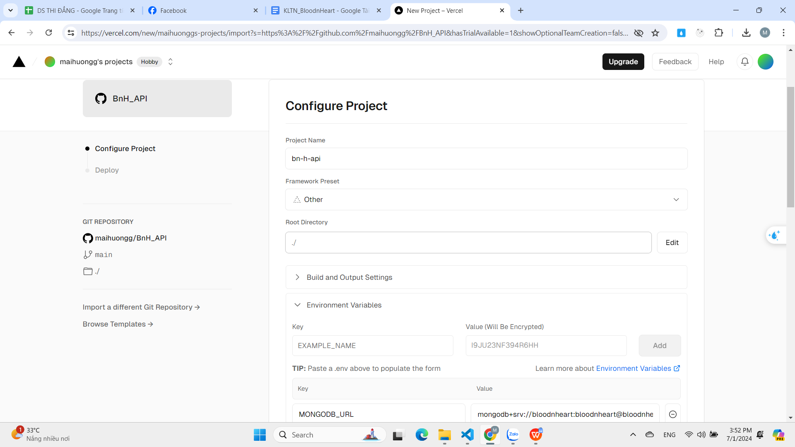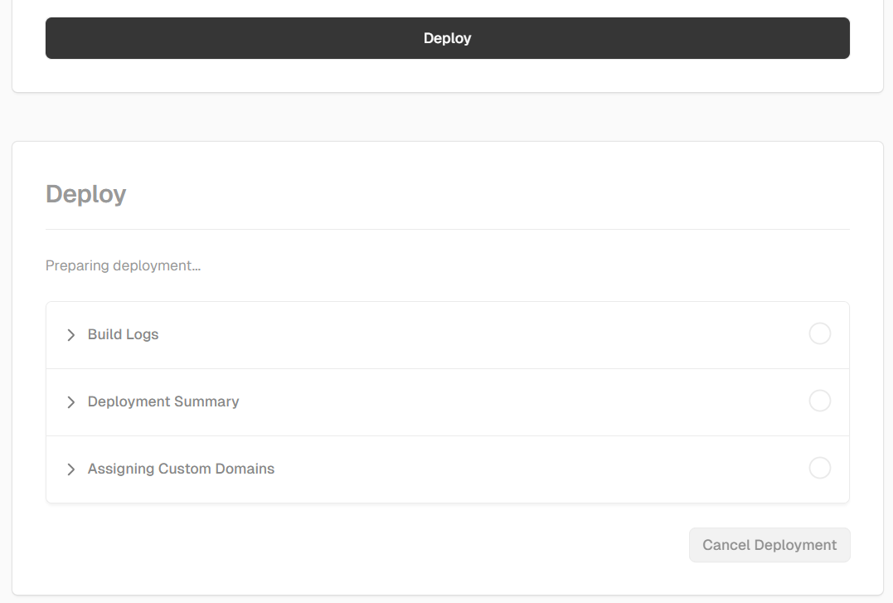

*Figure 5. 11 Configure project*

**Step 6:** Click "Deploy" to begin the deployment procedure after setup. Vercel will take care of the construction and deployment procedures automatically.

* Upon completion, a URL for your website will be sent to us. The Vercel dashboard allows us to manage deployments and monitor their progress.
* This procedure enables simple deployment using the Vercel web interface and does not need the use of the command line.
* Link deployment back-end: <https://bn-h-api.vercel.app/v1/>

**5.2.4.2. Deploy Front-end.**

**Step 1**: Start a New Project: Select "Import Project" or "New Project" from the dashboard to start a new project.

**Step 2:** Log in to Vercel: Go to Vercel and log in

**Step 3:** Start a New Project: Select "Import Project" or "New Project" from the dashboard to start a new project.

**Step 4:** Select the Project to Be Deployed: On GitHub, the import project is stored.

**Step 5: Set up deployment**

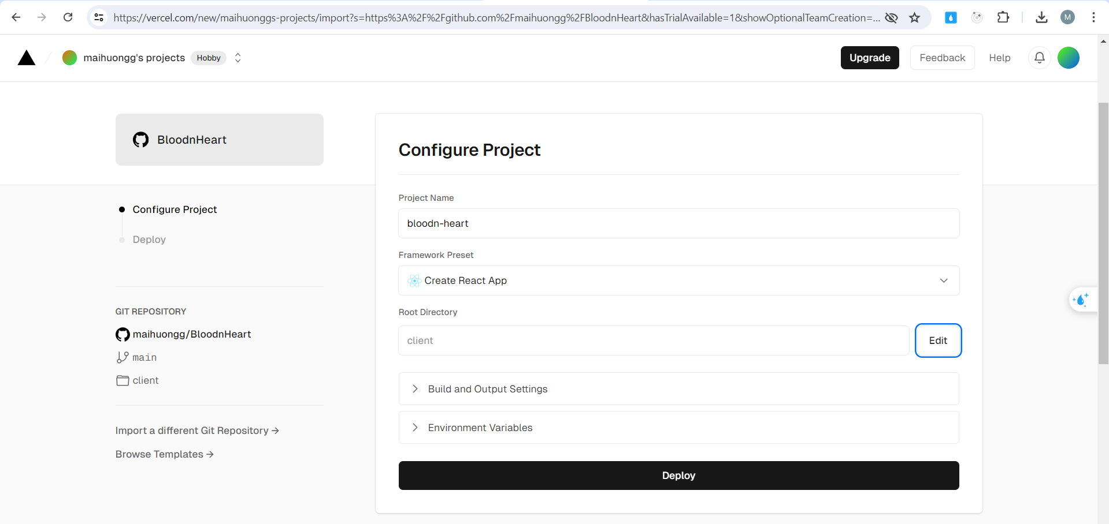

*Figure 5. 12 Set up frontend deployment*

**Step 6:** Click "Deploy" to begin the deployment procedure after setup. Vercel will take care of the construction and deployment procedures automatically.

* Upon completion, a URL for your website will be sent to us. The Vercel dashboard allows us to manage deployments and monitor their progress.
* This procedure enables simple deployment using the Vercel web interface and does not need the use of the command line.
* Link deployment front-end (user and guest): <https://bloodnheart.vercel.app/>
* Link deployment front-end (hospital and admin): <https://admin-bloodn-heart.vercel.app/>

# **CHAPTER 6: CONCLUSION**

## **6.1. Evaluation**

In the field of technology, we have successfully integrated a variety of technologies into the BloodnHeart project. Technically, the development of this platform has been an illuminating experience, offering valuable insights into the intricacies of product development.

When it came to the product itself, we wanted to develop a complete solution that could serve a wide range of users. Our goal for the product was to create a comprehensive solution with a minimalistic UI/UX design for broad accessibility. BloodnHeart facilitates easy participation in blood donation events through its user-friendly interface and unique features such as donation calendar management and event registration. The platform also fosters an engaged community by collaborating with hospitals and incorporating social elements. Prioritizing user data security, BloodnHeart addresses diverse needs, from event management to account administration, with designated roles for hospitals and officials. In essence, BloodnHeart not only promotes health awareness but actively involves the community in blood donation programs.

However, given that it presently only provides the most basic functionality one would anticipate from a blood donation website, the BloodnHeart platform is far from perfect. In the future, this product has a tonne of potential for growth. For example, the current system does not have service payment management, and our goal is to create features that allow users to confirm their driver's licenses and citizen identity cards. The capabilities of the product would be greatly improved by the addition of these features.

Throughout the BloodnHeart project, we've gained valuable insights into both technical aspects and the importance of fostering a spirit of teamwork. These lessons learned will undoubtedly contribute to the ongoing enhancement and development of our platform.

## **6.2. Difficulties and challenges**

*Table 6. 1 Difficulties and challenges*

| **Challenge** | **Impact** |
| --- | --- |
| New Technology Adoption | 20% |
| Ineffective Time Management | 15% |
| Technical Issues | 5% |

Undoubtedly, integrating new technologies into the BloodnHeart project presented a substantial challenge, accounting for 20% of the overall difficulty. Being the first time we utilized new technology, the team had to learn and build from scratch, resulting in a more time-consuming process.

Ineffective time management, constituting 15% of the challenges, proved complex as we juggled various project aspects, timelines, and priorities. This impacted progress and led to a reassessment of our time allocation strategies for improved productivity.

Technical issues, accounting for 5% of the difficulties, required a combination of troubleshooting skills, collaboration, and resourcefulness to ensure the project's smooth development.

During the report writing process, substantial changes were made to the product, providing valuable lessons for the team.

**REFERENCES**

| [1] | M. S, "Reactjs," 2023. [Online]. Available: https://www.linkedin.com/pulse/reactjs-manojkumar-s-folqf/?trk=articles_directory. |
| --- | --- |
| [2] | C. Deshpande, "The Best Guide to Know What Is React," 5 2023. [Online]. Available: https://www.simplilearn.com/tutorials/reactjs-tutorial/what-is-reactjs. |
| [3] | H. GOHEL, "MongoDB : Advantages and Disadvantages," SEPTEMBER 19, 2022. [Online]. Available: https://www.infraveo.com/blog/mongodb-advantages-and-disadvantages/. |
| [4] | A. Sharma, "Express JS Tutorial," [Online]. Available: https://www.simplilearn.com/tutorials/nodejs-tutorial/what-is-express-js. [Accessed 19 12 2023]. |
| [5] | T. Kaneriya, "Advantages & Disadvantages of Node.js : Why to Use Node.js?," Last Updated April 10, 2023. [Online]. Available: https://www.simform.com/blog/nodejs-advantages-disadvantages/. |